UNITED STATES

SECURITIES AND EXCHANGE COMMISSION

Washington, D.C. 20549

________________________

SCHEDULE 14A

Proxy Statement Pursuant to Section 14(a) of the

Securities Exchange Act of 1934

________________________

Filed by the Registrant x

Filed by a Party other than the Registrant o

Check the appropriate box:

- Preliminary Proxy Statement

- Confidential, for Use of the Commission Only (as permitted by Rule 14a-6(e)(2))

- Definitive Proxy Statement

- Definitive Additional Materials

- Soliciting Material Pursuant to §240.14a-12

Lear Corporation

(Name of Registrant as Specified in its Charter)

(Name of Person(s) Filing Proxy Statement, if other than the Registrant)

Payment of Filing Fee (Check the appropriate box):

- No fee required.

- Fee paid previously with preliminary materials.

- Fee computed on table in exhibit required by Item 25(b) per Exchange Act Rules 14a-6(i)(1) and 0-11.

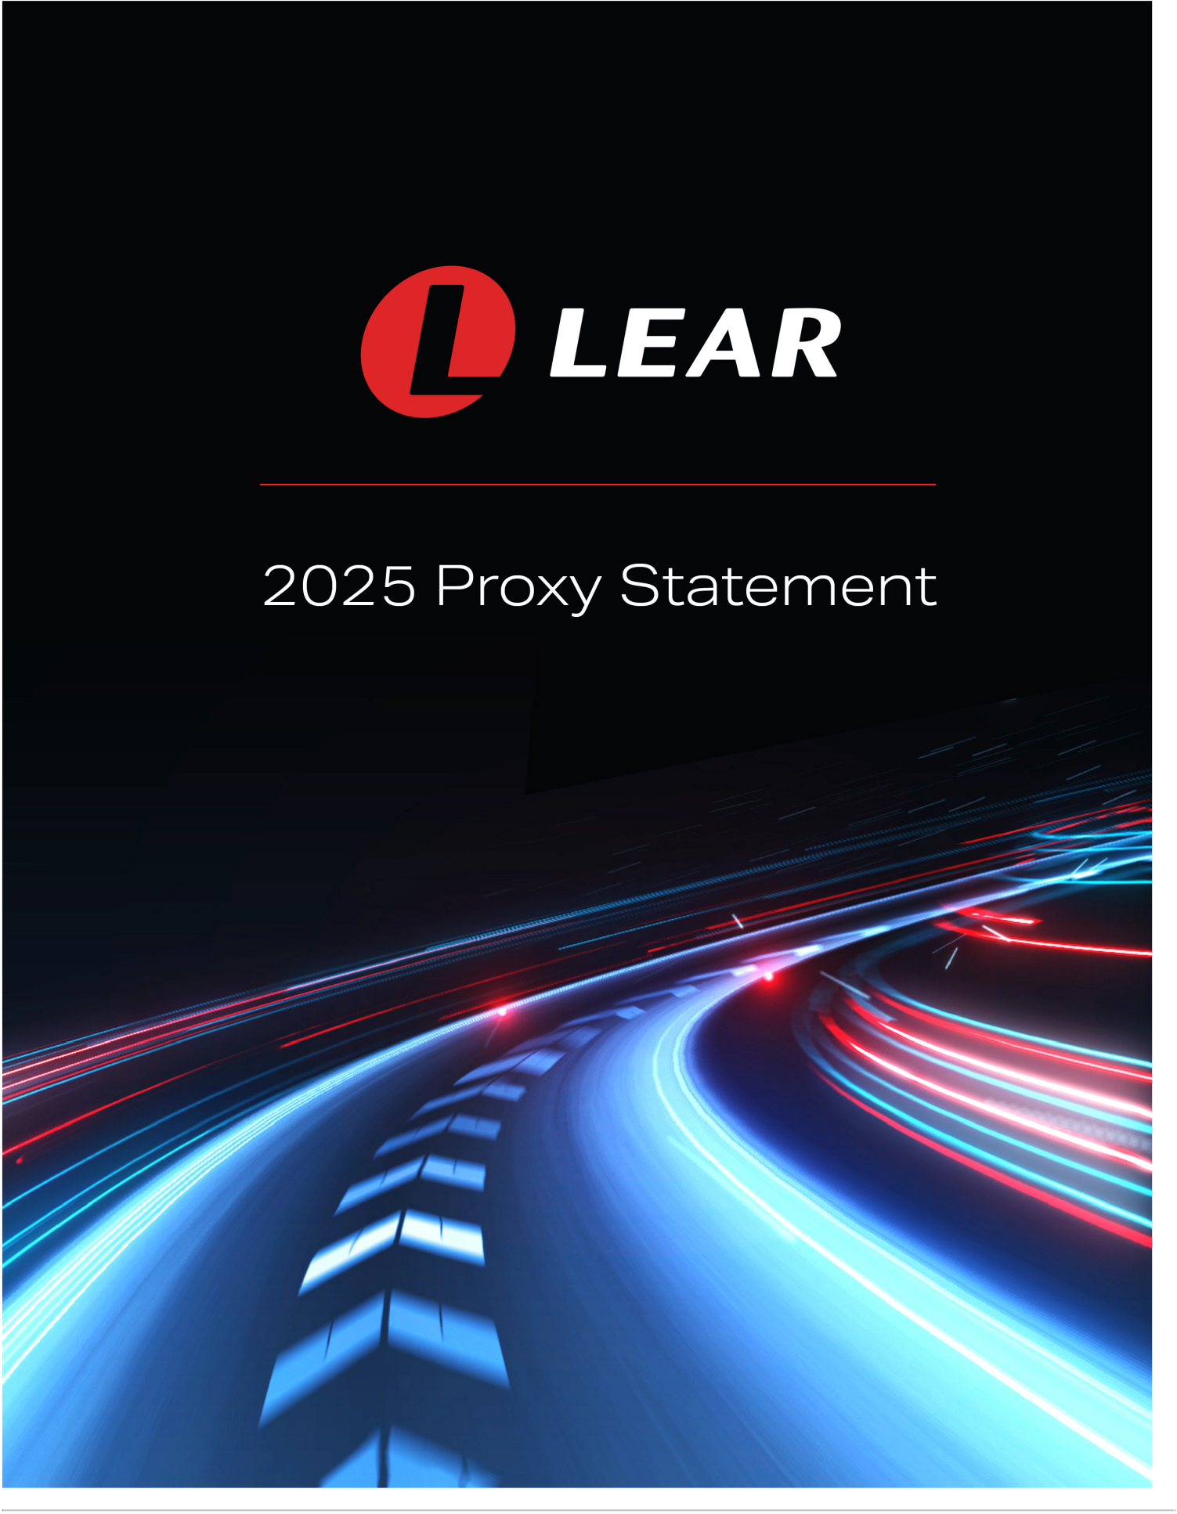



21557 Telegraph Road

Southfield, Michigan 48033

April 3, 2025

Dear Shareholder:

On behalf of the Board of Directors of Lear Corporation, you are cordially invited to attend the 2025 Annual Meeting of Shareholders (the

“Annual Meeting”) to be held through a virtual web conference at www.virtualshareholdermeeting.com/LEA2025 on May 16, 2025, at 9:00 a.m. (Eastern Time). You will be able to attend the Annual Meeting online, vote your shares electronically, and submit questions in

advance of and during the meeting by logging in to the website listed above using the 16-digit control number included in your Notice of Internet Availability of Proxy Materials, on your proxy card, or in any additional voting instructions accompanying these proxy materials. We recommend that you log in a few minutes before the meeting to ensure you are admitted when the meeting starts.

To facilitate broad shareholder attendance and participation and provide a consistent experience to all shareholders, regardless of location, the Annual Meeting will once again be virtual. We have included with this letter a proxy statement that provides you with

detailed information about the Annual Meeting. We encourage you to read the entire proxy statement carefully. You may also obtain more information about Lear Corporation from documents we have filed with the Securities and Exchange Commission (the “SEC”).

We are delivering our proxy statement and annual report on Form 10-K pursuant to the SEC rules that allow companies to furnish proxy

materials to their shareholders over the Internet. We believe that this delivery method expedites shareholders’ receipt of proxy materials and lowers the cost and environmental impact of our Annual Meeting. On or about April 3, 2025, we will mail to our shareholders a

notice containing instructions on how to access our proxy materials. In addition, the notice includes instructions on how you can receive a paper copy of our proxy materials.

You are being asked at the Annual Meeting to elect directors named in the accompanying proxy statement, to ratify the retention of

Ernst & Young LLP as our independent registered public accounting firm, to provide an advisory vote to approve our executive compensation and to transact any other business properly brought before the Annual Meeting.

As always, we encourage you to vote your shares prior to the Annual Meeting. You may vote your shares through one of

the methods described in the enclosed proxy statement. We strongly urge you to read the accompanying proxy statement carefully and to vote FOR the nominees proposed by the Board of Directors and in accordance with the recommendations

of the Board of Directors on the other proposals by following the voting instructions contained in the proxy statement.

Sincerely,
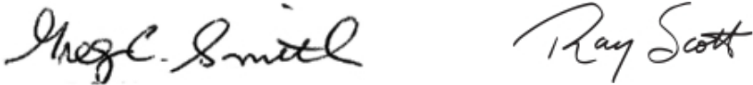

Greg C. Smith

Non-Executive Chairman

Raymond E. Scott

President, Chief Executive Officer and Director

This proxy statement is dated April 3, 2025, and is first being made available to shareholders via the Internet on or about April 3, 2025.



 |  |  | 21557 Telegraph Road
 |  |  | Southfield, Michigan 48033
 | NOTICE OF ANNUAL MEETING OF SHAREHOLDERS
Time and Date: |  | Friday, May 16, 2025, at 9:00 a.m. (Eastern Time)
 |  | Online check-in will be available beginning at 8:30 a.m. (Eastern Time). Please allow ample
 |  | time for the online check-in process.
Place: |  | The Annual Meeting will be held through a virtual web conference at
 |  | www.virtualshareholdermeeting.com/LEA2025. To participate in the Annual Meeting, you will
 |  | need your 16-digit control number included in your Notice of Internet Availability of the Proxy
 |  | Materials, on your proxy card, or in any additional voting instructions accompanying these
 |  | Proxy Materials.
Record Date: |  | March 18, 2025
Items of Business: |  | 1. | To elect the following eleven nominees to the Board of Directors (the “Board”): Julian G.
 |  |  | Blissett, Jonathan F. Foster, Bradley M. Halverson, Mary Lou Jepsen, Roger A. Krone, Rod
 |  |  | A. Lache, Patricia L. Lewis, Kathleen A. Ligocki, Conrad L. Mallett, Jr., Raymond E. Scott
 |  |  | and Greg C. Smith;
 |  | 2. | To ratify the retention of Ernst & Young LLP as the Company’s registered public accounting
 |  |  | firm for 2025;
 |  | 3. | To approve, in a non-binding advisory vote, the Company’s executive compensation; and
 |  | 4. | To conduct any other business properly brought before the Annual Meeting or any
 |  |  | postponement thereof.
Proxy Voting: |  | YOUR VOTE IS IMPORTANT. WHETHER OR NOT YOU PLAN TO ATTEND THE ANNUAL MEETING,
 |  | PLEASE VOTE YOUR SHARES OVER THE TELEPHONE, VIA THE INTERNET OR BY COMPLETING,
DATING, SIGNING AND RETURNING A PROXY CARD, AS DESCRIBED IN THE PROXY STATEMENT. YOUR PROMPT COOPERATION IS GREATLY APPRECIATED.

By Order of the Board of Directors,
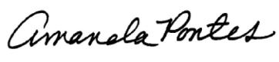

Amanda J. Pontes

Vice President, General Counsel

and Corporate Secretary
April 3, 2025


Notice of Internet Availability of Proxy Materials

We are making the accompanying proxy statement and our annual report on Form 10-K available to shareholders electronically via the Internet. On or about April 3, 2025, we will mail to most of our shareholders a notice containing instructions on how to access this proxy statement and our annual report on Form 10-K and to vote via the Internet or by

telephone. Other shareholders, in accordance with their prior requests, will receive e-mail notification of how to access our proxy materials and vote via the Internet or by telephone or will be mailed paper copies of our proxy materials and a proxy card on or about April 3, 2025.

Table of Contents

TABLE OF CONTENTS

2025 PROXY STATEMENT SUMMARY |  |  |  |  |  |  |  |  |  |  |  |  |  |  |  |  |  |  | 1
Annual Meeting of Shareholders |  |  |  |  |  |  |  |  |  |  |  |  |  |  |  |  |  |  |  | 1
Proxy Voting Roadmap |  |  |  |  |  |  |  |  |  |  |  |  |  |  |  |  |  |  | 1
Lear at a Glance |  |  |  |  |  |  |  |  |  |  |  |  |  |  |  |  |  |  | 2
2024 Financial Performance |  |  |  |  |  |  |  |  |  |  |  |  |  |  |  |  |  |  | 3
2024 Compensation Highlights |  |  |  |  |  |  |  |  |  |  |  |  |  |  |  |  |  |  | 4
Corporate Governance |  |  |  |  |  |  |  |  |  |  |  |  |  |  |  |  |  |  | 6
2025 Annual Meeting of Shareholders |  |  |  |  |  |  |  |  |  |  |  |  |  |  |  |  |  |  | 7
Items to be Voted on |  |  |  |  |  |  |  |  |  |  |  |  |  |  |  |  |  |  | 8
Director Nominees |  |  |  |  |  |  |  |  |  |  |  |  |  |  |  |  |  |  | 8
Sustainability Highlights for 2024 |  |  |  |  |  |  |  |  |  |  |  |  |  |  |  |  |  |  | 9
ELECTION OF DIRECTORS (PROPOSAL NO. 1) |  |  |  |  |  |  |  |  |  |  |  |  |  |  |  |  |  |  | 10
DIRECTORS AND CORPORATE GOVERNANCE |  |  |  |  |  |  |  |  |  |  |  |  |  |  |  |  |  |  | 11
Director Biographical Information and Qualifications |  |  |  |  |  |  |  |  |  |  |  |  |  |  |  |  |  |  | 11
Criteria for Selection of Directors and Director Recruitment Process |  |  |  |  |  |  |  |  |  |  |  |  |  |  |  |  |  |  | 17
Board Composition and Tenure |  |  |  |  |  |  |  |  |  |  |  |  |  |  |  |  |  |  | 19
Recommendation of Directors by Shareholders |  |  |  |  |  |  |  |  |  |  |  |  |  |  |  |  |  |  | 20
Independence of Directors |  |  |  |  |  |  |  |  |  |  |  |  |  |  |  |  |  |  | 20
Board’s Role in Risk Oversight |  |  |  |  |  |  |  |  |  |  |  |  |  |  |  |  |  |  | 21
Sustainability |  |  |  |  |  |  |  |  |  |  |  |  |  |  |  |  |  |  | 22
Other Board Information |  |  |  |  |  |  |  |  |  |  |  |  |  |  |  |  |  |  | 26
Director Compensation |  |  |  |  |  |  |  |  |  |  |  |  |  |  |  |  |  |  | 29
Security Ownership of Certain Beneficial Owners, Directors and Management |  |  |  |  |  |  |  |  |  |  |  |  |  |  |  |  |  |  | 31
Delinquent Section 16(a) Reports |  |  |  |  |  |  |  |  |  |  |  |  |  |  |  |  |  |  | 32
COMPENSATION DISCUSSION AND ANALYSIS ("CD&A") |  |  |  |  |  |  |  |  |  |  |  |  |  |  |  |  |  |  | 33
CD&A Executive Summary |  |  |  |  |  |  |  |  |  |  |  |  |  |  |  |  |  |  | 34
Summary of NEO Pay Results for 2024 |  |  |  |  |  |  |  |  |  |  |  |  |  |  |  |  |  |  | 36
Decision-Making Framework |  |  |  |  |  |  |  |  |  |  |  |  |  |  |  |  |  |  | 36
What We Pay and Why: Elements of Executive Compensation |  |  |  |  |  |  |  |  |  |  |  |  |  |  |  |  |  |  | 41
2024 Performance Results and Compensation Decisions |  |  |  |  |  |  |  |  |  |  |  |  |  |  |  |  |  |  | 44
Other Pay Elements |  |  |  |  |  |  |  |  |  |  |  |  |  |  |  |  |  |  | 51
Governance Policies and Practices |  |  |  |  |  |  |  |  |  |  |  |  |  |  |  |  |  |  | 52
EXECUTIVE COMPENSATION TABLES |  |  |  |  |  |  |  |  |  |  |  |  |  |  |  |  |  |  | 56
P&C COMMITTEE INTERLOCKS AND INSIDER PARTICIPATION |  |  |  |  |  |  |  |  |  |  |  |  |  |  |  |  |  |  | 76
P&C COMMITTEE REPORT |  |  |  |  |  |  |  |  |  |  |  |  |  |  |  |  |  |  | 77
AUDIT COMMITTEE REPORT |  |  |  |  |  |  |  |  |  |  |  |  |  |  |  |  |  |  | 78
FEES OF INDEPENDENT ACCOUNTANTS |  |  |  |  |  |  |  |  |  |  |  |  |  |  |  |  |  |  | 80
CERTAIN RELATIONSHIPS AND RELATED PARTY TRANSACTIONS |  |  |  |  |  |  |  |  |  |  |  |  |  |  |  |  |  |  | 81
RATIFICATION OF RETENTION OF INDEPENDENT REGISTERED PUBLIC ACCOUNTING FIRM FOR 2025 |  |  |  |  |  |  |  |  |  |  |  |  |  |  |  |  |  |  | 82
(PROPOSAL NO. 2)
ADVISORY VOTE TO APPROVE THE COMPANY’S EXECUTIVE COMPENSATION SET FORTH IN THIS PROXY |  |  |  |  |  |  |  |  |  |  |  |  |  |  |  |  |  |  | 83
STATEMENT (PROPOSAL NO. 3)
QUESTIONS AND ANSWERS ABOUT THE ANNUAL MEETING |  |  |  |  |  |  |  |  |  |  |  |  |  |  |  |  |  |  | 84
SHAREHOLDER PROPOSALS FOR 2026 ANNUAL MEETING OF SHAREHOLDERS |  |  |  |  |  |  |  |  |  |  |  |  |  |  |  |  |  |  | 88
OTHER MATTERS |  |  |  |  |  |  |  |  |  |  |  |  |  |  |  |  |  |  | 89
APPENDIX A RECONCILIATION OF NON-GAAP FINANCIAL MEASURES |  |  |  |  |  |  |  |  |  |  |  |  |  |  |  |  |  |  | 90

2025 Proxy Statement | i

Table of Contents

PROXY SUMMARY

LEAR CORPORATION

2025 PROXY STATEMENT SUMMARY

This summary highlights information that is contained elsewhere in this proxy statement by Lear Corporation (the "Company," "Lear,"

"we," "our" or "us"). It does not include all of the information necessary to make a voting decision, and you should carefully read this proxy statement in its entirety before casting your vote. Please see the section "Questions and Answers" beginning on page 84 for important information about proxy materials, voting, the Annual Meeting, the Company, documents and communications.

Annual Meeting of Shareholders


Proxy Voting Roadmap

Shareholders will be asked to vote on the following matters at the Annual Meeting. This section does not contain all of the information that you should consider in deciding how to vote. You should read the entirety of this proxy statement carefully before voting.

 | Voting Matter | Board Vote Recommendation | Page
 | Voting Matter | Board Vote Recommendation | Reference
Item | Election of Director Nominees Named in | FOR | 10
1 | this Proxy Statement | FOR
1 | this Proxy Statement | all eleven director nominees
Item | Ratification of Retention of Independent | FOR | 82
2 | Registered Public Accounting Firm | FOR
Item | Advisory Vote to Approve the Company's | FOR | 83
3 | Executive Compensation | FOR

2025 Proxy Statement | | 1

Table of Contents

PROXY SUMMARY

Lear at a Glance

Lear Corporation is a global automotive technology leader in Seating and E-Systems, enabling superior in-vehicle experiences for

consumers around the world. We supply complete seat systems, key seat components, complete electrical distribution and connection systems, high-voltage power distribution products, including battery disconnect units ("BDUs"), low-voltage power distribution products and electronic controllers to all of the world's major automotive manufacturers. At Lear, we are Making every drive betterTM by providing

technology for safer, smarter and more comfortable journeys, while adhering to our values — Be Inclusive. Be Inventive. Get Results the Right Way.


- See page 3 and Appendix A “Reconciliation of Non-GAAP Financial Measures” on page 90 for more information on this non-GAAP financial measure and how it is used.

Innovation, as a key pillar of our strategy, enables us to create industry-leading products that differentiate us in the competitive marketplace and support long-term sustainable growth aligned with automotive industry trends.
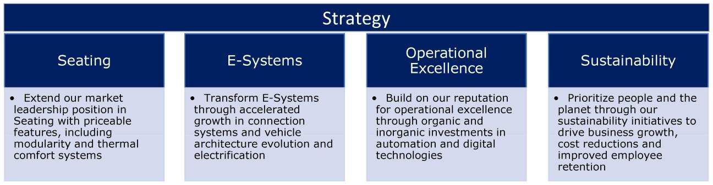

Lear focuses on developing technologies that will provide a competitive advantage in the future. We are a leader in quality, innovation, technology and operational excellence.

Lear is a recognized global leader in complete seat systems with industry-leading operating margins. In Seating, we have the most complete vertically integrated product portfolio, and our capabilities are driving the development of innovative modular solutions for our

customers. We continue to gain market share in Seating with over $2 billion in conquest wins since 2019. We launched our ComfortFlex™ module, a first of its kind system that integrates multiple thermal comfort technologies into a single module, and in 2024, we secured 19 contracts for this product representing annual revenue of approximately $135 million.

In E-Systems, our revenue growth outperformed that of the market by approximately 6 percentage points in 2024, and through the execution of our strategic and operational initiatives, we increased margins for the second consecutive year with a 50 basis point

improvement year-over-year.

- | LEAR CORPORATION

Table of Contents

PROXY SUMMARY

Business Highlights

2024 Financial Performance
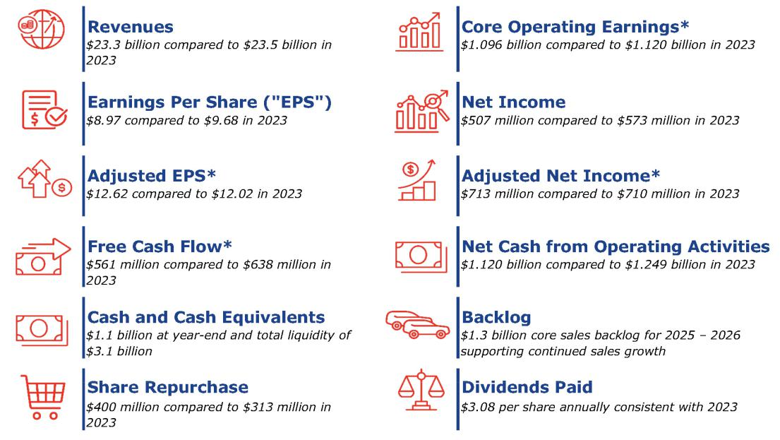

- Contained above, and elsewhere in this proxy statement, are certain financial measures that are not calculated in accordance with accounting principles generally accepted in the United States ("GAAP"). These measures, along with their corresponding GAAP measures and reconciliations thereto, have been previously disclosed in the exhibit to Lear’s Current Report on Form 8-K filed with the Securities and Exchange Commission (the "SEC") on February 6, 2025. Also see Appendix A “Reconciliation of Non-GAAP Financial Measures” on page 90 for more information on these non-GAAP financial measures and how they are used.

2024 Business Performance

• Achieved revenue of $23.3 billion; Lear revenue growth | • Serve all of the world’s major automotive manufacturers with
outperformed that of the industry by 2 percentage points | content on more than 480 vehicle nameplates worldwide
• Improved margins in E-Systems for the second | • Strengthened positions in all major markets for Seating with a 26%
consecutive year with a 50 bps improvement year-over- | global market share
year
• Increased adjusted earnings per share for the fourth | • Repurchased $400 million of shares and paid $174 million in
consecutive year | dividends
• Introduced IDEA by Lear (Innovative, Digital, Engineered, | • Continued to grow in China with customers including BYD, Changan,
Automated) initiative to drive automation and digitization | the Dongfeng Group, Geely and Leapmotor
and completed the related acquisition of WIP Industrial
Automation
• Awarded eight top-three finishes in the J.D. Power 2024 | • Named a 2025 Automotive News PACE award finalist for our Zone
U.S. Seat Quality and Satisfaction Study,SM including a | Control Module
sweep of all three awards in the Premium Car category

- Named to Fortune magazine's "World's Most Admired Companies" list for the ninth consecutive year

- Named 2025 industry leader in America's Most Just Companies - Automobiles & Parts industry

2025 Proxy Statement | | 3

Table of Contents

PROXY SUMMARY

How Our Compensation Program Supports Our Business Strategy

Our executive compensation program is designed to support shareholder value creation by driving and rewarding long-term business outcomes, promoting strong governance practices and encouraging responsible risk-taking. This is achieved by linking individual pay to

the Company’s performance over a diverse set of financial measures. Lear has a long-standing commitment to pay for performance. The majority of all senior executives' compensation is variable and covers annual and multi-year performance periods, and all senior executives have meaningful long-term Lear stock holdings. Long-term incentives use three-year performance-vesting awards

("Performance Shares") to align senior executives' compensation with the Company’s long-term performance.

Our Board’s People and Compensation Committee (“P&C Committee”), with the assistance of its independent compensation consultant,

provides strong oversight through the approval of performance goals across all financial measures and the certification of performance outcomes.

Our executive compensation program, including our compensation guiding principles, decision-making process and performance measures, is discussed in detail in the "Compensation Discussion and Analysis" of this proxy statement beginning on page 33.

2024 Compensation Highlights

2024 Annual Incentive Plan ("AIP") Design Overview and Changes

- For the 2024 performance period, the P&C Committee maintained Lear's traditional equal weighting for the two financial measures that determine the AIP – Adjusted Operating Income and Free Cash Flow:

  - Adjusted Operating Income target set 26% higher than the 2023 target

  - Free Cash Flow target set 39% higher than the 2023 target

- Added a Strategic Scorecard modifier, which can increase (or decrease) the AIP results based on the two financial measures by up to 10% depending on the achievement of specific and objective goals relating to innovation in areas of strategic importance such as automation and digitization.

2024-2026 Long-Term Stock Incentive Plan ("LTI") Design Overview and Changes

For the 2024-2026 LTI grants, the P&C Committee continued to align our leadership’s compensation with shareholder interests:

- Maintained award mix that heavily emphasizes performance-based awards: 75% of our CEO's LTI award (and 70% for other recipients) is comprised of Performance Shares:

  - Our Performance Share weighting continues to be higher than most of the Comparator Group, as well as many other large industrial companies (i.e., typically 50% - 60% of the regular annual equity award), as described in "Compensation Discussion and Analysis - Benchmarking" on page 39.

- Maintained performance measures designed to reward financial and Total Shareholder Return ("TSR") results: Performance Shares earned based on Adjusted Pretax Income, Adjusted Return on Invested Capital ("ROIC") Improvement and Relative TSR results:

  - The 2024-2026 Performance Shares can be earned based on the following performance measures (beginning on page

49):

    - Adjusted Pretax Income (50% of the award)

    - Adjusted ROIC Improvement (25% of the award)

    - Relative TSR (25% of the award)

  - The goals for all three performance measures were set prior to the start of the three-year performance period.

- Goal setting aligns with our long-range plan with all financial targets set prior to the start of the performance period and above prior year targets:

  - For the 2024-2026 Performance Shares, all performance goals were established and approved by the P&C Committee in November 2023, prior to the start of the performance period.

  - The cumulative Adjusted Pretax Income target for the 2024-2026 Performance Shares is 32% higher than for the 2023-2025 Performance Shares, and the Adjusted ROIC Improvement targets for the 2024-2026 Performance Shares increase each year during the performance period. For both Adjusted Pretax Income and Adjusted ROIC Improvement, the results for each year will be measured and the final payout will be based on the average of the annual results.

- | LEAR CORPORATION

Table of Contents

PROXY SUMMARY

Pay-for-Performance Alignment

Base salary and annual and long-term incentive award opportunities are the core elements of total direct compensation of our Chief Executive Officer ("CEO"), our Chief Financial Officer ("CFO") and each of our other executive officers listed in the Summary

Compensation Table (collectively, our Named Executive Officers, referred to herein as our "NEOs"). As shown below, the significant portion of performance-based pay aligns our NEOs' compensation with our shareholders’ interests. The target compensation mix for our CEO and our other NEOs on average for 2024 is shown below and further discussed in detail in the "Compensation Discussion and

Analysis" of this proxy statement beginning on page 33:
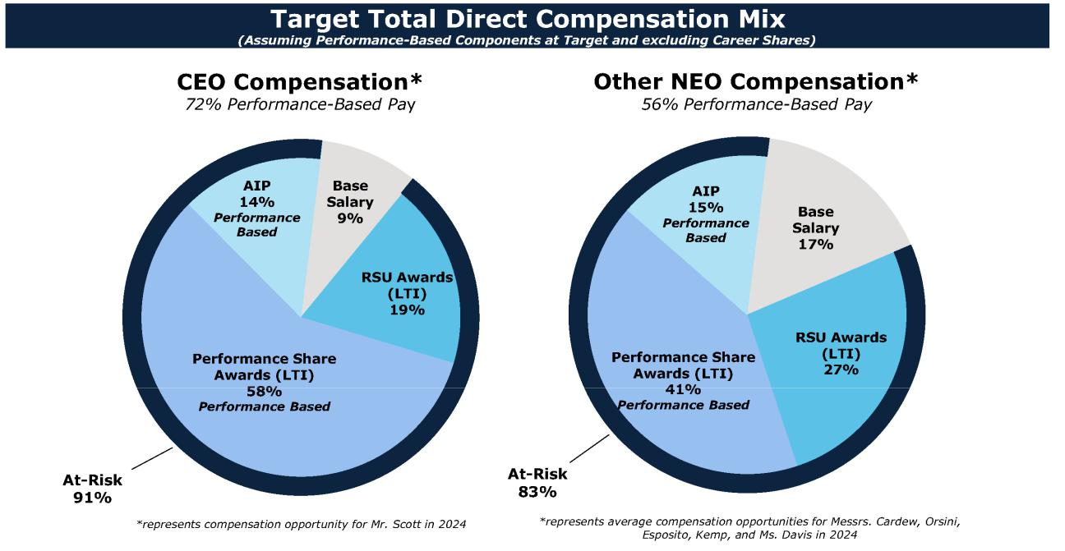

2025 Proxy Statement | | 5

Table of Contents

PROXY SUMMARY

Corporate Governance

Governance Highlights

Board Structure and Independence

 | • All of our non-executive directors | • Our Board committees are comprised | • Independent directors meet regularly
 | are independent | solely of independent directors | without management present
 | • We maintain separate Chairperson | • Our highly skilled Board provides a | • Our Board committees hold executive
 | of the Board and CEO roles | range of expertise and viewpoints | sessions without management present
 | • 42% of our Board members are | • We conduct a regular review of our
 | diverse and 25% are female; 66% | Board skills matrix
 | of the committee chairs are
 | diverse/women
Shareholder Rights
 | • We hold an annual election of all | • We have majority voting in | • We have advance notice provisions in our
 | directors | uncontested director elections | Second Amended and Restated Bylaws (the
 |  |  | "Bylaws")
Board Oversight
 | • We have structured processes for | • The Board and its committees oversee | • The P&C Committee oversees human capital
 | the Board's oversight of the | environmental, sustainability and | management, the executive compensation
 | Company's annual business plan | governance matters | programs, talent metrics and strategies
 | and corporate strategy
 | • We conduct a regular review and | • The Audit Committee oversees the | • Management conducts a strategic and
 | assessment of committee | integrity of the Company's financial | comprehensive succession planning review,
 | responsibilities | statements, related regulatory and | leadership talent review and human capital
 |  | legal compliance, cybersecurity risk | overview in a separate session with all Board
 |  | and compliance with Lear's Code of | members annually
 |  | Conduct & Business Ethics
 | • We have a structured and robust | • The Governance and Sustainability
 | process for the Board’s assessment | Committee (the "G&S Committee")
 | and oversight of key business risks | oversees corporate governance and
 |  | sustainability matters
Strong Corporate Governance Practices
 | • We maintain robust share | • We have a responsive, active and | • We have adopted a comprehensive
 | ownership guidelines for executive | ongoing shareholder engagement | sustainability strategy and corresponding
 | officers and directors | program | goals
 | • We prohibit hedging and pledging | • We have a robust Code of Business | • We conduct an annual risk assessment of
 | transactions by executive officers | Conduct & Ethics for employees and | compensation programs, practices and
 | and directors | directors | policies
 | • We have a supplemental Improper | • We have limits on annual director | • We conduct annual Board and committee
 | Conduct compensation clawback | compensation, and limits on the | self-assessments, and in 2024, our directors
 | policy in addition to clawbacks | number of other public company | completed board effectiveness surveys,
 | required by law, regulation, or | boards and other public company | which included in-depth director interviews
 | applicable listing standard | board audit committees on which | conducted by an independent third-party
 |  | directors may serve | firm
6 | | LEAR CORPORATION

Table of Contents

PROXY SUMMARY

Shareholder Outreach and Engagement

We believe that strong corporate governance practices should include regular outreach and conversations with our shareholders. Our Board also reviews material shareholder engagements, as well as any shareholder inquiries directly related to its responsibilities.
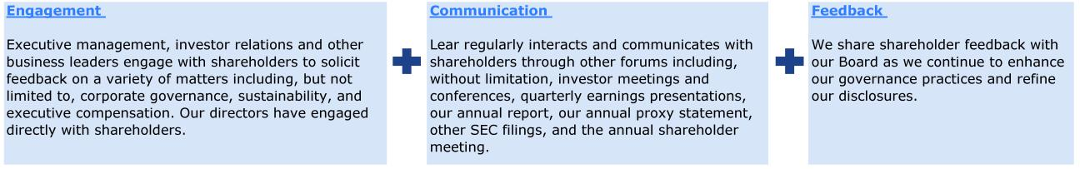

We regularly discuss our business outlook, financial performance, strategic priorities, industry dynamics, compensation, sustainability

initiatives, corporate governance and other topics of importance with investors. We actively engage with shareholders of all sizes through a combination of virtual and in-person engagements, including our annual meeting, our website, investor conferences and one-on-one

meetings when appropriate.

During 2024, we engaged with shareholders representing 70% of our outstanding shares. We also had 253 interactions with 116 institutions during 2024 as part of our regular ongoing shareholder engagement. These regular engagements allow us to obtain feedback

on our shareholders’ perception and understanding of our markets, business and industry. We are committed to maintaining an active dialogue with investors to better understand their perspectives and consider their input.

2025 Annual Meeting of Shareholders

- Date and Time: May 16, 2025, 9:00 a.m. (Eastern Time). Online check-in will be available at 8:30 a.m. (Eastern Time). Please allow ample time for the online check-in process.

- Location: The Annual Meeting will be held through a virtual web conference at www.virtualshareholdermeeting.com/LEA2025. To participate in the Annual Meeting, you will need your 16-digit control number included in your Notice of Internet Availability of the Proxy Materials, on your proxy card, or in any additional voting instructions accompanying these proxy materials.

- Record Date: March 18, 2025

- Voting: Shareholders as of the close of business on the record date are entitled to vote. Each share of common stock is entitled to one vote for each director nominee and one vote for the other proposals to be voted on.

- Shares of Common Stock Outstanding (as of the record date): 53,540,555

- Stock Symbol: LEA

- Exchange: New York Stock Exchange (“NYSE”)

- Registrar & Transfer Agent: Computershare Trust Company, N.A.

- Principal Executive Office: 21557 Telegraph Road, Southfield, Michigan 48033

- Corporate Website: lear.com

- Investor Relations Website: https://ir.lear.com/

2025 Proxy Statement | | 7

Table of Contents

PROXY SUMMARY

Items to be Voted on

 | Our Board’s
Proposal | Recommendation
Election of Director Nominees Named in this Proxy Statement (page 10) | FOR
Ratification of Retention of Independent Registered Public Accounting Firm (page 82) | FOR
Advisory Vote to Approve the Company’s Executive Compensation (page 83) | FOR
YOUR VOTE IS IMPORTANT. WHETHER OR NOT YOU PLAN TO ATTEND THE ANNUAL MEETING, PLEASE VOTE YOUR SHARES OVER THE TELEPHONE, VIA THE INTERNET OR BY COMPLETING, DATING, SIGNING AND RETURNING A PROXY CARD, AS DESCRIBED IN THE PROXY STATEMENT. YOUR PROMPT COOPERATION IS GREATLY APPRECIATED.

Director Nominees

 |  |  | Committee Membership
 |  | Director
Name and Principal Occupation | Age | Since | AC | P&C | G&S
Julian G. Blissett IND | 58 | 2025
Former Executive Vice President and President GM China, | 58 | 2025
General Motors
Jonathan F. Foster IND | 64 | 2009 | • |  | •
Managing Partner of Current Capital Partners LLC | 64 | 2009 | • |  | •
Bradley M. Halverson IND | 64 | 2020 | • | •
Former Group President and CFO, Caterpillar Inc.
Mary Lou Jepsen IND | 60 | 2016 |  | • | •
Founder, Chairperson and Former CEO, Openwater | 60 | 2016 |  | • | •
Roger A. Krone IND | 68 | 2020 | • |  | •
President and CEO, Boy Scouts of America | 68 | 2020 | • |  | •
Rod A. Lache IND | 55 | 2024
Former Managing Director and Senior Analyst, | 55 | 2024
Wolfe Research, LLC
Patricia L. Lewis IND | 63 | 2020 |  | • | •
Executive Vice President and Chief Sustainability Officer, UnitedHealth | 63 | 2020 |  | • | •
Group Incorporated
Kathleen A. Ligocki IND | 68 | 2012 |  | • | •
Former CEO of Tower Automotive and Agility Fuel Solutions | 68 | 2012 |  | • | •
Conrad L. Mallett, Jr. IND | 71 | 2002 | • |  | •
Corporation Counsel, City of Detroit | 71 | 2002 | • |  | •
Raymond E. Scott | 59 | 2018
President and CEO | 59 | 2018
Greg C. Smith IND | 73 | 2009 | E | E | E
Former Vice Chairman of Ford Motor Company

AC Audit Committee

P&C People and Compensation Committee

G&S Governance and Sustainability Committee

IND Independent director under NYSE and SEC rules

•Chair

•Member

- Ex Officio Member Director Term: One Year Board Meetings in 2024: 9
Standard Board Committee Meetings in 2024: Audit Committee 9, P&C Committee 8, G&S Committee 5

- | LEAR CORPORATION

Table of Contents

PROXY SUMMARY

Sustainability Highlights for 2024

Responsible and sustainable practices are integral to Lear’s strategy. We are committed to integrating sustainability into critical

processes, including enterprise risk management, facilities management, supplier selection and evaluation, and product innovation. These efforts reflect our core value of Getting Results the Right Way and underscore our dedication to creating lasting positive impacts. By pursuing these initiatives, we not only strengthen our strategic objectives but also contribute to the well-being of our people, the

health of our planet and the success of our business. Our key actions during 2024 included the following:

Environment Human Capital Management Governance


- Developed and commercialized innovative products that align with key sustainable and emerging industry trends, including BDUs for high voltage applications; FlexAirTM, our 100% recyclable non-foam alternative; and ReNewKnitTM, a sueded alternative material made entirely from recycled plastic and is fully recyclable

- Advanced our comprehensive renewable energy strategy, which encompasses on-site renewable energy generation at certain of our locations, the purchase of energy attribution certificates on an ongoing basis, and execution of virtual power purchase agreements to support new renewable energy projects where feasible

- Received validation from the Science Based Targets initiative ("SBTi") of our near-term greenhouse gas ("GHG") reduction targets

- Continued implementation of our internally developed waste generation and water usage playbooks globally to promote best practices on these topics within our facilities, enabling increased operational efficiency and reduced costs

- Conducted our annual in-depth talent review with the Board, including leadership depth and succession planning, as well as a comprehensive review of organizational talent and strategies to attract, motivate, develop and retain key employees

- Completed global annual pay equity review, with fewer than 1% of employees recommended for adjustment

- Enhanced our Expect Respect / Expect Inclusion anti-harassment training for our global workforce with training completed at all locations by end of first quarter 2025

- Expanded our Together We Grow merit-based program, which helps diverse high-potential future leaders build their networks and careers at Lear with an emphasis on engagement and relationship development, to include cohorts in Europe, Mexico and Honduras

- Published on our website our annual consolidated EEO-1 summary data as submitted to the U.S. Equal Employment Opportunity Commission

- Continued to expand our global Driving Wellness program, which includes localized initiatives to support the mental health and wellness of employees

- Continued to use a third-party supply chain evaluation partner to assess global production suppliers against sustainability criteria, including environmental stewardship and human rights, using a risk-based approach

- Launched a comprehensive training program designed to educate our internal supply chain purchasing teams on our sustainability policies, requirements and strategy, as well as key sustainability practices and principles

- Enhanced our forced and child labor training materials and resources, which are available to all suppliers through our Supplier Information Portal at lear.com

- Continued to enhance transparency and sustainability reporting with reference to the Global Reporting Initiative’s (“GRI”) standards, as well as the Sustainability Accounting Standards Board (“SASB”) and Task Force on Climate-Related Financial Disclosures (“TCFD”) recommendations

- Conducted training for non-production suppliers in Europe, Africa, Brazil and China on Lear's Code of Business Conduct & Ethics, anti-bribery and anti-corruption policy, and purchasing policies and processes

2025 Proxy Statement | | 9

Table of Contents

PROPOSAL NO. 1

ELECTION OF DIRECTORS (PROPOSAL NO. 1)

Mei-Wei Cheng, who has served as a member of our Board since 2019, will not be standing for re-election when his current term

expires, as he has reached the Company’s mandatory retirement age. The Board would like to thank Mr. Cheng for his years of dedicated service to the Company. In connection with Mr. Cheng’s retirement, the Board has resolved to decrease its size to eleven members

effective upon the expiration of the current term of the members of the Board at the Annual Meeting.

Upon the recommendation of our G&S Committee, the Board has nominated the eleven individuals listed below to stand for election to the Board for a one-year term ending at the annual meeting of shareholders in 2026 or until their successors, if any, are elected or

appointed. Our Bylaws provide for the annual election of directors. Each director nominee must receive the affirmative vote of a majority of the votes cast to be elected (i.e., the number of shares voted “for” a director nominee must exceed the number of votes cast

“against” that nominee). Unless contrary instructions are given, the shares represented by your proxy will be voted FOR the election of all director nominees. In addition, our Bylaws and Corporate Governance Guidelines contain a resignation policy which provides that in the event an incumbent director fails to receive a majority of the votes cast in an uncontested election, such director shall promptly

tender his or her resignation to the Board for consideration. The Board has determined that each director nominee, other than Mr. Scott, if elected, would be an independent director, as further described on page 20 in “Directors and Corporate Governance — Independence of Directors.”

Our Corporate Governance Guidelines also include a mandatory retirement age policy whereby an individual who has reached the age of seventy-five may not stand for election or re-election to the Board, as well as a policy that non-employee directors shall serve on no

more than three public company boards in addition to Lear's Board, the CEO shall serve on no more than one public company board in addition to Lear's Board, and employee directors (other than the CEO) shall serve on no more than two public company boards in addition to Lear's Board.

All of the director nominees listed below have consented to being named in this proxy statement and to serve if elected. However, if any nominee becomes unable to serve, proxy holders will have discretion and authority to vote for another nominee proposed by our Board.

Alternatively, our Board may reduce the number of directors to be elected at the Annual Meeting.

Name | Position
Julian G. Blissett | Director
Jonathan F. Foster | Director
Bradley M. Halverson | Director
Mary Lou Jepsen | Director
Roger A. Krone | Director
Rod A. Lache | Director
Patricia L. Lewis | Director
Kathleen A. Ligocki | Director
Conrad L. Mallett, Jr. | Director
Raymond E. Scott | Director, President and CEO
Greg C. Smith | Director, Non-Executive Chairman

Biographical information relating to each of the director nominees is set forth below under “Directors and Corporate Governance” and incorporated by reference herein.

THE BOARD UNANIMOUSLY RECOMMENDS A VOTE “FOR” THE ELECTION OF EACH OF LEAR’S DIRECTOR NOMINEES NAMED IN THIS PROXY STATEMENT.

PROXIES SOLICITED BY THE BOARD WILL BE VOTED “FOR” THE ELECTION OF EACH OF LEAR’S DIRECTOR NOMINEES NAMED IN THIS PROXY STATEMENT UNLESS SHAREHOLDERS SPECIFY A CONTRARY VOTE.

- | LEAR CORPORATION

Table of Contents

DIRECTORS AND CORPORATE GOVERNANCE

DIRECTORS AND CORPORATE GOVERNANCE

Director Biographical Information and Qualifications

Set forth below is a description of the business experience of each director nominee, as well as the specific qualifications, skills and

experiences considered by the G&S Committee and the Board in recommending our slate of director nominees. Each director nominee listed below is nominated for election to the Board for a term expiring at the annual meeting of shareholders in 2026. See “Election of Directors (Proposal No. 1).”
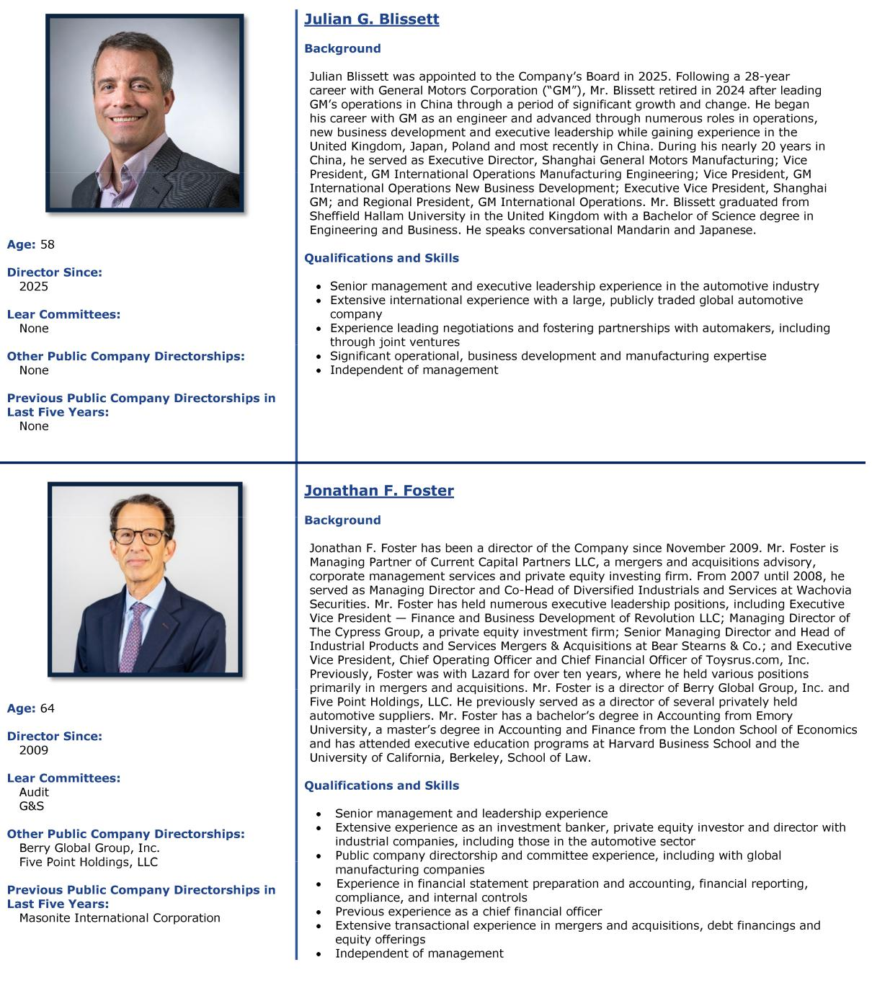

2025 Proxy Statement | 11

Table of Contents

DIRECTORS AND CORPORATE GOVERNANCE
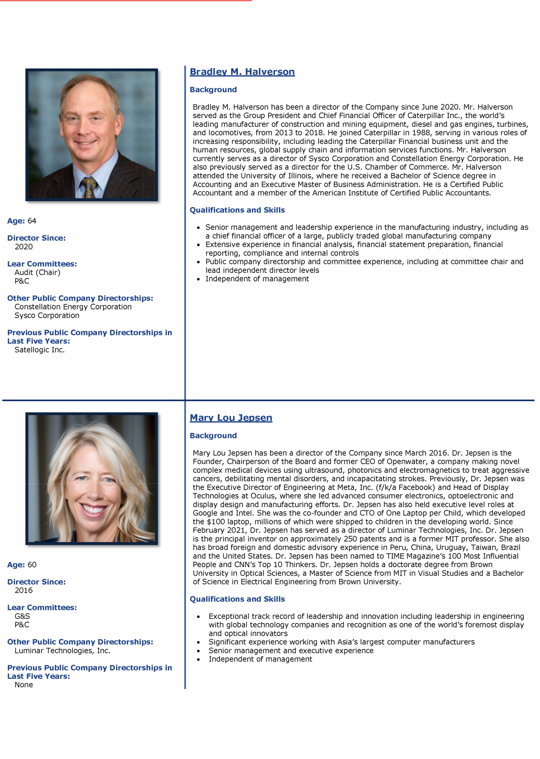

- | LEAR CORPORATION

Table of Contents

DIRECTORS AND CORPORATE GOVERNANCE
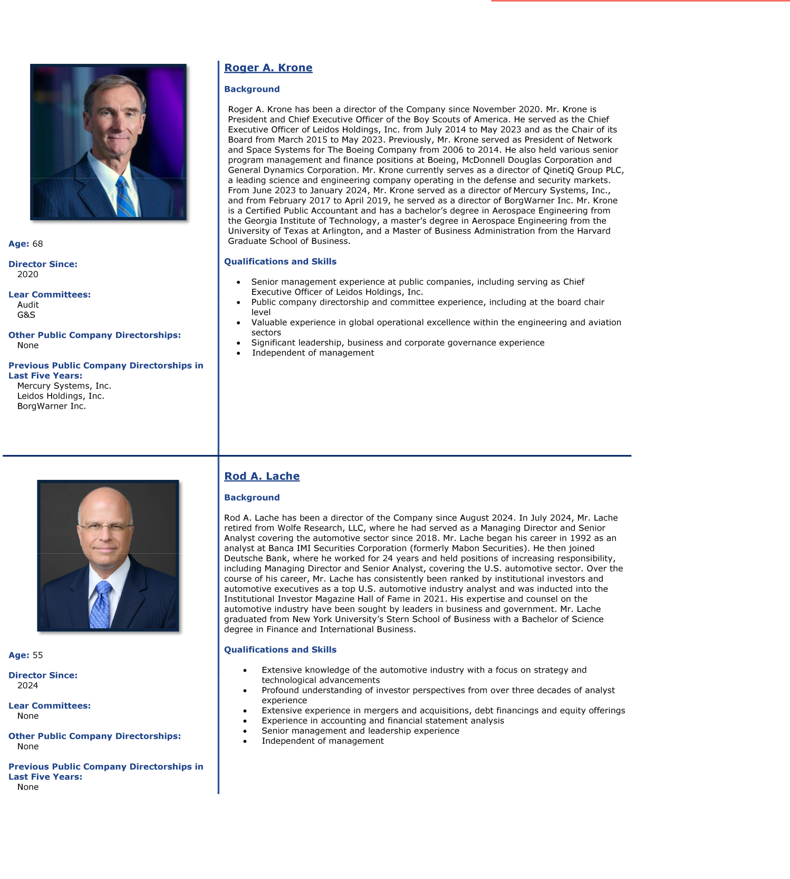

2025 Proxy Statement | 13

Table of Contents

DIRECTORS AND CORPORATE GOVERNANCE
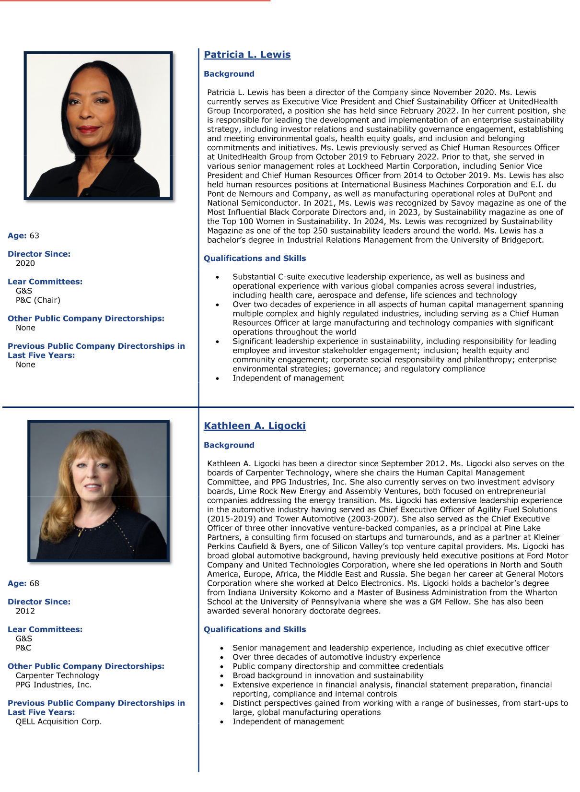

- | LEAR CORPORATION

Table of Contents

DIRECTORS AND CORPORATE GOVERNANCE
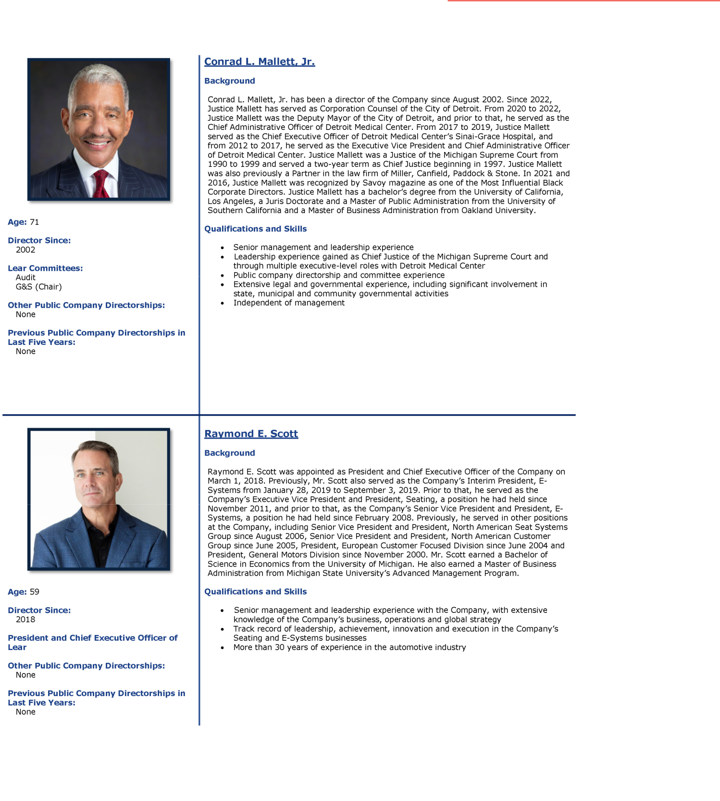

2025 Proxy Statement | 15

Table of Contents

DIRECTORS AND CORPORATE GOVERNANCE
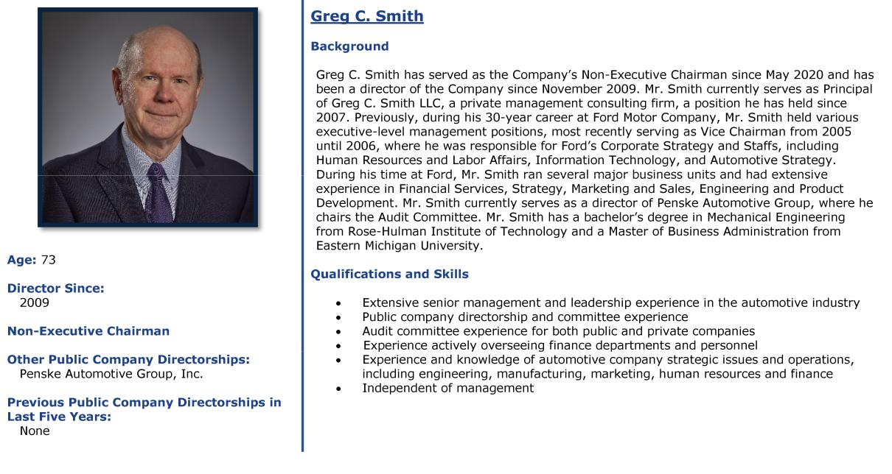

- | LEAR CORPORATION

Table of Contents

DIRECTORS AND CORPORATE GOVERNANCE

Criteria for Selection of Directors and Director Recruitment Process

The G&S Committee utilizes several criteria in evaluating and selecting candidates for Board membership including, without limitation, a

director nominee’s independence, skills, experience, perspective, background and diversity (which we define broadly to include differences in viewpoints, background, experience, skill, education, national origin, gender, race, age, culture and current affiliations that

may offer the Company exposure to contemporary business issues and is considered in the context of the Board as a whole). These criteria may vary from year to year, depending on the needs of the Company at the time.

The Board believes that diversity among directors is important to serving the long-term interests of Lear and its shareholders. In the

event the G&S Committee determines to recruit candidates as potential nominees to join the Board, the candidate pool will include qualified female and racially and/or ethnically diverse candidates and any third-party recruitment utilized in connection with such search

will be instructed to include such individuals in the list of candidates they provide the G&S Committee.

The general criteria set forth below are not listed in any particular order of importance:
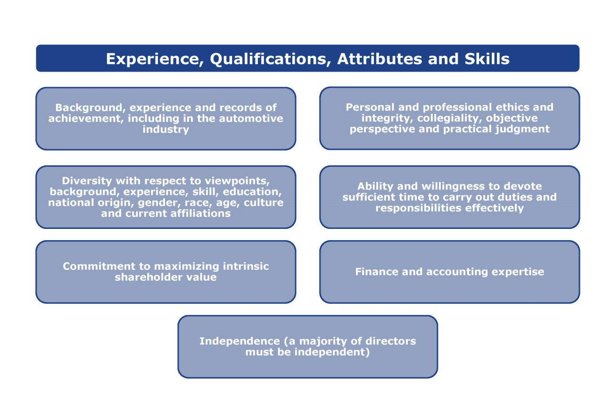

The above criteria should not be construed as minimum qualifications for director selection nor is it expected that director nominees will possess all of the criteria identified. Rather, they represent the range of complementary talents, backgrounds and experiences that the

G&S Committee believes would contribute to the effective functioning of our Board.

Our Corporate Governance Guidelines and G&S Committee charter provide guidelines with respect to the consideration of director

candidates. Under the Corporate Governance Guidelines, the G&S Committee is responsible for, subject to approval by the Board, establishing and periodically reviewing the criteria for Board membership, including independence standards, and selection of new directors. The G&S Committee also may recommend to the Board changes to the portfolio of director skills, experience, perspective and

background required for the effective functioning of the Board, considering the Company’s strategy and its regulatory, geographic and market environments. Any such changes to the director selection criteria must be approved by the Board.

2025 Proxy Statement | | 17

Table of Contents

DIRECTORS AND CORPORATE GOVERNANCE

To ensure that the Board is comprised of the talent necessary to effectively serve the Company and its shareholders, the Board regularly reviews its composition and succession plan. Based on the Board's current composition and needs, and with input from the Board, the

G&S Committee may compile a set of desired attributes of a potential new director. The G&S Committee evaluates candidates through a robust process that includes initial candidate screening, interviews with members of the G&S Committee and opportunities for interaction

with other Board members. Following this process, the G&S Committee may recommend director nominees to the Board for approval. Candidates for Board membership may be suggested by G&S Committee members and other Board members, as well as by management and shareholders. The G&S Committee also may retain a search firm (which may be paid a fee) to identify director

candidates. Once a potential candidate has been identified, the G&S Committee evaluates the potential candidate based on the Board’s criteria for selection of directors (described above) and the composition and needs of the Board at the time. All director candidates are

evaluated on the same basis. Candidates also are evaluated in light of Board policies, such as those relating to director independence and service on other boards, as well as considerations relating to the size and structure of the Board.
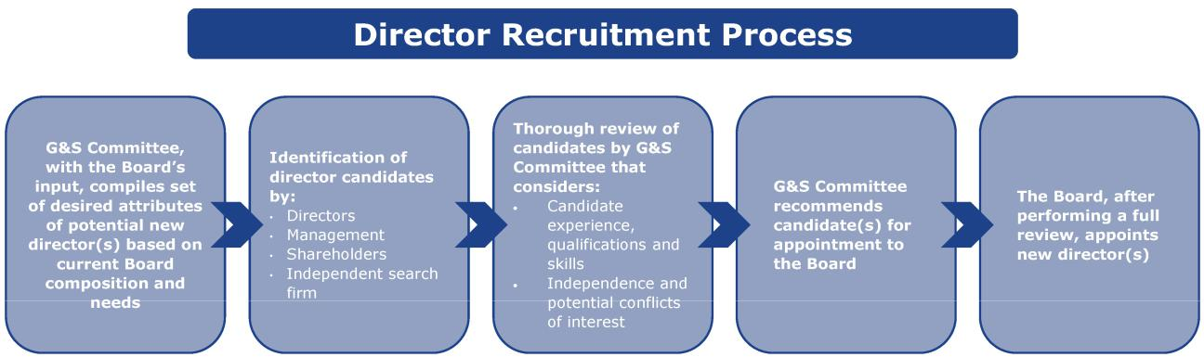

While the Board believes that longer-serving directors are integral to the Company's success given their deep understanding of our business, the Board also understands the value that fresh perspectives bring in a challenging and dynamic industry. Following the

Board's review of its then-current composition and needs, and using the director recruitment process described above, the Board appointed Messrs. Lache and Blissett as new directors within the past year. Mr. Lache, with his decades of automotive analyst

experience, brings a profound understanding of investor perspectives to Lear's Board. In light of Mr. Cheng's upcoming retirement, the Board identified international experience, particularly in Asian markets, as a desired attribute of a potential new director, and Mr. Blissett brings to the Board extensive international experience in the automotive industry.

- | LEAR CORPORATION

Table of Contents

DIRECTORS AND CORPORATE GOVERNANCE

Board Composition and Tenure

The following matrix provides certain information regarding the members of our Board, including certain types of knowledge, skills,

experiences and attributes possessed by one or more of our directors which our Board believes are relevant to our business or industry. The matrix does not encompass all of the knowledge, skills, experiences or attributes of our directors, and the fact that a particular

knowledge, skill, experience or attribute is not listed does not mean that a director does not possess it. In addition, the absence of a particular type of knowledge, skill, experience, or attribute with respect to any of our directors does not mean the director in question is unable to contribute to the decision-making process in that area. The type and degree of knowledge, skill and experience listed below

may vary among members of the Board.

Profile / Skills | Julian | Mei-Wei | Jon | Brad | Mary Lou | Roger | Rod | Patricia | Kathleen | Conrad | Raymond | Greg
Profile / Skills | Blissett | Cheng ⁽¹⁾ | Foster | Halverson | Jepsen | Krone | Lache | Lewis | Ligocki | Mallett | Scott | Smith
 |  |  |  |  | Demographics
Woman |  |  |  |  | u |  |  | u | u
African-American / Black |  |  |  |  |  |  |  | u |  | u
Pan-Asian |  | u
Non-U.S. Resident | u | u
 |  |  |  |  | Skills / Experience
CEO / Large Business | u | u | u | u | u | u |  |  | u | u | u | u
Head
CFO / Treasurer / Fin. |  |  | u | u |  | u |  |  |  |  |  | u
Serv. Exec. |  |  | u | u |  | u |  |  |  |  |  | u
Auto Industry | u | u | u |  |  | u | u |  | u |  | u | u
Technology |  | u |  |  | u | u | u | u | u |  | u | u
Strategy | u | u | u | u | u | u | u | u | u | u | u | u
Finance | u | u | u | u |  | u | u |  | u | u |  | u
Commercial / Marketing | u | u |  |  | u |  |  |  | u | u | u | u
Operations | u | u |  |  | u | u |  | u | u | u | u | u
Human Capital | u | u |  | u | u | u |  | u | u | u | u | u
Management | u | u |  | u | u | u
Legal / Governmental | u | u | u |  |  | u |  |  |  | u
Environmental, Social, |  | u | u | u | u | u |  | u | u | u | u | u
Governance
International | u | u | u | u | u | u |  | u | u |  | u | u

(1) Not standing for reelection at the Annual Meeting.

In the table above, a “u” indicates experience in the category gained directly or through active oversight of responsible person for the category.

The following chart sets forth the range of tenure of our current directors. Our directors' tenure is calculated based on full years of completed service from the date of initial appointment to the date of this proxy statement.
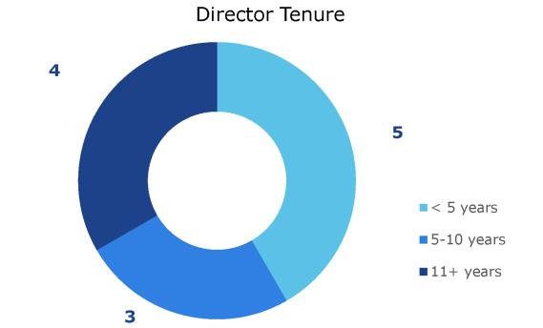

2025 Proxy Statement | | 19

Table of Contents

DIRECTORS AND CORPORATE GOVERNANCE

Recommendation of Directors by Shareholders

In accordance with its charter, the G&S Committee will consider candidates for election as a director of the Company recommended by

any Lear shareholder, provided that the recommending shareholder follows the procedures set forth in Section 1.13 of the Company’s Bylaws for nominations by shareholders of persons to serve as directors. The G&S Committee evaluates such candidates in the same manner by which it evaluates other director candidates considered by the G&S Committee, as described above.

Pursuant to Section 1.13 of the Bylaws, nominations of persons for election to the Board at a meeting of shareholders may be made by any shareholder of the Company entitled to vote for the election of directors at the meeting who sends a timely notice in writing to our Corporate Secretary. To be timely, a shareholder’s notice must be delivered to, or mailed and received by, our Corporate Secretary at the

Company’s principal executive offices not less than 90 nor more than 120 days prior to the first anniversary of the preceding year’s annual meeting; provided, however, that if the annual meeting is more than 30 days prior to the anniversary of the preceding year’s

annual meeting or more than 70 days after such anniversary date, notice by the shareholder must be delivered not earlier than the close of business on the 120th day prior to such annual meeting and not later than the close of business on the later of the 90th day prior to such annual meeting or the 10th day following the day on which “public announcement” of the date of such annual meeting is made by

the Company. For purposes of the Bylaws, “public announcement” means disclosure in a press release reported by the Dow Jones News Service, Associated Press or a comparable national news service or in a document publicly filed by us with the SEC.

The shareholder’s notice or recommendation is required to contain certain prescribed information about each person whom the shareholder proposes to recommend for election as a director, the shareholder giving notice and the beneficial owner, if any, on whose behalf notice is given. The shareholder’s notice must also include the consent of the person proposed to be nominated and to serve as a

director if elected. Recommendations or notices relating to director nominations should be sent to Lear Corporation, 21557 Telegraph Road, Southfield, Michigan 48033, Attention: Amanda J. Pontes, Vice President, General Counsel and Corporate Secretary. See

“Shareholder Proposals for 2026 Annual Meeting of Shareholders.” In addition, to comply with the universal proxy rules, shareholders who intend to solicit proxies in support of director nominees other than Lear nominees must provide notice that sets forth the information required by Rule 14a-19 under the Securities Exchange Act of 1934, as amended (the "Exchange Act"). Within two business

days after delivering such notice required by Section 1.13 of the Bylaws and Rule 14a-19, the shareholder shall certify to and notify the Secretary of the Company that the shareholder has met and complied with all of the requirements under the Bylaws and of Rule 14a-19. The shareholder shall supplement such notice as necessary so that the information provided or required remains true and correct not

later than five business days after the shareholder files a definitive proxy statement in connection with the annual meeting. Any deficiencies may be grounds for exclusion of the shareholder’s nominee.

A copy of our Bylaws has been filed as an exhibit to our 2024 Annual Report on Form 10-K filed with the SEC on February 14, 2025.

Independence of Directors

A majority of the members of the Board, and each member of the Audit Committee, P&C Committee and G&S Committee, must meet

the criteria for independence set forth under applicable law and the NYSE listing standards. No director qualifies as independent unless the Board determines that the director has no direct or indirect material relationship with the Company. In addition to considering the NYSE independence criteria, the Board will consider all relevant facts and circumstances of which it is aware in making an independence

determination with respect to any director.

The Board has made director independence determinations with respect to each of our current directors. Based on the NYSE

independence guidelines and consideration of the relevant facts and circumstances, the Board has affirmatively determined that (i) Messrs. Blissett, Cheng, Foster and Halverson, Dr. Jepsen, Messrs. Krone and Lache, Mses. Lewis and Ligocki, and Messrs. Mallett and Smith (a) have no relationships or only immaterial relationships with the Company, (b) meet the NYSE independence guidelines with

respect to any such relationships and (c) are independent; and (ii) Mr. Scott is not independent. Mr. Scott is our President and CEO.

- | LEAR CORPORATION

Table of Contents

DIRECTORS AND CORPORATE GOVERNANCE

Board’s Role in Risk Oversight

The Company’s management continually monitors the material risks facing the Company. Our enterprise risk management process is

designed to facilitate the identification, assessment and management of certain key risks the Company may encounter and which may impact our ability to achieve our strategic objectives. The enterprise risk management process supplements management’s ongoing

responsibilities to monitor and address risks by working with risk owners to identify the key mitigating actions for certain risks, which then are discussed with senior management.

The Board, with the assistance of its committees, is responsible for overseeing such management actions to ensure that material risks

affecting the Company are identified and managed appropriately. The Board and its committees oversee risks associated with their principal areas of focus, as summarized below:

Board/Committee Areas of Risk Oversight and Actions

Full Board | • Carefully evaluates the reports received from management and makes inquiries of
 | management on areas of particular interest to the Board
 | • Reviews with management material strategic, operational, financial and legal risks, including
 | risks related to cybersecurity, emerging technologies, and product quality and safety
 | • Considers specific risk topics in connection with strategic planning and other matters
 | • Oversees risk oversight and related activities conducted by the Board committees through
 | reports of the committee chairperson to the Board
Audit Committee | • Ensures that the Company has an internal audit function to provide management and the
 | Audit Committee with ongoing assessments of the Company’s risk management process and
 | system of internal controls
 | • Discusses with management the Company’s process for assessing and managing risks,
 | including the Company’s major risk exposures related to tax matters, financial instruments,
 | litigation, legal and compliance matters, cybersecurity and information security and the steps
 | necessary to monitor and control such exposures
 | • Oversees financial and ethics and compliance risks
 | • Periodically meets with senior management, our vice president of audit services, our chief
 | compliance officer and our independent auditor, Ernst & Young LLP, and reports on its findings
 | at each regularly scheduled meeting of the Board
 | • Periodically assesses reports provided by management on risks addressed in the enterprise
 | risk management process and other risks, and reports to the Board, as appropriate
 | • Periodically reviews and approves all changes to our Code of Business Conduct & Ethics
P&C Committee | • Oversees the review and evaluation of risks associated with succession planning and our
 | compensation policies and practices (see also “Compensation and Risk”)
G&S Committee | • Oversees risks associated with our governance structure and processes
 | • Reviews our organizational documents, Corporate Governance Guidelines and other policies
 | • Oversees sustainability issues, including as they pertain to environmental (including climate),
 | corporate social responsibility and supply chain matters

2025 Proxy Statement | 21

Table of Contents

DIRECTORS AND CORPORATE GOVERNANCE

Sustainability

Every Day, Striving for Better – Sustainability at Lear

Consistent with Lear’s vision, Making every drive betterTM, we work to ensure that our passion for our business is also channeled into
creating possibilities for a better world. This means that as part of our sustainability initiatives, which we execute under the mantra of Every Day, Striving for Better, we are committed to safety in our workplaces, integrity in the conduct of our business, increasing

efficiency in our operations and products, and supporting the global communities in which we live and work. Furthermore, we expect all of our suppliers of goods and services to share our commitment to environmental stewardship, social responsibility and ethical conduct.

Sustainability Oversight

The G&S Committee of our Board has responsibility for oversight of the Company’s sustainability strategy, including as it pertains to

environmental (including climate), human rights and other corporate social responsibility matters. In this regard, the G&S Committee works closely with our Audit and P&C Committees, which have responsibility for overseeing certain related sustainability topics such as compliance and human capital management, respectively. To better integrate sustainability considerations throughout our Company, Lear

also has added specific responsibilities to senior management (as shown in the chart below).
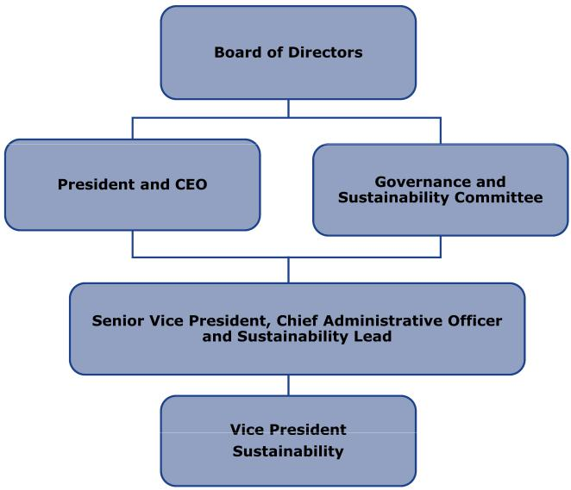

Our sustainability strategy is realized through, among other things, our comprehensive human capital management initiatives which emphasize leadership development, employee engagement and a culture that values individuals of all backgrounds; innovative product

development focused on key trends like sustainable materials and electrification; and policies, procedures and practices that ensure alignment with our core value to Get Results the Right Way. In addition, we value transparency in communication. In 2024, Lear released our annual Sustainability Report that includes disclosures with reference to the GRI standards, as well as reporting with the

SASB and TCFD recommendations. Lear is a participant in the United Nations Global Compact, and we align our sustainability efforts with the ten principles on human rights, labor, environment, and anti-corruption, along with the Sustainable Development Goals. To

learn more, see Lear’s Sustainability Report: www.lear.com/sustainability. The information on our website is not part of this proxy statement and is not deemed to be incorporated by reference herein.

- | LEAR CORPORATION

Table of Contents

DIRECTORS AND CORPORATE GOVERNANCE

Environmental Efforts

We are committed to advancing sustainability in our products and operations. Our core value of innovation helps us not only to create

and use environmentally friendly materials, but also to develop advanced technologies that facilitate sustainable, longer-term automotive industry megatrends. At the same time, our core capability of operational excellence drives us to focus continuously on improving energy efficiency and reducing our consumption of natural resources and creation of waste. More specifically:

Our innovative technologies enable electrification and use renewable materials

- Our vertical integration capabilities, together with our lightweight seat recliners, tracks, latches and other components, can facilitate weight reductions and other performance efficiencies in our products, in turn enabling enhanced fuel efficiency, lower emissions and increased battery driving range.

- We are leveraging available technology to create more sustainable alternatives, such as FlexAirTM, our 100% recyclable non-foam alternative that reduces CO₂ emissions and mass compared to traditional foam offerings.

- We have developed and are commercializing a range of fabrics that contain recycled, renewable or recyclable yarns, including our ReNewKnitTM sustainable sueded alternative material, which is a first-to-market automotive textile that is fully recyclable at its end of life and composed of 100% recycled plastic bottles.

- Lear’s ComfortFlex™ and ComfortMax Seat™ modules improve vehicle efficiency by streamlining design and enhancing comfort. These technologies integrate heating, ventilation, lumbar support and massage directly into our seat covers. By reducing components by up to 50% and boosting airflow to occupants by up to 40%, they make vehicles both lighter and more efficient.

- We have products that are aligned with the continuing shift to electrification, such as our electrical distribution and connection systems and BDUs, which control all electrical energy flowing into and out of the high voltage battery on electrified vehicles.

We have set carbon reduction goals against a 2019 baseline and continue to implement a multifaceted strategy to achieve these goals

- In 2024, our near-term goals (50% reduction in carbon emissions at our facilities by 2030, 100% usage of renewable energy for electric power consumed at our facilities by 2030 and 35% reduction in our Scope 3 emissions or indirect upstream and downstream greenhouse emissions by 2033) were validated by the SBTi.

- We aspire to achieve net zero emissions at our facilities, both upstream and downstream where we have influence, by 2050.

- We continue to implement our renewable energy strategy, which includes on-site renewable energy generation at certain sites, the purchase of energy attribution certificates in certain locations on an ongoing basis, and the execution of virtual power purchase agreements to support new renewable energy projects.

- Twenty on-site solar array installations in seven countries are providing a portion of the electricity we consume.

- We source renewable energy for all Lear facilities in the United Kingdom, Germany, Spain, Portugal, Brazil and Argentina.

We are reducing emissions, saving energy and conserving natural resources in our operations

- Our Energy Efficiency Playbook, first released in 2021, continues to be leveraged at our global manufacturing sites on an ongoing basis to improve energy efficiency and reduce energy usage.

- In 2023, we implemented additional playbooks specific to waste generation and water usage which, like the Energy Efficiency Playbook, are focused on promoting sustainable operating practices within our global facilities, while at the same time increasing operational efficiency and potentially reducing costs.

- In 2024, 150 of our global sites conducted "energy treasure hunts" and identified more than 800 projects with a total potential savings of 32 million kilowatt hours of energy (enough energy to power more than 3,000 homes for a year).

2025 Proxy Statement | | 23

Table of Contents

DIRECTORS AND CORPORATE GOVERNANCE

Human Capital Management

We deliver the highest quality products and services by maintaining a work environment that prioritizes safety and fosters collaboration, inclusion, tolerance and respect. More specifically:

We create meaningful employment and focus on development opportunities for our team members around the world

- Our approximately 152,000 hourly employees receive competitive pay and benefits such as transportation, meals, medical leave, paid holidays and health care.

- In 2024, we delivered more than 6.4 million hours of safety, development, leadership, quality, continuous improvement, lean manufacturing, and ISO and International Automotive Task Force certification training.

- Our health and safety management system is compliant with the ISO 45001:2015 standard, and we are continuing to implement a more comprehensive health and safety program which combines ISO 14001:2015 and 45001:2018 requirements to improve efficiency and performance. Nearly 70% of Lear sites are now ISO 45001:2018 certified.

- In 2024, 213 of our 255 sites had zero lost time injury/illness cases.

- Launched in 2017, Lear’s Together We Win program is a global employee engagement program focused on driving cultural change in our operations by providing best practices and a roadmap for our plants to improve in the areas of leadership, work environment, employee involvement and team empowerment to ensure a best-in-class employee experience.

- Our Driving Wellness campaign promotes well-being in mind, body, nutrition and balance for our employees, including training mental health first aiders to help coworkers cope with stress, anxiety and depression. We also provide financial training, conflict resolution and other wellness initiatives.

- Our Global Wellness Council leverages our various well-being programs where possible for our employees.

We value diversity, collaboration, inclusion, equity, tolerance and respect

- In 2024, we enhanced our Expect Respect / Expect Inclusion anti-harassment training for our global workforce with training completed at all locations by end of first quarter 2025. Lear’s Together We Belong program encompasses our internal initiatives and education programs to help our employees increase their understanding of their unique differences and the importance of an inclusive culture.

- In 2024, we expanded our Together We Grow merit-based program to include cohorts in Europe, Mexico and Honduras. The program was launched in 2021 to help diverse high-potential future leaders build their networks and careers at Lear with an emphasis on engagement and relationship development.

- We support six employee-led resource groups (“ERGs”) spanning 23 countries; each group is supported by an executive sponsor and is open to all employees. Lear’s ERGs build community, a sense of belonging, and a culture where everyone in our diverse and global workforce feels heard, accepted and valued.

- We completed a global annual pay equity review and fewer than 1% of employees were recommended for adjustment.

- We published on our website our annual consolidated EEO-1 summary data as submitted to the U.S. Equal Employment Opportunity Commission.

Lear employees dedicate themselves to supporting the global communities where they live and work

- In 2024, we were especially proud of our employees' efforts to support our global communities. Through our Operation GIVE campaign at our Southfield, Michigan headquarters, more than $750,000 in employee contributions benefited local programs focused on economic well-being, education and the environment. In addition, our teams completed numerous volunteer projects to support the global communities where we live and work.

- | LEAR CORPORATION

Table of Contents

DIRECTORS AND CORPORATE GOVERNANCE

Governance

Governance at Lear is driven by our commitment to Get Results the Right Way. This means not only developing systems and processes

to ensure compliance with regulations and company policies, but also creating a culture of ethics and integrity in everything we do. We expect our vendors and supply chain partners to share and demonstrate the same commitment, and we work with them to reinforce this expectation.

We partner with our suppliers to ensure sustainability throughout the supply chain

- We require suppliers to comply with our Supplier Sustainability Policy, which includes commitments to human rights, environmental standards, safe working conditions and responsible sourcing.

- We provide our suppliers with training on critical sustainability topics, including our supplier sustainability minimum requirements and sustainability assessment validation criteria.

- Leveraging a third-party supply chain evaluation partner, we continue to assess global production suppliers against sustainability criteria, including environmental stewardship and human rights, using a risk-based approach.

- Lear’s Supplier Portal provides access to our policies and commitments, along with resources and awareness materials on certain sustainability topics, such as human rights, and forced and child labor.

- In 2024, we conducted training for non-production suppliers in Europe, Africa, Brazil and China on Lear's Code of Business Conduct & Ethics, anti-bribery and anti-corruption policy, and purchasing policies and processes.

- In 2024, we launched a comprehensive training program designed to educate our internal supply chain purchasing teams on our sustainability policies, requirements and strategy, as well as key sustainability practices and principles.

- Our No Deforestation Policy requires that all materials supplied to us are from legal sources, that land is not clear-cut or burned for production or development, and that our suppliers comply with governmental laws, regulations and guidelines regarding deforestation.

Our cybersecurity efforts protect our products, our customers and our enterprise

- Our information security team, led by our Chief Information Officer and Chief Information Security Officer, is comprised of cybersecurity specialists with extensive experience and relevant certifications. We have implemented and maintain multiple layers of physical, administrative and technical security processes designed to protect our manufacturing facilities from disruptions that may result from cybersecurity incidents, as well as safeguard the confidentiality of our critical systems and data residing on those systems, including employee data, customer data and intellectual property.

We have an experienced and diverse Board of Directors

- See page 19 for a description of director skills and experiences.

- 42% of our directors are diverse by ethnicity and/or gender.

- 66% of our committee chairs are diverse.

Other key aspects of our corporate governance efforts include:

- All of our director nominees are independent, except our President and CEO;

- We have a Non-Executive Chairman of the Board;

- We have a majority voting standard with a director resignation policy for uncontested director elections;

- We have robust stock ownership guidelines for our directors and executive officers;

- Risk oversight is conducted by the full Board and its committees;

- All directors are elected annually;

- Executive sessions of independent directors are held at regularly scheduled Board meetings;

- Excellent track record of attendance at all Board and committee meetings in 2024;

- Board and its committees complete annual formal written self-evaluations and participate in oral evaluations; and

- In 2024, directors completed board effectiveness surveys, which included in-depth director interviews conducted by an independent third-party firm.

2025 Proxy Statement | 25

Table of Contents

DIRECTORS AND CORPORATE GOVERNANCE

The Board has approved Corporate Governance Guidelines, as well as a Code of Business Conduct & Ethics. Our corporate governance documents, including the Corporate Governance Guidelines, the Code of Business Conduct & Ethics and committee charters, are

available on our website at www.lear.com or in printed form upon request by contacting Lear Corporation at 21557 Telegraph Road, Southfield, Michigan 48033, Attention: Investor Relations. The Board regularly reviews corporate governance developments and modifies

these documents as warranted. Any modifications will be reflected on our website. The information on our website is not part of this proxy statement and is not deemed to be incorporated by reference herein.

Other Board Information

Leadership Structure of the Board

Greg C. Smith is our Non-Executive Chairman of the Board and has served in that role since May 2020. Our Board has decided to maintain separate Chairperson and CEO roles to allow our CEO to focus on the execution of our business strategy, growth and development, while allowing the Chairperson to lead the Board in its fundamental role of providing advice to, and independent oversight

of, management, as well as oversight of Board meetings. The Board recognizes the time, effort and energy that the CEO is required to devote to his position in the current business environment, as well as the commitment required to serve as our Chairperson. While our

Bylaws and Corporate Governance Guidelines do not require that our Chairperson and CEO positions be separate, the Board believes that having separate positions and having an independent director serve as Non-Executive Chairperson is the appropriate leadership structure for the Company at this time.

Board Meetings

In 2024, our Board held nine meetings. In addition to our Board meetings, our directors attend meetings of committees established by our Board. Each of Lear’s directors attended at least 75% of the meetings of our Board and the committees on which he or she served

during 2024. Our directors are encouraged to attend all annual and special meetings of our shareholders. In 2024, our annual meeting of shareholders was held on May 16, 2024, in virtual format, and all directors attended.

Meetings of Non-Employee Directors

In accordance with our Corporate Governance Guidelines and the listing standards of the NYSE, our non-employee directors meet

regularly in executive sessions of the Board without management present. Mr. Smith, our Non-Executive Chairman, presided over these executive sessions in 2024.

Committees of the Board

The Board has three standing committees: the Audit Committee, the P&C Committee and the G&S Committee. The following chart sets forth the non-employee directors who currently serve as members of each of the Board committees.

 | Audit | P&C | G&S
Non-employee Directors⁽¹⁾ | Committee | Committee | Committee
Mei-Wei Cheng | X | X
Jonathan F. Foster | X |  | X
Bradley M. Halverson | C | X
Mary Lou Jepsen |  | X | X
Roger A. Krone | X |  | X
Patricia L. Lewis |  | C | X
Kathleen A. Ligocki |  | X | X
Conrad L. Mallett, Jr. | X |  | C
Greg C. Smith* | E | E | E

- Non-Executive Chairman of the Board "C" Denotes member and chair of committee "X" Denotes member
"E" Denotes Ex Officio member

- Messrs. Blissett and Lache do not currently serve on any committees of the Board. In accordance with Board practice, new non-employee directors are not appointed to any committees of the Board in their first year of service on the Board to allow such directors to gain more familiarity with the Company.

- | LEAR CORPORATION

Table of Contents

DIRECTORS AND CORPORATE GOVERNANCE

Audit Committee

In 2024, the Audit Committee held nine meetings. Each member of the Audit Committee is a non-employee director. In addition, the Board has determined that all of the members of the Audit Committee are independent, financially literate and financial experts, as further discussed in “Audit Committee Report.” For a description of the Audit Committee’s responsibilities and findings and additional

information about the Audit Committee, see “Audit Committee Report.”

A copy of the current Audit Committee charter is available on our website at https://ir.lear.com/ or in printed form upon request.

People and Compensation Committee

In 2024, the P&C Committee held eight meetings. Each member of the P&C Committee is a non-employee director. In addition, the Board has determined that all of the members of the P&C Committee are independent as defined in the listing standards of the NYSE,

including the independence standards applicable to compensation committees.

The P&C Committee has overall responsibility for approving and evaluating director and officer compensation plans, policies and programs of the Company and reviewing the disclosure of such plans, policies and programs to our shareholders in the Company's

annual proxy statement. The P&C Committee also supports initiatives pertaining to human capital management, including talent development and retention, the employee experience and timely succession planning for the CEO and senior executive officers. The P&C

Committee utilizes an independent compensation consultant to assist it in its duties. The P&C Committee operates under a written charter setting forth its functions and responsibilities. A copy of the current P&C Committee charter is available on our website at https://ir.lear.com/ or in printed form upon request.

In consultation with the Company’s management, the P&C Committee establishes the general policies relating to senior management compensation and oversees the development and administration of such compensation programs. Our human resources executives and

staff support the P&C Committee in its work. These members of management work with compensation consultants whose engagements have been approved by the P&C Committee, accountants and legal counsel, as necessary, to implement the P&C Committee’s decisions, to monitor evolving competitive practices.The P&C Committee has final authority to approve, modify or reject the independent

consultant's recommendations and to make its decisions in executive session. The P&C Committee approves all compensation of our executive officers, including equity awards. Under our equity award policy, an aggregate equity award pool to non-executive officers may

be approved by the P&C Committee and allocated to individuals by the CEO. The policy also allows the P&C Committee to delegate to the CEO the ability to grant equity awards to non-executive officer employees who are newly hired or promoted or deemed to be deserving of special retention or recognition awards.

Pay Governance LLC (“Pay Governance”) is the P&C Committee's independent compensation consultant. Pay Governance reports directly to the P&C Committee, including with respect to management’s recommendations of compensation programs and awards. The P&C

Committee has the sole authority to approve the scope and terms of the engagement of such compensation consultant and to terminate such engagement. The mandate of Pay Governance is to serve the Company and work with the P&C Committee in its review of executive and director compensation practices, including the competitiveness of pay levels, program design, market trends and technical

considerations. Pay Governance has assisted the P&C Committee with the development of competitive market data and a related assessment of the Company’s executive and director compensation levels, evaluation of annual and long-term incentive compensation strategy and compilation and review of total compensation data and pay tally sheets (including data for certain termination and change

in control scenarios) for the Company’s NEOs. As part of this process, the P&C Committee also reviewed a comprehensive analysis of peer group companies provided by Pay Governance. See “Compensation Discussion and Analysis — Decision-Making Framework —

Benchmarking Methodology and Peer Group Selection.” Other than with respect to consulting on executive and director compensation matters, Pay Governance has performed no other services for the P&C Committee or the Company.

The Company and the P&C Committee reviewed the independence of Pay Governance in light of SEC rules and NYSE listing standards

regarding compensation consultants and has concluded that the work performed by Pay Governance does not constitute a conflict of interest.

Governance and Sustainability Committee

In 2024, the G&S Committee held five meetings. Each of the members of the G&S Committee is a non-employee director. In addition, the Board has determined that all of the members of the G&S Committee are independent as defined in the listing standards of the

NYSE.

The G&S Committee is responsible for, among other things: (i) Board succession planning and identifying individuals qualified to become members of the Board, consistent with criteria approved by the Board; (ii) recommending director nominees to the Board for election at

the next annual meeting of the shareholders of the Company; (iii) in the event of a vacancy on or an increase in the size of the Board, recommending director nominees to the Board to fill such

2025 Proxy Statement | | 27

Table of Contents

DIRECTORS AND CORPORATE GOVERNANCE

vacancy or newly established Board seat; (iv) recommending directors to the Board for membership on each committee of the Board;
- establishing and reviewing annually our Corporate Governance Guidelines; (vi) reviewing potential conflicts of interest involving our executive officers; and (vii) overseeing sustainability issues, including as they pertain to environmental, human rights and other corporate social responsibility matters. The G&S Committee operates under a written charter setting forth its functions and responsibilities.

A copy of the current G&S Committee charter is available on our website at https://ir.lear.com/ or in printed form upon request.

Communications to the Board

Shareholders and interested parties can contact the Board (including the Non-Executive Chairman and non-employee directors) through

written communication sent to Lear Corporation, 21557 Telegraph Road, Southfield, Michigan 48033, Attention: Amanda J. Pontes, Vice President, General Counsel and Corporate Secretary. Our General Counsel reviews all written communications and forwards to the Board a summary and/or copies of any such correspondence that is directed to the Board or that, in the opinion of the General Counsel, deals

with the functions of the Board or its committees or that she otherwise determines requires the Board’s or any Board committee’s attention. Concerns relating to accounting, internal accounting controls or auditing matters are immediately brought to the attention of

our internal audit department and handled in accordance with procedures established by the Audit Committee with respect to such matters. From time to time, the Board may change the process by which shareholders may communicate with the Board. Any such changes will be reflected in our Corporate Governance Guidelines, which are posted on our website at https://ir.lear.com/.

Communications of a confidential nature can be made directly to our non-employee directors or the Chairman of the Audit Committee regarding any matter, including any accounting, internal accounting control or auditing matter, by submitting such concerns to the Audit

Committee or the Non-Executive Chairman. Any submissions to the Audit Committee or the Non-Executive Chairman should be marked confidential and addressed to the Chairman of the Audit Committee or the Non-Executive Chairman, as the case may be, c/o Lear Corporation, P.O. Box 604, Southfield, Michigan 48037. In addition, confidential communications may be submitted in accordance with

other procedures set forth from time to time in our Corporate Governance Guidelines, which are posted on our website at https://ir.lear.com/. Any submission should contain, to the extent possible, a full and complete description of the matter, the parties

involved, the date of the occurrence or, if the matter is ongoing, the date the matter was initiated and any other information that the reporting party believes would assist the Audit Committee or the Non-Executive Chairman in the investigation of such matter.

- | LEAR CORPORATION

Table of Contents

DIRECTORS AND CORPORATE GOVERNANCE

Director Compensation

Overview

In order to attract and retain highly qualified directors to represent our shareholders, our philosophy is to set compensation within a

competitive range of non-employee director pay at comparable companies. At least every two years, the independent compensation consultant presents an analysis of director pay levels among our Comparator Group (described in “Compensation Discussion and Analysis — Benchmarking” beginning on page 38) and a broader set of large companies. We use the same Comparator Group and

process to review and set director pay as is used for our NEOs.

As a result of the competitive pay review that was conducted in September 2023, we increased the annual cash retainer payable to all non-employee directors by $20,000 and increased the incremental fees payable to the chairs of the Audit Committee, the G&S

Committee and the P&C Committee by $10,000, $10,000 and $5,000, respectively, effective May 16, 2024. This was the first increase to non-employee director compensation since June 2022.

The following table summarizes the compensation that each non-employee director is entitled to receive as part of the Outside Directors Compensation Plan, as amended effective May 16, 2024:

Outside Directors Compensation Plan
 | Annual Cash Retainer | Annual RSU Award
Annual Board Retainer | $135,000 | $175,000
Additional Position Amounts:
Non-Executive Chair | $80,000 | $120,000
Audit Committee Chair | $30,000
G&S Committee Chair | $25,000
P&C Committee Chair | $25,000
Presiding Director⁽¹⁾ | $10,000

(1) Because we have an independent Non-Executive Chair, we do not have a Presiding Director.

General

Directors who are also our employees receive no compensation for their services as directors, except reimbursement of expenses incurred in attending meetings of our Board or its committees.

Annual Cash Retainer

The annual cash retainer for each non-employee director is paid in advance in equal installments on the last business day of the month.

Non-employee directors generally do not receive Board or Board committee meeting fees; however, each non-employee director is eligible to receive $1,500 for each Board meeting in excess of twelve that he or she attends in a calendar year.

Annual RSU Award

Each non-employee director is granted RSUs on the date of the annual meeting of shareholders at which a director is elected or re-elected to serve on the Board. Non-employee directors receive RSUs with a grant date value of approximately $175,000 (with an

additional $120,000 granted to the Non-Executive Chair). The RSU awards vest on the earlier of the first anniversary of the grant date and the date of the next annual meeting of shareholders that is at least 50 weeks following the immediately preceding year’s annual meeting, subject to forfeiture in the event that a director’s service on the Board ceases for any reason prior to the vesting date. If a non-

employee director joins the Board other than on the date of the annual meeting, a pro-rated RSU award is granted.

Deferrals

A non-employee director may elect to defer receipt of all or a portion of the annual retainer and any meeting fees. To the extent that any

such cash payments are deferred, they are credited to a notional account and bear interest at an annual rate equal to the prime rate (as defined in the Outside Directors Compensation Plan). Non-employee directors may also elect to defer all or a portion of the annual RSU

grant into a stock account where, subject to and following satisfaction of the applicable vesting requirements, notional stock units are credited until distribution in the form of shares of common stock at pre-selected date(s).

2025 Proxy Statement | | 29

Table of Contents

DIRECTORS AND CORPORATE GOVERNANCE

In general, and subject to Section 409A of the Internal Revenue Code, amounts deferred are paid upon the earliest of:

- the date selected by such director;

- the date the director ceases to be a director; or

- the date of a change in control (as defined in the Outside Directors Compensation Plan).

Cash amounts that are deferred are paid in cash in a lump sum payment or installments in accordance with the director’s election. RSUs that are deferred are paid in shares of common stock in a lump sum or installments in accordance with the director’s election.

2024 Director Compensation Table

The following table provides information on the compensation paid to our non-employee directors for 2024. Mr. Scott, who is also an employee, receives no additional compensation for his services as a director. Mr. Blissett does not appear below because he joined the Board in 2025.

2024 Director Compensation

 | Fees Earned or Paid
Name | in Cash⁽¹⁾ | Stock Awards⁽³⁾ | Total
Mei-Wei Cheng⁽²⁾ | $128,333 | $174,893 | $303,226
Jonathan F. Foster | $152,500 | $174,893 | $327,393
Bradley M. Halverson | $133,333 | $174,893 | $308,226
Mary Lou Jepsen | $128,333 | $174,893 | $303,226
Roger A. Krone⁽²⁾ | $128,333 | $174,893 | $303,226
Rod A. Lache ⁽⁴⁾ | $56,250 | $131,200 | $187,450
Patricia L. Lewis | $145,000 | $174,893 | $319,893
Kathleen A. Ligocki | $137,083 | $174,893 | $311,976
Conrad L. Mallett, Jr. | $150,000 | $174,893 | $324,893
Greg C. Smith | $208,333 | $294,977 | $503,310

- Includes cash retainer and other fees earned for service as directors in 2024.

- Mr. Cheng elected to defer $128,333 and Mr. Krone elected to defer $9,583 of their 2024 cash retainers.

- As described in “Equity Compensation” below, on May 16, 2024, each of our non-employee directors who were members of the Board on the date of the 2024 annual meeting of shareholders received a RSU grant that vests on the earlier of the first anniversary of the grant date and the date of the next annual meeting of shareholders that is at least 50 weeks following the immediately preceding year’s annual meeting of shareholders, subject to each director’s continued service on the Board. The amounts reported in this column reflect the aggregate grant date fair value determined in accordance with Accounting Standards Codification (“ASC”) 718, “Compensation-Stock Compensation.” As of December 31, 2024, each of our non-employee directors who were members of the Board on such date held the following outstanding and unvested RSUs: Messrs. Cheng, Foster, Halverson, Krone and Mallett, along with Dr. Jepsen and Mses. Lewis and Ligocki – 1,337; Mr. Lache - 1,205; and Mr. Smith – 2,255. Mr. Cheng and Ms. Ligocki elected to defer 100% of their 2024 RSU grants; Mr. Mallett elected to defer 5% of his 2024 RSU grant (in each case, subject to vesting of the RSUs).

- Mr. Lache was appointed to the Board in August 2024 and received a pro-rated RSU grant.

The Company has a long-standing practice of having stock ownership guidelines for non-employee directors. Each non-employee director must achieve a stock ownership level of a number of shares with a value equal to five times the base annual cash retainer and must hold

50% of the net shares from their annual stock grants received until they are in compliance with these guidelines. As of our latest measurement date (December 31, 2024), all of our non-employee directors who were directors on the measurement date met the

required ownership level (other than Mr. Halverson, who joined the Board in June 2020, Mr. Krone and Ms. Lewis, who joined the Board in November 2020, and Mr. Lache, who joined the Board in August 2024, each of whom is in compliance with the 50% hold requirement). Mr. Blissett, who joined the Board in February 2025, will be reviewed for compliance with the ownership guidelines at the

end of 2025.

- | LEAR CORPORATION

Table of Contents

DIRECTORS AND CORPORATE GOVERNANCE

Security Ownership of Certain Beneficial Owners, Directors and Management

The following table sets forth, as of March 18, 2025 (except as indicated below), beneficial ownership, as defined by SEC rules, of our

common stock (including shares of common stock subject to stock options that are currently exercisable or exercisable within 60 days of March 18, 2025) and restricted stock units ("RSUs") held by the persons or groups specified. Each of the persons listed below has sole voting and investment power with respect to the beneficially owned shares listed unless otherwise indicated. The percentage calculations

set forth in the table are based on 53,540,555 shares of common stock outstanding on March 18, 2025, rather than based on the percentages set forth in shareholders’ Schedules 13G or 13D, as applicable, filed with the SEC.

 | Number of Shares Percentage of
 | of Common Stock | Common Stock | Number of
 | Owned | Owned | RSUs
 | Beneficially | Beneficially | Held⁽¹⁷⁾
5% Beneficial Owners:
BlackRock, Inc.⁽¹⁾ | 7,539,684 | 14.1% | 0
Pzena Investment Management, LLC⁽²⁾ | 7,764,912 | 14.5% | 0
The Vanguard Group⁽³⁾ | 6,491,850 | 12.1% | 0
NEOs and Directors:
Raymond E. Scott⁽⁴⁾⁽⁵⁾⁽⁶⁾ | 250,077 | * | 42,312
Jason M. Cardew⁽⁴⁾⁽⁷⁾ | 49,600 | * | 62,144
Frank C. Orsini⁽⁴⁾⁽⁷⁾ | 52,704 | * | 79,610
Carl A. Esposito⁽⁴⁾⁽⁷⁾⁽¹⁶⁾ | 52,610 | * | 30,967
Harry A. Kemp⁽⁴⁾⁽⁷⁾ | 15,277 | * | 26,439
Alicia J. Davis⁽⁴⁾⁽⁷⁾ | 10,261 | * | 18,656
Julian G. Blissett⁽⁶⁾⁽⁸⁾ | 448 | * | 0
Mei-Wei Cheng⁽⁶⁾⁽⁹⁾ | 8,001 | * | 0
Jonathan F. Foster⁽⁶⁾⁽¹⁰⁾ | 13,782 | * | 0
Bradley M. Halverson⁽⁶⁾⁽¹⁰⁾ | 6,312 | * | 0
Mary Lou Jepsen⁽⁶⁾⁽¹⁰⁾ | 11,034 | * | 0
Roger A. Krone⁽⁶⁾⁽¹¹⁾ | 5,527 | * | 0
Rod A. Lache⁽⁶⁾⁽¹²⁾ | 3,383 | * | 0
Patricia L. Lewis⁽⁶⁾⁽¹⁰⁾ | 5,527 | * | 0
Kathleen A. Ligocki⁽⁶⁾⁽¹³⁾ | 20,494 | * | 0
Conrad L. Mallett, Jr.⁽⁶⁾⁽¹⁴⁾ | 12,985 | * | 0
Greg C. Smith⁽⁶⁾⁽¹⁵⁾ | 16,146 | * | 0
Total Executive Officers and Directors as a Group (19 individuals)⁽¹⁶⁾ | 489,079 | * | 253,018

  - Less than 1%.

- Information contained in the table above and this footnote is based on a report on Schedule 13G/A filed with the SEC on January 23, 2024, by BlackRock, Inc. (“BlackRock”). BlackRock is the beneficial owner of 7,539,684 shares, with sole dispositive power as to all such shares and sole voting power as to 7,098,522 such shares. Various persons have the right to receive or the power to direct the receipt of dividends from, or the proceeds from, the sale of the Company’s common stock. No one person’s interest in the Company’s common stock is more than five percent of the total outstanding common stock. BlackRock’s principal place of business is 50 Hudson Yards, New York, New York 10001.

- Information contained in the table above and this footnote is based on a report on Schedule 13G filed with the SEC on October 7, 2024, by Pzena Investment Management, LLC (“Pzena”). Pzena is the beneficial owner of 7,764,912 shares, with sole dispositive power as to all such shares and sole voting power as to 6,617,051 such shares. Pzena’s principal place of business is 320 Park Avenue, 8th Floor, New York, New York 10022.
- Information contained in the table above and this footnote is based on a report on Schedule 13G/A filed with the SEC on January 31, 2025, by The Vanguard Group (“Vanguard”). Vanguard is the beneficial owner of 6,491,850 shares, with sole dispositive power as to 6,388,423 such shares, shared dispositive power as to 103,427 such shares and shared voting power as to 32,327 such shares. Vanguard’s principal place of business is 100 Vanguard Blvd., Malvern, Pennsylvania 19355.

- The individual is a NEO.

- Mr. Scott is retirement-eligible and therefore qualifies for accelerated vesting of all of his Career Shares and RSUs that would vest within 24 months of his retirement on any given date. As a result, Mr. Scott’s share ownership includes 60,533 Career

2025 Proxy Statement | | 31

Table of Contents

DIRECTORS AND CORPORATE GOVERNANCE

Shares and 42,854 unvested RSUs (all Career Shares and RSUs awarded more than one year prior to the record date). Mr. Scott's Career Shares and unvested RSUs would be forfeited only if he were terminated for “cause” pursuant to the terms of his employment agreement. Mr. Scott's share ownership also includes 102,961 shares of common stock that he has the right to acquire pursuant to stock options that are currently exercisable.
- The individual is a director.

- Messrs. Cardew, Orsini, Esposito and Kemp and Ms. Davis are not yet retirement-eligible, and thus, their share ownership does not include any Career Shares or unvested RSUs. If they remain employed by the Company, Messrs. Cardew, Orsini, Esposito and Kemp and Ms. Davis will become retirement-eligible on June 29, 2025, April 2, 2027, May 19, 2026, September 15, 2030, and April 26, 2027, respectively. Messrs. Cardew, Orsini and Esposito's respective share ownership also includes 24,356; 29,419; and 21,512 shares of common stock, respectively, that each person has the right to acquire pursuant to stock options that are currently exercisable.

- For Mr. Blissett, the information contained in the table above includes 448 RSUs vesting on May 16, 2025, within 60 days following the record date.

- For Mr. Cheng, the information contained in the table above includes 4,546 deferred stock units, which are fully vested and convert into shares of common stock on a 1-for-1 basis upon pre-established dates selected by the director. The table also includes 1,337 RSUs vesting on May 16, 2025, within 60 days following the record date, which will be deferred upon vesting in accordance with the director’s election.
- The information contained in the table above includes 1,337 RSUs vesting on May 16, 2025, within 60 days following the record date.

- For Mr. Krone, the information contained in the table above includes 3,611 deferred stock units, which are fully vested and convert into shares of common stock on a 1-for-1 basis upon the earliest of the director’s departure from the Board, a change in control or the pre-established date selected by the director. The table also includes 1,337 RSUs vesting on May 16, 2025, within 60 days following the record date, which will be deferred upon vesting in accordance with the director’s election.

- For Mr. Lache, the information contained in the table above includes 1,205 RSUs vesting on May 16, 2025, within 60 days following the record date.

- For Ms. Ligocki, the information contained in the table above includes 15,532 deferred stock units, which are fully vested and convert into shares of common stock on a 1-for-1 basis upon the earliest of the director’s departure from the Board, a change in control or the pre-established date selected by the director. The table also includes 1,337 RSUs vesting on May 16, 2025, within 60 days following the record date, which will be deferred upon vesting in accordance with the director’s election.

- For Mr. Mallett, the information contained in the table above includes 11,648 deferred stock units, which are fully vested and convert into shares of common stock on a 1-for-1 basis upon the earliest of the director’s departure from the Board, a change in control or the pre-established date selected by the director. The table also includes 1,337 RSUs vesting on May 16, 2025, within 60 days following the record date, a portion of which will be deferred upon vesting in accordance with the director’s election.

- For Mr. Smith, the information contained in the table above includes 2,255 RSUs vesting on May 16, 2025, within 60 days following the record date. The table also includes 13,891 shares of common stock held in Ann Cournoyer Smith Irrev Trust for the benefit of Mr. Smith’s children of which Mr. Smith is the trustee.
- Includes Amy Doyle, Nicholas Roelli and Marianne Vidershain. Mr. Esposito's ownership is not included because he no longer serves as an executive officer.
- Includes, as of March 18, 2025, Career Shares and unvested RSUs held by our executive officers. These Career Shares and unvested RSUs are subject to all of the economic risks of stock ownership but may not be voted or sold and are subject to vesting provisions as set forth in the respective grant agreements.

Delinquent Section 16(a) Reports

Based upon our review of reports filed with the SEC and written representations that no other reports were required, we believe that all of our directors, executive officers and beneficial owners of more than ten percent of our equity securities complied with the reporting
requirements of Section 16(a) of the Exchange Act during 2024, with the exception of one late Form 4 filed on May 28, 2024, for Mr.
Krone reporting one transaction. This report was late due to an inadvertent administrative error.

- | LEAR CORPORATION

Table of Contents

COMPENSATION DISCUSSION AND ANALYSIS ("CD&A")

CD&A Executive Summary |  |  |  |  |  |  |  | 34
Letter from the People and Compensation Committee |  |  |  |  |  |  |  | 34
About Lear |  |  |  |  |  |  |  | 35
2024 Financial Performance Highlights |  |  |  |  |  |  |  | 35
Named Executive Officers ("NEOs") |  |  |  |  |  |  |  | 35
Summary of NEO Pay Results for 2024 |  |  |  |  |  |  |  | 36
Decision-Making Framework |  |  |  |  |  |  |  | 36
Total Rewards Philosophy and Compensation Principles |  |  |  |  |  |  |  | 36
Compensation Governance |  |  |  |  |  |  |  | 36
Total Compensation Process and Review |  |  |  |  |  |  |  | 37
Authority of P&C Committee Under Incentive Plans |  |  |  |  |  |  |  | 38
Benchmarking Methodology and Peer Group Selection |  |  |  |  |  |  |  | 38
Lear Versus 2024 Comparator Group |  |  |  |  |  |  |  | 39
Pay Setting Process and Cycles |  |  |  |  |  |  |  | 40
Tally Sheets |  |  |  |  |  |  |  | 40
Say-on-Pay Results |  |  |  |  |  |  |  | 40
Compensation Alignment with Shareholders |  |  |  |  |  |  |  | 40
Engaging with Shareholders to Continue to Enhance our Compensation Program |  |  |  |  |  |  |  | 41
What We Pay and Why: Elements of Executive Compensation |  |  |  |  |  |  |  | 41
Executive Compensation Objectives and Core Elements |  |  |  |  |  |  |  | 41
Pay for Performance |  |  |  |  |  |  |  | 42
Compensation Mix |  |  |  |  |  |  |  | 43
Target Pay Mix for CEO and Other NEOs |  |  |  |  |  |  |  | 43
2024 Performance Results and Compensation Decisions |  |  |  |  |  |  |  | 44
Base Salary |  |  |  |  |  |  |  | 44
Annual Incentive Plan (AIP) |  |  |  |  |  |  |  | 45
2024 Award Opportunity |  |  |  |  |  |  |  | 45
2024 Financial Performance Measures |  |  |  |  |  |  |  | 45
New 2024 Strategic Scorecard Modifier (+/- 10%) |  |  |  |  |  |  |  | 45
2024 Performance Goals |  |  |  |  |  |  |  | 46
2024 Performance Results and Corresponding Payouts |  |  |  |  |  |  |  | 47
Long-Term Stock Incentive Plan ("LTI") Compensation |  |  |  |  |  |  |  | 47
2022-2024 Performance Results and Corresponding Payouts |  |  |  |  |  |  |  | 48
2024-2026 Long-Term Incentive Award Opportunity |  |  |  |  |  |  |  | 48
2024-2026 Performance Measures and Goals |  |  |  |  |  |  |  | 49
Summary of Outstanding Performance Periods |  |  |  |  |  |  |  | 50
Special RSU Awards |  |  |  |  |  |  |  | 51
Other Pay Elements |  |  |  |  |  |  |  | 51
Perquisites |  |  |  |  |  |  |  | 51
Retirement Benefits |  |  |  |  |  |  |  | 51
Career Shares |  |  |  |  |  |  |  | 52
Governance Policies and Practices |  |  |  |  |  |  |  | 52
Equity Award Policy |  |  |  |  |  |  |  | 52
Employment Agreements/Termination/Change in Control Benefits |  |  |  |  |  |  |  | 52
Compensation and Risk |  |  |  |  |  |  |  | 53
Stock Ownership Guidelines |  |  |  |  |  |  |  | 53
Insider Trading Policy |  |  |  |  |  |  |  | 54
Clawback Policies |  |  |  |  |  |  |  | 54
Tax Treatment of Executive Compensation |  |  |  |  |  |  |  | 55
Accounting Treatment |  |  |  |  |  |  |  | 55

2025 Proxy Statement | 33

Table of Contents

COMPENSATION DISCUSSION AND ANALYSIS

CD&A Executive Summary

Letter from the People and Compensation Committee

Dear Shareholders:

In 2024, Lear continued its strong performance despite a challenging economic environment, reduced production volumes, wage inflation and lower than anticipated demand for electric vehicles. Through our strong operational performance, we were able to meet

these challenges and deliver revenue of $23.3 billion, very near our record 2023 revenue.

On behalf of Lear's P&C Committee, thank you for your continuing support of Lear's executive compensation program. The P&C

Committee represents our shareholders and diligently works to ensure that the Company's executive compensation program aligns with the interests of our shareholders and long-term value creation, while serving to attract, retain and reward our talented workforce.

The P&C Committee, on behalf of the Board, prioritizes responsiveness to your views on executive compensation. We especially want to

thank those shareholders who have provided feedback to us over the course of the last year. We were pleased to hear favorable feedback about our program.

At Lear, our executive incentive compensation plans reflect:

- our actual and relative business results, using financial measures such as adjusted operating income, free cash flow, adjusted pretax income, adjusted ROIC improvement and relative total shareholder return;

- a focus on product and process innovation;

- our sustainable long-term focus with multi-year timeframes, consistent structures and focus on meaningful stock ownership; and

- our emphasis on human capital, values and leadership.

As we look forward, we will continue to face new challenges as automakers rethink their product launches in the face of an evolving macroeconomic and geopolitical environment and uncertainties in consumer powertrain demand. Amid these challenges, we will continue

to focus on what we can control to position Lear for future success. We are confident that these efforts, particularly our focus on innovation, automation and the use of artificial intelligence, will allow us to deliver differentiated, higher quality and lower cost products

for our customers and lead to future success.

The "Compensation Discussion and Analysis" that follows summarizes the alignment between the Company's demonstrated performance and the compensation outcomes for the NEOs. When determining incentive performance and payout results, the P&C Committee uses a

rigorous process against pre-established financial measures. The 2024 pay results for our NEOs are summarized on page 36. We believe our executive compensation program demonstrates our commitment to linking executive compensation to the Company's near-term and long-term strategies while being responsive to shareholder feedback.

The P&C Committee encourages management to make decisions that drive long-term value creation. We look forward to your feedback to ensure continued alignment between our executive compensation program and shareholder interests, while allowing the Company to

attract and retain the talent we need to execute the Company's strategy.

Sincerely,
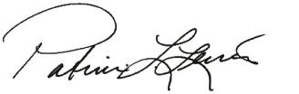

Patricia L. Lewis

People and Compensation Committee Chair

- | LEAR CORPORATION

Table of Contents

COMPENSATION DISCUSSION AND ANALYSIS

About Lear

Lear Corporation is a global automotive technology leader in Seating and E-Systems, enabling superior in-vehicle experiences for consumers around the world. We supply complete seat systems, key seat components, complete electrical distribution and connection

systems, high-voltage power distribution products, including BDUs, low-voltage power distribution products and electronic controllers to all of the world's major automotive manufacturers. At Lear, we are Making every drive betterTM by providing technology for safer, smarter and more comfortable journeys, while adhering to our values — Be Inclusive. Be Inventive. Get Results the Right Way.
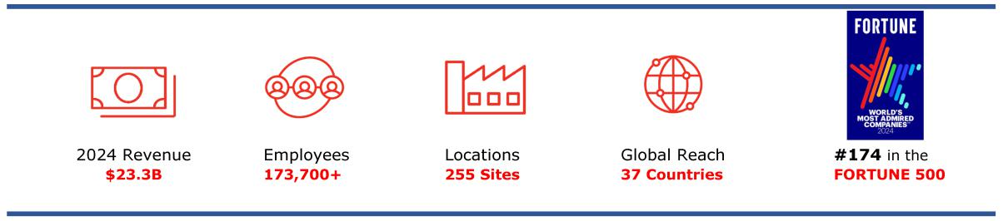

Our business is organized under two reporting segments: Seating and E-Systems. Each of these segments has a varied product and technology portfolio across a number of component categories. We continuously evaluate this portfolio, aligning it with industry trends while balancing risk-adjusted returns, which allows us to offer value-added solutions to our customers.

2024 Financial Performance Highlights
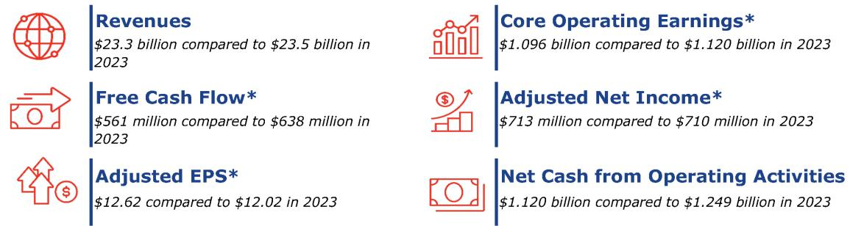

- See page 3 and Appendix A “Reconciliation of Non-GAAP Financial Measures” on page 90 for more information on these non-GAAP financial measures and how they are used.

Named Executive Officers ("NEOs")

The CD&A and Executive Compensation Tables outline Lear Corporation's executive compensation program and process for determining pay as it applies to the NEOs. For 2024, Lear's NEOs were:


Mr. Esposito served as SVP & President, E-Systems until May 16, 2024, and currently serves as SVP, IDEA by Lear in a non-executive officer capacity.

2025 Proxy Statement | | 35

Table of Contents

COMPENSATION DISCUSSION AND ANALYSIS

Summary of NEO Pay Results for 2024

- Annual Incentive Plan (AIP) payout at 89% of target for results below the stretch financial goals (the Adjusted Operating Income target was 26% higher than the target set in the 2023 AIP and the Free Cash Flow target was 39% higher than the target set in the 2023 AIP).

- Performance Shares for the 2022-2024 performance cycle paid at 112% of target (3-year cumulative Adjusted Pretax Income target was 12% higher than the target set in the 2021-2023 performance cycle).

- Base salaries were increased effective September 1, 2024, with increases ranging from 3.5 to 7.1%; it had been 21 months since the last increase.

Decision-Making Framework

Our executive compensation program is designed to reward financial performance, strong leadership and operational excellence, all of which are key elements in driving sustainable growth and shareholder value. This program allows us to compete for top talent and build

a management team that is well positioned to drive Lear's performance. The basic foundational concepts of our executive compensation program are grounded in best practices.

Total Rewards Philosophy and Compensation Principles

Our underlying total rewards philosophy is to provide performance-based and market competitive programs tied to performance and

aligned with the interests of our shareholders. Our objective is to attract, motivate and retain the caliber of executive officers and other key employees necessary to deliver sustained long-term performance for our shareholders in a challenging and dynamic industry. The

P&C Committee strives to create a pay-for-performance culture and strongly believes that executive compensation should be tied to the successful execution of our long-term corporate strategy. Our total rewards programs are an important part of delivering on this overall value proposition.

Our pay-for-performance structure and the resulting compensation provided to our executives are guided by the following principles:

- Align with Our Shareholders: Our incentive plans and resulting compensation paid are designed to align directly with the long-term interests of our shareholders.

- Enable Company Strategy: Compensation earned is based on the achievement of stretch goals that drive the Company's strategies both for the near-term and the long-term.

- Drive Business Performance: The performance measures in our incentive plans are selected and weighted based on our strategy to drive and reward annual and long-term business performance. As a result, incentive payouts and the resulting total realized or potentially realized pay are commensurate with the Company's performance relative to goals set prior to the start of the respective performance periods, and the value of equity awards, which represent the majority of our executives' total compensation, directly aligns with the experience of our shareholders.

- Avoid Excessive Risk-Taking: Our incentive compensation plans have an appropriate mix of short-term and long-term pay components with varying performance measures, weightings and goal ranges, and other elements. Our governance practices help us avoid risks that are reasonably likely to have a material adverse effect on the Company.

- Be Market Competitive: Target compensation opportunities and the resulting compensation earned are competitive with that provided to executives at peer companies so as to attract, motivate and retain key talent and be reflective of our global business structure and market conditions.

Compensation Governance

We believe our executive compensation practices drive performance and serve our shareholders’ long-term interests. We avoid certain practices that do not adhere to our compensation principles or further our shareholders’ interests. The following table summarizes the

key governance and design features of our executive compensation program.

- | LEAR CORPORATION

Table of Contents

COMPENSATION DISCUSSION AND ANALYSIS

What We Do What We Do Not Do

- Pay program aligned with business strategy

- Balanced mix of performance measures

- High percentage of performance-based pay

- Individual incentive compensation payouts are capped

- Incentive compensation payouts vary and are commensurate with results

- Annual market practices and comprehensive compensation risk review
- Robust stock ownership guidelines

- Provide_{awards} single-trigger change in control vesting of equity
- Provide single-trigger change in control severance benefits

- Reprice, backdate or spring-load equity awards

- Allow directors and officers to hedge or pledge our stock

- Provide change in control excise tax gross-ups

- Guarantee regular incentive plan awards

- Provide excessive perquisites

✓ | Robust clawback policies cover equity awards (performance | ✘ | Pay dividend equivalents on equity awards during vesting or
✓ | and time-vesting), cash awards and severance and | ✘ | performance periods
 | termination benefits

- Fully independent compensation consultant retained by the P&C Committee

- Lengthy holding period for Career Shares (underlying shares generally not distributed until the earlier of age 62 or three years after retirement) to drive retention and shareholder alignment

✘

✘

Include evergreen provisions in our LTI

Provide excessive severance

Total Compensation Process and Review

The P&C Committee oversees the executive compensation program design and decision-making process for our NEOs and other executive officers. The P&C Committee is comprised of independent, non-employee members of the Board and works very closely with its independent compensation consultant and management to review the effectiveness of the Company’s executive compensation

program throughout the year. The P&C Committee’s charter, which reflects the specific details of its authority and responsibilities, may be accessed on our website at https://ir.lear.com/corporate-governance.
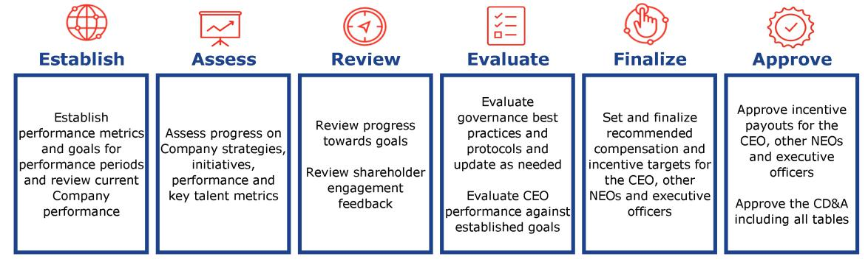

The P&C Committee annually reviews key elements of our executive compensation program, including the various components of

compensation for our NEOs and a summary of market practices and emerging trends, and discusses potential implications to the Company in the context of our business strategy and talent needs. This includes a specific review of dollar amounts for pay elements and potential payment obligations under our executive employment agreements and pay tally sheets for our NEOs. In addition, although the

P&C Committee assesses each component independently, the total complement of the components must work in harmony to achieve a proper balance, which, in

2025 Proxy Statement | | 37

Table of Contents

COMPENSATION DISCUSSION AND ANALYSIS

turn, helps manage compensation risk. To this end, we also annually complete a comprehensive compensation risk assessment with assistance from our outside legal counsel and independent compensation consultant.

Our human resources staff supports the P&C Committee's efforts, in partnership with its compensation consultant and our accountants, legal counsel and other advisors, and works to implement the P&C Committee’s decisions, monitor evolving competitive practices and

make compensation recommendations (except with respect to the CEO's pay for which recommendations are presented by the independent compensation consultant) to the P&C Committee.

The P&C Committee has engaged Pay Governance as an independent, outside consultant and advisor for rigorous review, analysis and

advice related to the compensation of our executive officers and other executive compensation-related matters. Pay Governance takes direction from and is solely responsible to the P&C Committee. A representative from Pay Governance attended all P&C Committee

meetings, either in person or virtually, consulted with and advised P&C Committee members on executive compensation, developed executive benchmarking and other executive compensation data, and advised on the structure, design and amounts of the various compensation elements. For most compensation topics for which the P&C Committee is responsible, it has directed Pay Governance to

work with management to develop recommendations that reflect the P&C Committee’s objectives for the compensation program. Pay Governance performs no other services for the Company. The P&C Committee annually reviews the services provided, independence, performance, fees paid and other factors when assessing the independence and performance of Pay Governance.

The P&C Committee typically meets in executive session after each of its regularly scheduled meetings to discuss and decide executive compensation matters.

The P&C Committee anchors its compensation decisions in a clearly articulated compensation philosophy with strong pay-for-performance alignment; recommendations and market data from the independent compensation consultant; shareholder feedback; its assessment of NEO and other executive officer performance and achievement of Company goals; and consideration of the business

climate and industry factors.

Authority of P&C Committee Under Incentive Plans

Under the AIP and the LTI, the P&C Committee has the authority to select a range of award types, performance measures and weightings and to apply adjustments to the financial measures used for annual and long-term incentive awards. Such adjustments may exclude, without limitation, the impact of gains or losses on the sale of assets, the effects of changes in accounting principles or the

application thereof, or unusual or non-recurring items, including the impact of significant differences from the assumptions contained in the financial budget or long-range plan upon which the applicable performance targets were established. Any such adjustments to financial measures are intended to better reflect the performance of approximately 7,800 AIP and 140 performance-based LTI award

participants, align award payments with decisions that support our long-term financial plan and strategies, avoid unintended inflation or deflation of awards due to unusual or non-recurring items during the performance period, and emphasize our preference for long-term,

sustainable growth.

Benchmarking Methodology and Peer Group Selection

The P&C Committee targets base salaries, annual incentive awards, long-term incentive awards and total direct compensation of our

NEOs and other executive officers on average to be within a competitive range (i.e., +/- 15%) of the median of the Company’s compensation comparator group (the “Comparator Group”) and other comparably sized general industrial companies. We believe the

Comparator Group represents the industries and companies with which we currently compete with for executive talent and/or business.

In addition to reviewing annual market pay benchmarking, other factors (including our business strategy, talent needs, succession planning, executives’ experience levels and cost) are considered in setting target pay which may result in some positions having target

pay higher or lower than the competitive range. Actual compensation relative to target pay opportunities will vary based on performance and, for long-term incentive awards, the value of our common stock at payment. The P&C Committee regularly assesses the composition of the Comparator Group.

- | LEAR CORPORATION

Table of Contents

COMPENSATION DISCUSSION AND ANALYSIS

See below for our Comparator Group selection process:
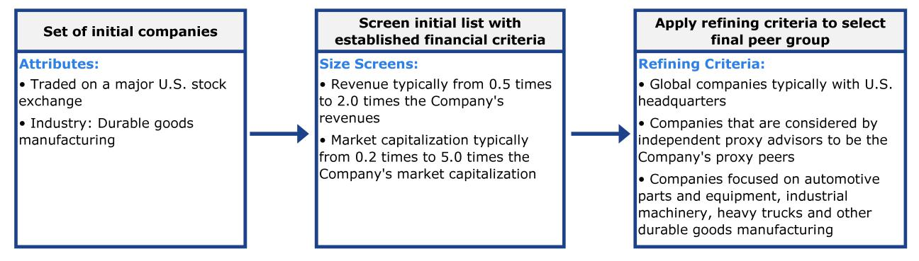

The Company supplements its review of the Comparator Group with a broader nationally published survey of general industrial companies (not individually selected or identified) for benchmarking of executive compensation levels and, as appropriate, compensation

design practices.

Lear Versus 2024 Comparator Group

The annual revenues of the companies in the 2024 Comparator Group for their most recently reported fiscal year ranged from $10.3 billion to $51.5 billion, with a median of $18.2 billion. How Lear compares to the companies in the 2024 Comparator Group for revenue and market capitalization is shown below.
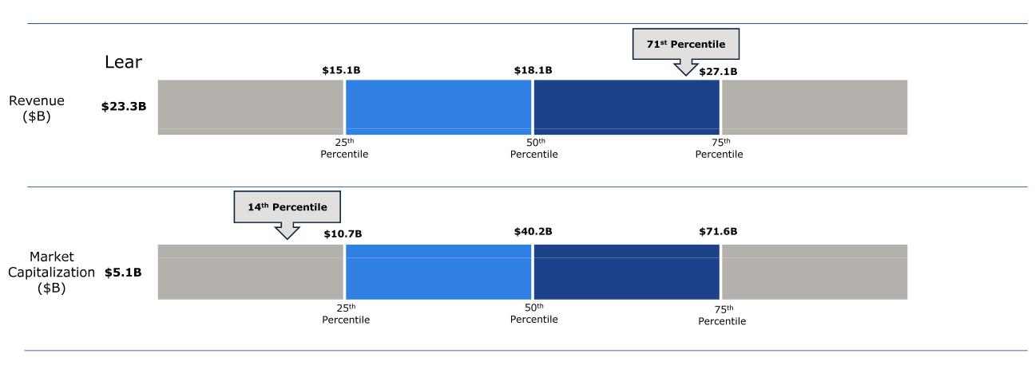

The 2024 Comparator Group was selected in September 2023. The revenue and market capitalization percentiles were determined as of

December 31, 2024. Lear's percentile positioning was approximately the same at the time the Comparator Group was selected and as of the end of 2024.

The companies in the 2024 Comparator Group are shown below.

2024 Comparator Group

Adient plc (ADNT)

Aptiv PLC (APTV)

BorgWarner Inc. (BWA)

Corning Incorporated (GLW)

Cummins Inc. (CMI)

Dana Incorporated (DAN)

Deere & Company (DE)

Eaton Corporation plc (ETN)

Emerson Electric Co. (EMR)

Goodyear Tire & Rubber Company (GT)

Honeywell International Inc. (HON) Parker-Hannifin Corporation (PH)

Illinois Tool Works Inc. (ITW) Stanley Black & Decker, Inc. (SWK)

L3Harris Technologies, Inc. (LHX) TE Connectivity plc (TEL)

Magna International Inc. (MGA) Textron Inc. (TXT)

PACCAR Inc. (PCAR) Whirlpool Corporation (WHR)

2025 Proxy Statement | 39

Table of Contents

COMPENSATION DISCUSSION AND ANALYSIS

The above companies were used to inform the NEO target annual and long-term incentive changes effective January 2024. The Comparator Group was increased from 16 companies in 2023 to 20 companies in 2024 with the additions of Corning Incorporated, Dana

Incorporated, Honeywell International Inc. and Stanley Black & Decker, Inc. These companies were added because, in addition to satisfying the screening criteria described above, the number of companies in the 2023 Comparator Group was near the lower end of the

desired range of 15-25 companies, with continued mergers and acquisitions likely to further decrease the number of companies in the Comparator Group.

To assess the Relative TSR performance measure of our Performance Shares, a second peer group consisting of 24 companies that are

primarily automotive suppliers (the "Relative TSR Peer Group") is used. The Relative TSR Peer Group is described in more detail beginning on page 49.

Pay Setting Process and Cycles

Tally Sheets

When determining compensation for the CEO, other NEOs and executive officers, the P&C Committee reviews tally sheets that detail the various elements of compensation for each executive officer. These tally sheets are used to evaluate the appropriateness of the total

compensation package, to compare each NEO’s total compensation opportunity with the actual aggregate payment and to ensure that the compensation appropriately reflects the compensation program’s focus on pay for performance. Tally sheets provide for an overall

assessment of our compensation program, while ensuring the proper linkage to financial performance and shareholder interests.

Say-on-Pay Results

The P&C Committee reviewed the results of the shareholder advisory vote on NEO compensation and incorporated these results as one of the many factors considered in connection with the overall review of our compensation program. Our compensation practices have

been consistently supported by our shareholders, as evidenced by our Say-on-Pay results. Last year, we received 90.2% shareholder support, and our average Say-on-Pay shareholder support over the prior five years is 91.8% (excluding abstentions and broker non-

votes).

Compensation Alignment with Shareholders

Our executive compensation program is designed to drive the execution of our business strategy by strongly aligning pay opportunities with performance outcomes. The P&C Committee considers multiple perspectives in assessing the achievement of this critical objective,

including a multi-year history of incentive payouts as a percentage of target, financial and TSR results, and the NEOs’ pay relative to the Comparator Group. These analyses, which are prepared by the P&C Committee's independent compensation consultant, found that relative to the Comparator Group:

- NEO target pay levels are in the competitive range (i.e., +/- 15%) of market median with an emphasis on performance-based pay opportunities.

- Our incentive plan performance measures are well-aligned to our business strategy, correlative to TSR and generally consistent with the performance measures used by the Comparator Group (and the broader industrial market).

- Our annual incentive and performance share payouts are directionally aligned with performance relative to the Comparator Group.

Our typical approach for newly promoted executives is to start pay below the market median and then increase pay to the market median over several years, while emphasizing at-risk, performance-based incentive award opportunities.

Consistent with our pay-for-performance philosophy, stretch goals are set for the AIP and Performance Share award opportunities. As such, in some years, payouts will be above target (when results exceed target), and in other years, payouts will be below target (when

results are below target). Our last five completed performance periods reflect this pay-for-performance alignment with payouts varying commensurate with results, as shown below:


Historical Performance Payouts

AIP | 2020 | 2021 | 2022 | 2023 | 2024
AIP | 60% | 100% | 124% | 170% | 89%
Performance Shares | 2018-2020 | 2019-2021 | 2020-2022 | 2021-2023 | 2022-2024
Performance Shares | 22% | 74% | 111% | 118% | 112%

For both the AIP and Performance Shares, three of the last five payouts were at or below target and two of the last five payouts were above target. These payouts are aligned with our performance against our financial metrics for the performance periods, reflecting the

alignment of our incentive payouts with our shareholder results.

- | LEAR CORPORATION

Table of Contents

COMPENSATION DISCUSSION AND ANALYSIS

The actual amounts realized, if any, from Performance Share award opportunities can vary significantly, due to performance and the Company’s stock price, from the grant amounts shown in the Stock Awards column of the Summary Compensation Table. This is

reflected in the CEO’s target pay mix, with 91% of total pay at-risk and 58% of total pay from performance share opportunities.

Engaging with Shareholders to Continue to Enhance our Compensation Program

Our directors and management recognize the benefits of robust dialogue with shareholders and have engaged consistently in

governance-focused shareholder outreach. We continue to solicit the perspectives of our investors which we share with the P&C Committee. Among other topics, we invite dialogue with our shareholders regarding best practices and policy issues, our compensation

programs, the financial measures that drive our business strategy and other issues to inform our compensation program review process. During fall 2024, we reached out to 17 shareholders whose holdings represent approximately 70% of our shares outstanding to gather feedback on various topics, including our executive compensation program. The predominant feedback we received from investors was

that they were supportive of our compensation programs and practices.

Based on shareholder engagements and feedback during the fall of 2023, we made the following changes to our 2024 incentives:

- Reintroduced ROIC as a financial measure starting with the 2024-2026 Performance Shares, and

- Returned to the traditional approach of setting all goals for the performance measures prior to the start of the 3-year performance period.

The P&C Committee and the management team review and discuss feedback as part of our comprehensive review of our compensation program's alignment to our business strategy, support of our talent needs, and relevance to market practices and other factors. Based

on consistent feedback from the 2024 shareholder outreach, we retained our annual and long-term incentive designs for 2025.

In addition to the formal outreach discussed above, members of management continue to have regular and extensive interaction with our investors throughout the year to discuss our business segments, end markets, financial results and operational execution at investor

conferences, Company-hosted events, non-deal roadshows and quarterly conference calls. In 2024, Lear met with 116 institutional investors for a total of 253 interactions. We share financial and sustainability information relevant to our shareholders through our

Sustainability Report, our Investor Relations website, our Annual Report on Form 10-K and this proxy statement.

What We Pay and Why: Elements of Executive Compensation

Executive Compensation Objectives and Core Elements

Our executive compensation program reflects our pay-for-performance philosophy and encourages executives to make decisions that drive the creation of shareholder value for the short and long term.

The P&C Committee uses a mix of fixed and variable compensation elements in order to achieve the following objectives of our compensation program:

- link executive pay to Company performance;

- optimize profitability, cash flow and revenue growth, as well as return on investment;

- align the interests of management with those of shareholders;

- utilize multi-year vesting periods and performance measures aligned to long-term shareholder value creation including stock performance;

- align management’s compensation with our business strategy and goals;

- promote teamwork within our group of global managers (our “One Lear” concept); and

- attract, motivate, reward and retain the best executive talent with market-based competitive compensation opportunities.

To achieve these objectives, we provide a total compensation program for executive officers that consists of base salary, annual and long-term incentive award opportunities, which are summarized below for 2024, as well as certain benefits (covered later).

2025 Proxy Statement | | 41

Table of Contents

COMPENSATION DISCUSSION AND ANALYSIS


Element

Purpose

Base Salary |  | 2024 Annual Incentive Plan |  | Long-Term Stock Incentive
Base Salary |  | (AIP) |  | Plan (LTI) RSUs⁽¹⁾ ⁽²⁾
Provide competitive rate of pay |  | Align a portion of annual pay to |  | Align executive pay with long-
to attract, motivate and retain |  | performance against key goals |  | term shareholder interests and
key executive officers |  | for the year |  | value creation

Long-Term Stock Incentive Plan (LTI) 2024-2026 Performance Shares⁽¹⁾

Align executive pay with performance against key financial goals and long-term

shareholder interests and value creation


Fixed vs.

Variable

Performance Period

Performance Measure(s)

Award Opportunity

Fixed Cash


--

Individual Performance


Merit Increases

Variable Cash

One Year:
01/01/2024- 12/31/2024

Two financial measures:

50% Adjusted Operating Income

50% Free Cash Flow

The Strategic Scorecard modifier of +/- 10% is applied to the result of the two financial measures

0% - 200%

Awards capped at 200%, inclusive of Strategic Scorecard

Modifier

Variable Equity


Three-Year Cliff Vesting for annual RSU awards

Stock Price Alignment


Stock Price Appreciation

Variable Equity

Three Years:
01/01/2024 - 12/31/2026

Three financial measures:

50% Adjusted Annual Pretax Income

25% Adjusted ROIC
Improvement

25% Relative TSR⁽³⁾

0% - 200%

- An RSU represents the right to receive a share of common stock when the RSU vests and is settled

- RSUs and Performance Shares are settled in common stock

- Relative TSR is capped at target (i.e., 100%) if Lear's TSR is negative over the performance period

Pay for Performance

Our incentive plans are designed to optimize long-term financial returns for our shareholders and reward our NEOs for delivering on the Company’s strategy. As part of a market-based pay program, we maintain many design features and corporate governance practices to ensure a strong link between executive pay, Company performance and shareholder interests:

- We use a high percentage of performance-based pay, with 91% of the 2024 target annual compensation for the CEO at risk including 77% granted in long-term equity, and, on average, 83% of the 2024 target annual compensation for the other NEOs at risk including 68% granted in equity.

- Our compensation program is aligned with our business strategy, and earnings is the key driver for us to achieve our business strategy goals.

- To drive these results, our incentive plans use key performance measures including Adjusted Operating Income, Free Cash Flow, Adjusted Pretax Income and Adjusted ROIC Improvement.

- We use Relative TSR as a Performance Share market measure to align shareholder interests with executive pay outcomes.

Our strategic, operational and financial performance over time is reflected in our results and returns to shareholders. All of the annual incentive opportunity and the majority of the long-term incentive opportunity are determined based on specific performance measures

that drive achievement of our business strategy, while ensuring sharp focus on critical results. In addition, as part of the Company’s long-term strategy to provide competitive retirement benefits, the Company has historically granted time-based Career Shares, including in 2024. See page 52 for more detailed information on Career Shares.

- | LEAR CORPORATION

Table of Contents

COMPENSATION DISCUSSION AND ANALYSIS

In order to drive profitable growth with efficient capital management, we selected complementary performance measures (which assess earnings and capital management, as well as relative TSR, over annual or three-year periods) to use in our 2024 incentive plans:

Measure | Weighting | Background, Definition and Rationale
Annual Incentive Plan (AIP)
Adjusted Operating | 50% | • Pretax income before equity income, interest expense, other income/expense, restructuring costs, and
Income |  | certain transactions and non-recurring items.
 |  | • Adjusted Operating Income is a well understood operating metric that can be influenced by all levels of
 |  | employees of the Company.
 |  | • Provides motivation to maximize earnings from current operations.
Free Cash Flow | 50% | • Net cash provided by operating activities, less capital expenditures, excluding certain transactions and other
 |  | non-recurring items.
 |  | • Free Cash Flow is a well understood operating metric that can be influenced by all levels of employees of the
 |  | Company.
 |  | • Provides motivation to maximize cash flow through earnings and appropriate management of working capital
 |  | and investments.
Strategic Scorecard | Modifier +/- 10% • Drives performance in strategic areas that contribute to long-term success and ensures successful execution
 |  | of our most critical innovation and strategic priorities.
Long-Term Stock Incentive Plan (LTI)
Adjusted Pretax | 50% for | • Net income for each year in the three-year performance period before provision for income taxes, income
Income | Performance | attributable to non-controlling interests, restructuring costs, and certain transactions and non-recurring
 | Shares | items.
 |  | • Focuses on earnings generated from products sold, encouraging profitable revenue growth and efficient
 |  | management of costs over time.
 |  | • Performance goals for all years were set prior to the start of the three-year performance period.
 |  | Performance results for each year are independently assessed and then averaged to determine the three-
 |  | year payout.
Adjusted ROIC | 25% for | • Adjusted Operating Income less taxes divided by average invested capital.
Improvement | Performance
 | Shares | • Focuses on the basis point improvement over the baseline of 2023 Adjusted ROIC.
 |  | • Performance goals for all years were set prior to the start of the three-year performance period. Performance
 |  | results for each year are independently assessed and then averaged to determine the three-year payout.
Relative TSR | 25% for | • Relative TSR for the Performance Share awards for the three-year performance period (2024-2026) based
 | Performance | on the three-year TSR achieved by the Company relative to the three-year TSR achieved by a group of
 | Shares | automotive suppliers and industrial companies listed on page 49 over the performance period (starting TSR

assessment period in December 2023 compared to ending TSR assessment period in December 2026).

• Focuses on alignment of executive pay with value creation for our shareholders relative to our peers.

• Target award earned for median Relative TSR, with maximum award of 200% of target for Relative TSR of at

least the 75th percentile. Award is capped at target if the Company’s TSR is negative for the performance period.

Compensation Mix

Target Pay Mix for CEO and Other NEOs

Base salary and annual and long-term incentive award opportunities are the elements of our NEOs’ total direct compensation. To support our compensation philosophy, our NEOs’ total direct compensation opportunity is heavily weighted toward at-risk compensation within

our annual and long-term incentive plans. Our annual incentive awards and the performance-based component of our long-term incentive awards are considered performance-based pay, as the payouts are dependent on the achievement of specific financial

performance measures. Our long-term incentive plan also utilizes time-based RSU awards that are subject to three-year cliff vesting, further aligning the NEOs with our shareholders as the final value realized is based on the Company’s share price after the three-year period.

2025 Proxy Statement | | 43

Table of Contents

COMPENSATION DISCUSSION AND ANALYSIS

The significant portion of at-risk performance-based pay directly aligns our NEOs with our shareholders’ interests. The 2024 target total direct compensation mix for our CEO and our other NEOs on average is shown below:
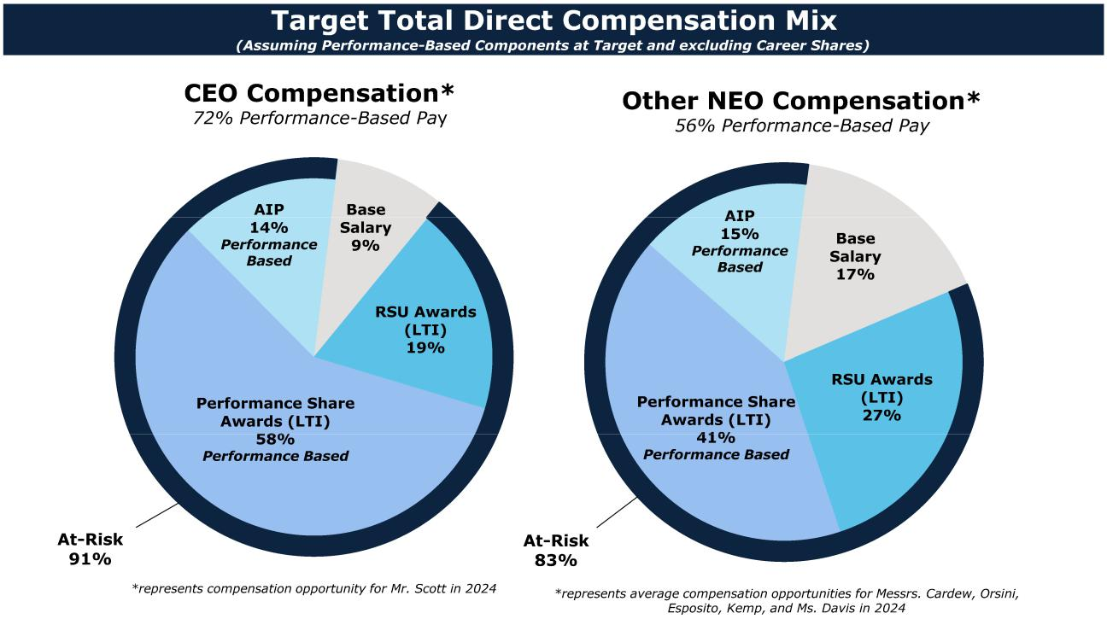

2024 Performance Results and Compensation Decisions

Base Salary

Base salaries for our NEOs are targeted, on average, around the median level for comparable positions based on market benchmarking. The process of determining base salaries includes a review of scope, duties and responsibilities for each NEO role, an evaluation of NEO

performance and experience, and attention to internal equity considerations. Our CEO’s base salary and total compensation are reviewed by the P&C Committee following the annual CEO performance review. Generally, in February of each year, the CEO and P&C Committee reach agreement on his goals and objectives for the upcoming year, and the P&C Committee evaluates his performance for the prior year

against the prior year’s agreed goals and objectives. Our CEO has traditionally received a lower percentage of his total compensation in the form of fixed amounts like base salary relative to our other executives in order to more closely link his compensation to the

performance of the Company. Increases in base salary for our senior executives are also determined by the results of the Board’s annual leadership review. At this review, our CEO assesses the performance of our top executives and presents his perspectives to our Board.

The 2023 and 2024 base salaries of our NEOs are summarized in the table below.

- The annual base salaries for our NEOs remained unchanged for 21 months from December 1, 2022 until September 1, 2024.

- Increases to annual base salaries for our NEOs were effective September 1, 2024, to generally align with increases for our salaried employees.

- Mr. Kemp was promoted to his current role effective October 1, 2022, and had not had a subsequent salary increase in the 23 months since his promotion. With his growth and tenure in the role, his salary increase was intended to align his compensation closer to the market median for his role.

- | LEAR CORPORATION

Table of Contents

COMPENSATION DISCUSSION AND ANALYSIS

Base Salaries

 |  | 2023 Base |  | 2024 Base
 |  | Salary Rate⁽¹⁾ |  | Salary Rate⁽²⁾ | % Change
Raymond E. Scott | $ | 1,300,000 | $ | 1,370,000 | 5.4 %
Jason M. Cardew | $ | 850,000 | $ | 880,000 | 3.5 %
Frank C. Orsini | $ | 850,000 | $ | 900,000 | 5.9 %
Carl A. Esposito | $ | 725,000 | $ | 750,375 | 3.5 %
Harry A. Kemp | $ | 700,000 | $ | 750,000 | 7.1 %
Alicia J. Davis | $ | 550,000 | $ | 580,000 | 5.5 %

- Effective December 1, 2022.
- Effective September 1, 2024 in alignment with the Company's annual increase cycle. The 2024 salary paid to each NEO reflected on the Summary Compensation Table is pro-rated based on the effective date of the salary increase.

Annual Incentive Plan (AIP)

Our NEOs and approximately 7,800 other salaried employees are eligible to participate in the AIP, which provides annual cash incentive award opportunities based upon the achievement of performance goals important to our success. Awards, if earned, are paid early in the

following year based on our performance achieved in the prior fiscal year.

2024 Award Opportunity

Each NEO is assigned an annual target opportunity expressed as a percentage of his or her base salary. An executive’s target annual

incentive percentage generally increases as his or her ability to affect our performance increases. Consequently, as an executive’s responsibilities increase, his or her variable compensation in the form of an annual incentive, which is dependent on Company

performance, generally makes up a larger portion of the executive’s total compensation opportunity. Other than for Mr. Esposito, whose target AIP increased from 80% to 90% of base salary as a result of a market competitiveness review, the 2024 target AIP for each NEO is unchanged from 2023.

2024 Target Annual Incentive Opportunity

 | 2024 Base Salary |  | Target AIP (% |  | Target AIP
 |  | Rate | of Base Salary) |  | Opportunity
Raymond E. Scott | $ | 1,370,000 | 160% | $ | 2,192,000
Jason M. Cardew | $ | 880,000 | 100% | $ | 880,000
Frank C. Orsini | $ | 900,000 | 100% | $ | 900,000
Carl A. Esposito | $ | 750,375 | 90% | $ | 675,338
Harry A. Kemp | $ | 750,000 | 90% | $ | 675,000
Alicia J. Davis | $ | 580,000 | 80% | $ | 464,000

AIP awards, if any, are determined based on the Company's final financial performance and the application of the Strategic Scorecard

modifier which can impact results by up to +/- 10%. The potential payouts range from 0 to 200 percent of target AIP opportunity, inclusive of the Strategic Scorecard modifier.

2024 Financial Performance Measures

The 2024 AIP used Adjusted Operating Income and Free Cash Flow because they are highly visible and important measures of operating performance that are relied upon by investors.

- Adjusted Operating Income weighted at 50%, measures our profit from operations.

- Free Cash Flow weighted at 50%, measures our ability to generate cash through earnings and the efficient use of working capital and fixed assets.

The performance goals for each financial measure were established and approved by the P&C Committee in November 2023, prior to the beginning of the performance period.

New 2024 Strategic Scorecard Modifier (+/- 10%)

For 2024, the P&C Committee adopted a new Strategic Scorecard modifier that could increase or decrease the payout under the AIP based on achievement of the two financial performance measures by up to 10 percentage points,

2025 Proxy Statement | 45

Table of Contents

COMPENSATION DISCUSSION AND ANALYSIS

subject to the overall maximum payout of 200% of an AIP participant's target bonus. The Strategic Scorecard modifier was added to drive performance and accelerate advancement in strategic areas important to our long-term success, especially in the areas of product

and process innovation and automation, and because it allows the P&C Committee to consider progress towards or achievement of critical innovation and strategic priorities in addition to financial performance under the AIP.

There were seven specific and quantifiable goals under the Strategic Scorecard modifier focused on product innovation, process innovation and transformation, and operational innovation. The goals, which were not individually weighted, included winning new product innovation customer contracts, deploying automation and robotic processes, and managing and analyzing utility consumption

data to drive efficiencies and decrease usage to lower costs and to support our sustainability targets. Specific levels were established for threshold performance and maximum performance. At overall threshold performance, no adjustment is made to the 2024 AIP payout.

Performance above threshold can result in an increase to the AIP payout, and performance below threshold can result in a decrease to the AIP payout.

2024 Performance Goals

We operate in a highly cyclical industry with volatility and uncertainty having increased significantly since 2020 due to a variety of factors, including the COVID-19 pandemic, semiconductor supply issues, macroeconomic and geopolitical issues and the pace of consumer adoption of electric vehicles, particularly in Europe and North America, our two largest markets. All of these factors impact the

budgeting process that is the basis for the target financial goals which are set each year to have comparable degrees of difficulty based on the challenges and opportunities forecasted at the start of a given year. As a result, in many years, this yields target goals above the

prior year actual results (particularly in upward automotive industry cycles), and in other years, the target goals may be below the prior year actual results, with the intent of setting appropriate performance goals each year that reflect our expectations for the year.

The 2024 AIP performance goals and payout calculation are shown below:
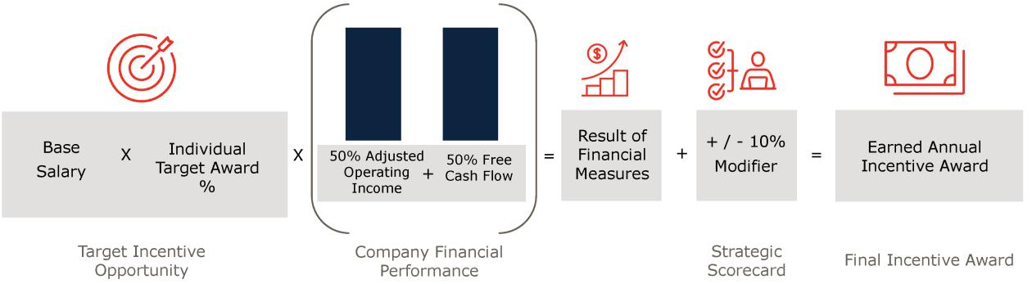

For 2024, our performance goals were significantly increased from those set for 2023 based on our strong 2023 performance and forecasts, both internal and external, of regional vehicle production volumes and electric vehicle adoption rates.

For the 2024 performance period, the target financial goals were set as follows:

- Adjusted Operating Income goal set at $1,215 million

  - The 2024 goal was set 26% higher than the 2023 Adjusted Operating Income target of $963 million and $100 million higher than the 2023 Adjusted Operating Income result of $1,115 million⁽¹⁾

- Free Cash Flow goal set at $630 million

  - The 2024 goal was set 39% higher than the 2023 Free Cash Flow target of $453 million and near the very strong 2023 Free Cash Flow result of $638 million⁽¹⁾
- Consistent with historical practice, the P&C Committee adjusted the Adjusted Operating Income results to neutralize the impact of a forecasted divestiture which did not occur in 2023. Our Adjusted Operating Income is calculated in the same manner as Core Operating Earnings, except $5 million was removed from Adjusted Operating Income to reflect the earnings from the planned divestiture.

The P&C Committee reviews the annual and long-range financial plans, recommendations from management, input from the

independent compensation consultant and performance of the open incentive performance periods prior to approving the targets for the AIP performance measures.

- | LEAR CORPORATION

Table of Contents

COMPENSATION DISCUSSION AND ANALYSIS

The 2024 AIP goals were set based on the Board-approved budget, with the target goals reflecting a stretch level of performance which at the time was anticipated to be challenging but achievable and the maximum goals set well above target, requiring significant

achievements and reflecting a level of performance at which the P&C Committee believed a 200% of target award was warranted. The P&C Committee approves the AIP performance measures, including the goals in the Strategic Scorecard modifier, late in the year
prior to the start of the performance period. Because the financial performance measures and goals are set before year end, the actual results for the current year and current performance period are not known. Therefore, the P&C Committee uses projected year-end results as a comparison when setting the goals for the upcoming year.

2024 Performance Results and Corresponding Payouts

AIP payouts are aligned and directly commensurate with our financial results. As shown below, the AIP, before the application of the Strategic Scorecard modifier, was earned at 80% of target, reflecting our performance against 2024 Adjusted Operating Income and

Free Cash Flow goals (including certain adjustments as described on pages 90-91).

2024 financial results for AIP purposes:

- Adjusted Operating Income of $1,101 million⁽¹⁾ was below the target goal of $1,215 million

- Free Cash Flow of $561 million was below the target goal of $630 million

- The P&C Committee determined that the Strategic Scorecard modifier should increase the 2024 AIP payout by 9% from 80% to 89% due to strong performance on six of the seven strategic goals.

- Consistent with historical practice, the P&C Committee adjusted the Adjusted Operating Income results to eliminate the impact of a 2024 unplanned divestiture. Our Adjusted Operating Income is calculated in the same manner as Core Operating Earnings, except $5 million was added to Adjusted Operating Income to reflect the forecasted lost earnings associated with the unplanned divestiture in 2024.

2024 Annual Incentive Plan Goals & Results

 |  |  |  |  | Performance | Performance
 | Weight | Threshold | Target | Maximum | Performance | Result as % of
 |  |  |  |  | Result | Result as % of
 |  |  |  |  | Result | Target
Adjusted Operating Income | 50% | $911M | $1,215M | $1,458M | $1,101M | 82%
Free Cash Flow | 50% | $473M | $630M | $788M | $561M | 78%
 |  |  |  | Financial Performance Payout |  | 80%
 |  |  |  |  | Scorecard Adjustment | 9%
 |  |  |  |  | Final Payout | 89%

The AIP award for each NEO is shown below:

2024 Annual Incentive Plan Payouts

 | Target Opportunity |  | Target |  | 2024 Incentive
 | (as % of Base) |  | Amount(1) | Payout % |  | Amount(2)
Raymond E. Scott | 160% | $ | 2,192,000 | 89% | $ | 1,950,880
Jason M. Cardew | 100% | $ | 880,000 | 89% | $ | 783,200
Frank C. Orsini | 100% | $ | 900,000 | 89% | $ | 801,000
Carl A. Esposito | 90% | $ | 675,338 | 89% | $ | 601,050
Harry A. Kemp | 90% | $ | 675,000 | 89% | $ | 600,750
Alicia J. Davis | 80% | $ | 464,000 | 89% | $ | 412,960

- Reflects base salary as of December 31, 2024, multiplied by the Target Opportunity.

- The 2024 Incentive Amount represents the amount actually earned, which is calculated as the Target Amount multiplied by the Payout %.

Long-Term Stock Incentive Plan ("LTI") Compensation

The long-term incentive component of our executive compensation program is designed to provide our senior management with performance-based award opportunities, to drive superior long-term performance and to align the interests of our senior management

with those of our shareholders.

2025 Proxy Statement | | 47

Table of Contents

COMPENSATION DISCUSSION AND ANALYSIS

2022-2024 Performance Results and Corresponding Payouts

LTI payouts are aligned and directly commensurate with our financial results. Earned equity awards are also subject to changes in our

stock price over a multi-year period. Our strategic, operational and financial performance over time is reflected in our results and returns to shareholders. At the end of 2024, the 2022-2024 performance-based incentive cycle was completed, with the results summarized below, and a payout of 112% of target, reflecting our performance against three years of Adjusted Annual Pretax Income goals

(including certain adjustments as described below and on pages 90-91) and our three-year Relative TSR performance. For each year in the performance period, the P&C Committee set the Adjusted Annual Pretax Income goal based on the Board-approved budget which

reflected its performance expectations for the upcoming year.

The 2022-2024 Performance Shares were distributed on February 13, 2025, based on our performance for the three-year performance period beginning January 1, 2022. Final performance share results were approved by the P&C Committee as shown below:

2022-2024 Performance Shares

 | Weight | Threshold | Target | Maximum | Performance |  | Payout Results
 |  |  |  |  | Result |  | as % of Target
Adjusted Annual Pretax | 66.7% | $1,697M | $2,610M | $3,002M | $2,799M | (1) | 141%
Income ($)
Relative TSR (Percentile) | 33.3% | 25th | 50th | 75th | 26.7th |  | 53%
 |  |  |  |  | Final Payout |  | 112%

- In determining the payouts, consistent with historical practice, the P&C Committee adjusted the Adjusted Annual Pretax Income results to eliminate the impact of acquisitions and divestitures made during the performance period. These adjustments increased the cumulative Adjusted Annual Pretax Income result by $15 million over the performance period. For 2022, the impact of two acquisitions was excluded as the acquisitions were not contemplated when the 2022 goal was set. For 2023, the impact of a divestiture that did not occur was excluded as the divestiture was contemplated when the 2023 goal was set. For 2024, the impact of a divestiture that did occur was excluded as the divestiture was not contemplated when the 2024 goal was set.

The resulting share amounts earned by our NEOs are shown below:

2022-2024 Performance Shares

 |  |  | Actual Shares
 | Target Shares |  | Earned
 | (#) | Result | (#)
Raymond E. Scott | 34,580 | 112% | 38,729
Jason M. Cardew | 8,974 | 112% | 10,050
Frank C. Orsini | 8,974 | 112% | 10,050
Carl A. Esposito | 6,861 | 112% | 7,683
Harry A. Kemp | 5,218 | 112% | 5,844
Alicia J. Davis | 3,630 | 112% | 4,063

2024-2026 Long-Term Incentive Award Opportunity

The 2024 LTI award mix for our CEO was approximately 75% Performance Shares and 25% RSUs and was 70% Performance Shares and 30% RSUs for our other NEOs. The weightings and the target LTI opportunity as a percentage of salary for each NEO is unchanged from 2023. Vesting of the Performance Shares is based on the achievement of performance goals over the three-year performance period

(2024-2026). The RSUs cliff vest on the third anniversary of the date of grant, with exceptions for death, disability, retirement, qualifying terminations within two years following a change in control and certain other qualifying involuntary terminations.

Our weighting of Performance Shares is higher than most of the Comparator Group and many other large industrial companies, which often assign Performance Shares a lower weighting (e.g., typically 50% to 60% of the regular annual equity award mix). Our heavy weighting of Performance Shares increases the sensitivity of the value of our NEOs’ long-term equity incentives to Company performance

– not only does the underlying value of a Performance Share fluctuate with changes in the Company’s stock price, but the number of shares earned varies based on the Company’s achievement of financial and relative TSR goals.

- | LEAR CORPORATION

Table of Contents

COMPENSATION DISCUSSION AND ANALYSIS

2024-2026 Target Long-Term Incentive Opportunity

 | 2024 Base Salary |  | Target LTI (% of |  | Target LTI
 |  | Rate⁽¹⁾ | Base Salary) |  | Opportunity⁽²⁾
Raymond E. Scott | $ | 1,300,000 | 900% | $ | 11,700,000
Jason M. Cardew | $ | 850,000 | 400% | $ | 3,400,000
Frank C. Orsini | $ | 850,000 | 400% | $ | 3,400,000
Carl A. Esposito | $ | 725,000 | 300% | $ | 2,175,000
Harry A. Kemp | $ | 700,000 | 255% | $ | 1,785,000
Alicia J. Davis | $ | 550,000 | 250% | $ | 1,375,000

- The values reflect the base salary rate in effect when the awards were granted in January 2024. As discussed on page 44, base salaries were increased effective September 1, 2024.
- The values reflected in the Summary Compensation Table and the 2024 Grants of Plan-Based Awards table, both shown in "Executive Compensation Tables" beginning on page 56, may differ from these target values due to the fair value determination of the Relative TSR component under the accounting standards.

2024-2026 Performance Measures and Goals

The Performance Shares granted for the performance period are earned based on three performance measures.
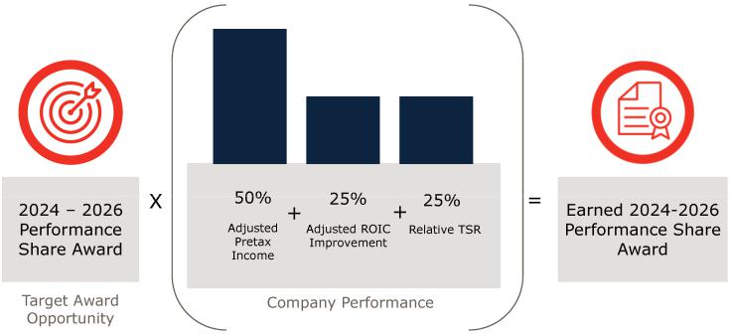

Adjusted Pretax Income (50% weighting)

The Adjusted Pretax Income goals for the full three-year performance period were approved by the P&C Committee in November 2023

based on our Board-approved 2024 annual budget and our expectations for 2025 and 2026 set forth in our long-range plan. The target goal for 2024-2026 is 31.8% higher than that used for the 2023-2025 performance period, and the 2024-2026 target goal represents a 32% increase over our 2022-2024 performance period results. The results for each year will be measured, and the final payout will be

based on the average of the annual results.

Adjusted ROIC Improvement (25% Weighting)

The Adjusted ROIC Improvement goals were approved in November 2023 based on our Board-approved 2024 annual budget and the expectations for 2025 and 2026 set forth in our long-range plan. The results for each year will be measured, and the final payout will be based on the average of the annual results.

Our 2023 Adjusted ROIC was 10.28%. Over the 2024-2026 performance period, an improvement of 160 basis points compared to 2023 Adjusted ROIC is needed for target performance, a 260 basis point improvement is needed for maximum performance, and a 60 basis

point improvement is needed for threshold performance.

Relative TSR (25% Weighting)

Relative TSR performance will be measured based on the Company’s three-year TSR relative to the TSR of the Relative TSR Peer Group,

which is comprised of automotive suppliers and other industrial companies. Unlike the Comparator Group that is selected, in part, based on comparable revenues and is used for compensation benchmarking and pay decisions, the Relative TSR Peer Group includes companies with a wider range of revenues and a strong historical stock price correlation to our common stock and is used to assess

performance versus peer companies. The portion of the Performance Share award based on the achievement of this metric is capped at the target payout (i.e., 100%) if our TSR is negative for the performance period even if our TSR outperforms that of the Relative TSR

Peer Group.

2025 Proxy Statement | 49

Table of Contents

COMPENSATION DISCUSSION AND ANALYSIS

Consistent with our market median-based pay philosophy, the relative TSR target payout is set at the 50th percentile (“P50”) of the Relative TSR Peer Group. This directly aligns the award payout with relative performance (i.e., P50 pay for P50 TSR) and reflects the

most common practice among our Comparator Group and other similarly situated large companies. The design limits payouts to 100% of target in the event our absolute TSR is negative at the end of the three-year performance period. Collectively, these design features

reflect our guiding principles of providing market competitive compensation that aligns with the long-term interests of our shareholders.

Companies in the Relative TSR Peer Group may vary slightly cycle-to-cycle, reflecting mergers and acquisitions, significant changes in company structure and other factors. For the 2024-2026 cycle, Cooper-Standard Holdings was replaced with Phinia Inc., a spin off of

BorgWarner Inc.'s fuel injection business. Cooper-Standard Holdings was replaced because its relatively small market capitalization made it more susceptible to large TSR fluctuations. The Relative TSR Peer Group for the 2024-2026 cycle is as follows:

2024-2026 Performance Shares – Relative TSR Peer Group

Adient plc (ADNT) | Continental Aktiengesellschaft
Adient plc (ADNT) | (CON)
Allison Transmission Holdings, Inc. | Cummins Inc. (CMI)
(ALSN)
American Axle & Mfg. Holdings, | Dana Incorporated (DAN)
Inc. (AXL) | Dana Incorporated (DAN)
Aptiv PLC (APTV) | Eaton Corporation plc (ETN)
Autoliv, Inc. (ALV) | Forvia SE (FRVIA)
BorgWarner Inc. (BWA) | Gentex Corporation (GNTX)

Gentherm Incorporated (THRM) | Standard Motor Products, Inc.
Gentherm Incorporated (THRM) | (SMP)
LCI Industries (LCII) | TE Connectivity PLC (TEL)
Magna International Inc. (MGA) | Textron Inc. (TXT)
Modine Manufacturing Company | The Goodyear Tire & Rubber
(MOD) | Company (GT)
PACCAR Inc. (PCAR) | Valeo SA (FR)
Phinia Inc. (PHIN) | Visteon Corporation (VC)

Summary of Outstanding Performance Periods

Each Performance Share award reflects a three-year performance period resulting in overlapping awards. The potential payout for each Performance Share ranges from 0 to 200 percent of the target opportunity.

- For the 2023-2025 Performance Shares, ongoing industry volatility, supply chain disruptions and other macroeconomic conditions made it difficult to set performance goals for all three years prior to the start of the performance period. As a result, one-year Adjusted Annual Pretax Income performance goals were set each November or December for the following year based on the Board-approved budget for that year.

  - The 2023-2025 Performance Shares are tracking slightly above target for Adjusted Annual Pretax Income and Adjusted ROIC Improvement and below target with respect to Relative TSR.

- For the 2024-2026 Performance Shares, we returned to the traditional approach of setting all performance goals for the three-year performance period prior to the start of the performance period based on the Board-approved 2024 annual budget and the expectations for 2025 and 2026 set forth in our long-range plan. For the performance period, the Adjusted Pretax Income target goal was set 31.8% higher than the 2023-2025 target goal, and the Adjusted ROIC target goal requires improvement over the performance period.

  - The 2024-2026 Performance Shares are tracking below target for Adjusted Pretax Income and below threshold with respect to both Adjusted ROIC Improvement and Relative TSR.

- For the 2025-2027 Performance Shares, we set all performance goals for the three-year performance period in December 2024, prior to the start of the performance period. The Adjusted Pretax Income target goal was set lower than the 2024-2026 target goal given the expected decline in industry production volumes and EV adoption rates in Europe and North America.

The chart below reflects the performance period for the three outstanding Performance Share awards as of the filing date of this proxy statement, including the corresponding performance measures and weightings.

- | LEAR CORPORATION

Table of Contents

COMPENSATION DISCUSSION AND ANALYSIS
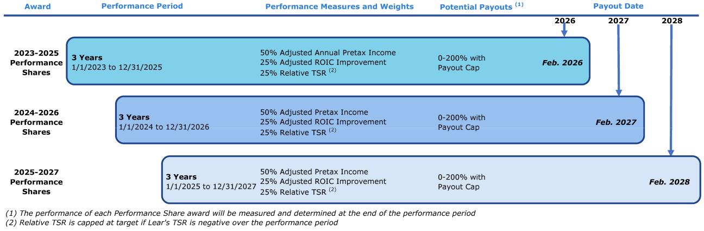

Special RSU Awards

In August 2024, the P&C Committee granted special RSU awards to Mr. Cardew, our Senior Vice President and CFO, and to Mr. Orsini, our Executive Vice President and President of our Seating business. The P&C Committee does not typically grant special awards (e.g.,

the last such grant to a named executive officer was made in 2019 to compensate the officer for equity awards from his prior employer that were forfeited upon joining Lear) and has no plans to grant special awards to any other executive officers. The P&C Committee

determined that these special awards were needed for succession planning and to recognize each officer's strong performance. In determining the size of the special RSU awards for Messrs. Cardew and Orsini, the P&C Committee considered the criticality of their roles, the date on which each will become retirement eligible, successor readiness, the size of similar awards made by other companies

within the 2024 Comparator Group and expectations for stock price improvement when industry conditions improve.

Mr. Cardew, a strategic leader as we navigate highly volatile market conditions and declining automotive volumes, becomes retirement eligible in June 2025. Mr. Cardew received RSUs with a grant date value of $1 million that vest in two equal installments on December

31, 2026 and December 31, 2027, subject to his continued employment with us. Mr. Orsini, who has been integral in leading our largest business unit and expanding its capabilities, efficiencies and innovations, becomes retirement eligible in April 2027. Mr. Orsini received

RSUs with a grant date value of $2 million that vest in three equal installments on the third, fourth and fifth anniversaries of grant (in August 2027, 2028 and 2029), subject to his continued employment with us. Unlike our annual equity awards, these awards do not contain retirement vesting provisions, to reinforce retention.

Other Pay Elements

Perquisites

To remain competitive in the market, we provide our executives with enhanced life insurance benefits and a low-cost annual executive

physical through a company-designated provider. In addition, we permit Mr. Scott, our CEO, to have limited personal use of corporate aircraft so long as the aggregate incremental cost to Lear does not exceed $50,000 per year. Due to credible threats made, we also commissioned an overall, third-party security review in 2024. Based on that review, the Board determined that additional security

services should be provided to our executive officers for their protection and to protect Lear's interests. During 2024, we provided our named executive officers with an executive protection risk assessment, a home security system installation with monitoring and

cybersecurity protection (e.g., digital privacy protection, personal device security, home network security). The P&C Committee and the Board believe the costs of our security program are an appropriate and necessary business expense and does not consider such costs to be a perquisite. Pursuant to SEC guidance, we have reported the aggregate incremental costs of the security program in the "All Other

Compensation" column of the Summary Compensation Table.

Retirement Benefits

Our NEOs participate in our 401(k) retirement savings plan, frozen qualified pension plan, frozen pension equalization plan and supplemental savings plan, as eligible. These benefits provide rewards for long-term service to the Company and an income source in an

executive’s post-employment years. The various components of our retirement benefit program (including our frozen defined benefit pension plans) disclosed in this proxy statement are summarized in the table below. The general terms of these plans and formulas for

calculating benefits are summarized following the Summary Compensation Table, 2024 Pension Benefits table and 2024 Nonqualified Deferred Compensation table, respectively, in “Executive Compensation” beginning on page 56.

2025 Proxy Statement | | 51

Table of Contents

COMPENSATION DISCUSSION AND ANALYSIS


Summary of Retirement Benefits

 |  |  |  |  | Pages for Further
 | Type | Plan/Program | Component/Feature | Purpose | Details
 |  |  | Deferral | Standard 401(k) plan and
 |  | Salaried Retirement Program | Company Match | matching contribution | 58
 |  | (Qualified) | Automatic Company | Non-matching contribution
 |  |  | Contribution | Non-matching contribution
 | Defined Contribution |  | Contribution
 | Defined Contribution | Salaried Retirement | Deferral
 |  | Salaried Retirement | Company Match | Program for amounts above
 |  | Restoration Program (Non- | Company Match | Program for amounts above | 58
 |  | Qualified) | Automatic Company | tax-qualified plan limits
 |  |  | Contribution
 |  | Lear Corporation Pension Plan | Qualified Pension Plan (frozen) |  | 63
 | Defined Benefit (frozen as | Pension Equalization Program | Part of SERP (frozen) | N/A | 64
 | of 12/31/06) |  |  | N/A
 |  | Salaried Retirement
 |  | Restoration Program (Pension | Part of SERP (frozen) |  | 64
 |  | Makeup)
 |  |  | Shares not distributed until | Facilitates a very long-term
 |  | Career Shares | Shares not distributed until | shareholder perspective by the
 | Additional | Career Shares | earlier of age 62 or 3 years | shareholder perspective by the | 52
 | Additional | (described below) | earlier of age 62 or 3 years | NEOs and other senior
 |  | (described below) | after retirement | NEOs and other senior
 |  |  | after retirement | executives

Career Shares

Each November, the P&C Committee grants Career Shares, which are RSUs that generally must be held until after retirement. The annual granting of Career Shares is an integral component of the Company’s strategy to align NEOs and other senior executives with the mindset of a very long-term shareholder. The grants are also intended to motivate and retain key talent during industry cycles and

support long-term talent initiatives and succession planning. Individual awards are differentiated by position level, performance and other factors.

On November 20, 2024, the P&C Committee approved grants of Career Shares to our NEOs, in the amounts reported in the Summary Compensation Table on page 56 and the 2024 Grants of Plan-Based Awards table on page 59, and other senior leaders. Career Shares are generally required to be held until retirement, since they are not distributed until the later of age 62 or the vesting date. For

purposes of illustration, our NEOs are required to hold earned Career Shares for an average of six years from the grant date (based on the number of years until the earliest distribution opportunity), during which time the Career Shares will remain subject to forfeiture in the event of a voluntary resignation or termination for Cause before achievement of retirement eligibility.

Governance Policies and Practices

Equity Award Policy

We do not time the grant of equity awards in coordination with the release of material non-public information. Our equity awards are

generally approved on the dates of our regularly scheduled P&C Committee meetings and are effective as of such dates or specified prospective dates.

The P&C Committee's equity award policy provides that the effective grant date of equity awards must be either the date of P&C

Committee or other committee approval or some future date or event date specifically identified in such approval. We currently do not grant stock options or stock appreciation rights, but if such awards were to be granted, the exercise price would not be less than the

closing market price of our common stock on the grant date. The P&C Committee must approve all awards to our executive officers. The policy also allows the P&C Committee to delegate to the CEO the ability to grant equity awards to non-executive officer employees who are newly hired or promoted or deemed to be deserving of special retention or recognition awards. The CEO must report to the P&C

Committee at least annually on the exercise of his authority under this delegation. The aggregate award pool for awards to non-executive officers is approved by the P&C Committee.

Employment Agreements/Termination/Change in Control Benefits

As described in detail and quantified in “Executive Compensation — Potential Payments Upon Termination or Change in Control” on page

66, our NEOs receive certain benefits under their employment agreements upon their termination by the Company without “cause” or upon their resignation for “good reason,” including such terminations following a change in control of the Company. The employment

agreements also provide for restrictive covenants relating to non-

- | LEAR CORPORATION

Table of Contents

COMPENSATION DISCUSSION AND ANALYSIS

competition, confidential information and non-solicitation of the Company’s employees and customers. These benefits are intended to ensure that members of senior management are not influenced by their personal situations and are able to be objective in evaluating a

potential change in control transaction. The P&C Committee regularly reviews termination and change in control benefits and believes that the severance benefits in connection with certain terminations of employment constitute reasonable levels of protection for our

executives. The LTI provides all participants, including NEOs, double-trigger vesting (i.e., qualifying termination of employment within two years following a change in control) of equity awards (that are not assumed or replaced by the successor company), which protects employees and supports an orderly transition of leadership.

None of the employment agreements with the Company’s executive officers contains an excise tax gross-up provision.

Compensation and Risk

Annually, the P&C Committee reviews the potential impact of our compensation programs on organizational risk. The risk assessment was conducted by senior leaders of the Company, including representatives from finance, legal and human resources, and included a

review of the employee compensation structures and pay administration practices. The P&C Committee and its independent compensation consultant reviewed and discussed the findings of the assessment and concluded that our employee compensation

programs are designed with the appropriate balance of risk and reward in relation to our overall business strategy and do not incent executives or other employees to take unnecessary or excessive risks.

As a result, we believe that risks arising from our employee compensation policies and practices are not reasonably likely to have a material adverse effect on the Company. In reaching these conclusions, we considered the attributes of all of our programs, including:

- Appropriate compensation mix between fixed (base salary) and variable (annual and long-term incentive) pay opportunities;

- Review of market data and competitive practices for elements of executive compensation;

- Performance measures tied to key Company annual and long-term performance measures and correlated to total shareholder returns;

- Alignment of annual and long-term award objectives to ensure that both types of awards encourage consistent behaviors and sustainable performance results;

- Balanced mix of performance measures for incentive awards (Adjusted Operating Income, Free Cash Flow, Adjusted Pretax Income, Adjusted ROIC Improvement, Relative TSR) that encourage value creation, retention and stock price appreciation;

- Long history of pay outcomes aligning to our performance with incentive opportunities and payouts varying commensurate with our financial and TSR performance results;

- Stock Ownership Guidelines; and

- Robust clawback policies for improper conduct and accounting restatements.

We also reviewed our compensation programs for certain design features that may have the potential to encourage excessive risk-taking, including: over-weighting towards annual incentives, highly leveraged payout curves, unreasonable performance thresholds and

steep payout cliffs at certain performance levels that may encourage short-term business decisions to meet payout thresholds. We concluded that our compensation programs do not include such elements.

Stock Ownership Guidelines

The management stock ownership guidelines create a strong link between our long-term success and the ultimate pay of our executive officers, as shown in the table below.

- Covers all executive officers and establishes a multiple of each executive officer's base salary.

- Includes only actual share holdings and a portion of unvested RSUs (60%) if the executive is retirement eligible and has held the RSUs a minimum of 12 months.

- Excludes unvested Performance Shares and excludes unvested RSUs (except as otherwise described above).

- Excludes stock options.

- Requires each executive to hold 50% of the net shares acquired upon the vesting of equity awards until the ownership requirement is achieved.

2025 Proxy Statement | | 53

Table of Contents

COMPENSATION DISCUSSION AND ANALYSIS

- Share ownership targets for executives reaching age 60 are reduced by 10% annually up to a maximum reduction of 50%.
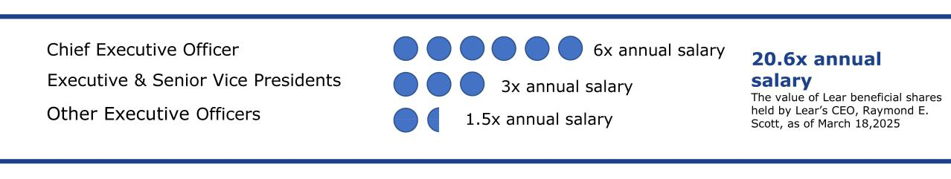

Our stock ownership guidelines are reviewed periodically to ensure ongoing alignment with market practice and for reasonableness. As of our latest measurement date (December 31, 2024), all NEOs have met their respective ownership requirement, other than Mr. Kemp

and Ms. Davis, each of whom continues to retain at least 50% of the net shares acquired upon vesting of equity awards until the stock ownership target guideline is achieved.

Insider Trading Policy

We have adopted an Insider Trading Policy applicable to our directors, officers and certain other designated employees, as well as related persons and controlled entities of the foregoing, that governs the purchase, sale and other dispositions of the Company's securities. While the Company is not subject to the Insider Trading Policy itself, the Company will not engage in transactions in its securities while

aware of material nonpublic information. We believe that the Company's Insider Trading Policy is reasonably designed to promote compliance with insider trading laws, rules and regulations, and listing standards applicable to the Company.

Our Insider Trading Policy, which is available on our website at https://ir.lear.com/corporate-governance, also prohibits our officers and directors from:

- speculating in our stock (quick buy and sell or vice versa)

- selling our stock "short"

- using publicly traded options (e.g., puts, calls and other derivative securities)

- using standing orders or margin accounts for our stock

- using pledges, hedges or other monetization transactions relating to our stock

These prohibitions, which apply whether or not the securities were granted to or held directly or indirectly by the officer or director, are, among other things, designed to not allow the officer or director to hedge or offset any decrease in the value of our common stock.

Clawback Policies

Lear maintains two compensation recovery policies:

- Incentive-Based Compensation Recoupment Policy (the "Recoupment Policy")

- Improper Conduct Compensation Recoupment Policy (the "Improper Conduct Policy")

The Recoupment Policy requires Lear, in the event of a financial restatement, to recover from our current and former executive officers

the amount of incentive compensation received during the three completed fiscal years immediately preceding the required financial restatement date that exceeds the amount of incentive compensation that would have been received had the restated financial

statements been used to calculate the incentive compensation.

Our Improper Conduct Policy covers more Lear employees and applies in a broader range of circumstances. The material terms of our Improper Conduct Policy are summarized below.

- | LEAR CORPORATION

Table of Contents

COMPENSATION DISCUSSION AND ANALYSIS

 | Improper Conduct Policy
Provision | Policy
 | Any conduct, act or omission that causes (or has the potential to cause) material financial, operational or
 | reputational harm to Lear or material disruption, damage, impairment of or interference with, our business
 | and that relates to acts of fraud, bribery or embezzlement; certain criminal acts (such as violation of the
Triggers | Foreign Corrupt Practices Act); breaches of obligations under our Code of Business Conduct & Ethics relating to
 | law or regulations; breaches of a restrictive covenant; violations of certain internal policies (e.g., the
 | Harassment-Free Workplace Policy, the Romantic Relations Policy, the Equal Employment Opportunities Policy);
 | or the creation of a hostile work environment.
Who Is Covered | Current and former LTI participants (approximately 350 people)
Compensation | All incentive-based cash and LTI awards (both time and performance-based), proceeds following a sale of
Subject to Recovery | shares, severance and termination benefits and any compensation designated by the P&C Committee
Look-back Period | 3 years from date the P&C Committee determines the policy was triggered
Oversight | P&C Committee
Effective Date | 10/2/2023

Tax Treatment of Executive Compensation

While the P&C Committee considers corporate tax deductibility as one of several relevant factors in determining compensation, it retains the flexibility to design and maintain executive compensation arrangements that it believes will attract and retain executive talent consistent with Lear's best interests and those of its shareholders, even if such compensation is not deductible by Lear for federal

income tax purposes. For 2024, Section 162(m) of the Internal Revenue Code limited Lear's deduction to $1 million for the annual compensation paid to each of our NEOs.

Accounting Treatment

We have generally considered the accounting treatment of various forms of awards in determining the components of our overall

compensation program. We have generally sought to grant stock-settled equity awards to executives, which receive fixed accounting treatment, as opposed to cash-settled equity awards, which receive variable accounting treatment. We intend to continue to evaluate

these factors in the future.

2025 Proxy Statement | | 55

Table of Contents

EXECUTIVE COMPENSATION

EXECUTIVE COMPENSATION TABLES

The following table shows information concerning the annual compensation for services to the Company and its subsidiaries in all capacities of the CEO, CFO and the other NEOs during the last three completed fiscal years. The footnotes accompanying the Summary

Compensation Table generally explain amounts reported for 2024, unless otherwise noted.

Summary Compensation Table

 |  |  |  |  |  | Change in Pension
 |  |  |  |  |  | Value and
 |  |  |  |  |  | Nonqualified
 |  |  |  |  | Non-Equity | Deferred
Year |  |  | Stock | Option | Incentive Plan | Compensation | All Other | Total
Year | Salary | Bonus | Awards(2) | Awards | Compensation(3) | Earnings(4) | Compensation(5) | Compensation
 | ($) | ($) | ($) | ($) | ($) | ($) | ($) | ($)
Raymond E. Scott(1) President and CEO
2024 | 1,323,333 | — | 13,263,959 | — | 1,950,880 | 44,310 | 859,053 | 17,441,535
2023 | 1,300,000 | — | 13,349,215 | — | 3,536,000 | 41,649 | 664,508 | 18,891,372
2022 | 1,272,500 | — | 11,118,747 | — | 2,418,000 | — | 567,097 | 15,376,344
Jason M. Cardew(1) Senior Vice President and Chief Financial Officer
2024 | 860,000 | — | 4,891,937 | — | 783,200 | — | 393,719 | 6,928,856
2023 | 850,000 | — | 3,914,999 | — | 1,445,000 | 35,123 | 310,215 | 6,555,337
2022 | 826,167 | — | 2,990,707 | — | 1,054,000 | — | 268,735 | 5,139,609
Frank C. Orsini(1) Executive Vice President and President, Seating
2024 | 866,667 | — | 5,891,903 | — | 801,000 | — | 403,840 | 7,963,410
2023 | 850,000 | — | 3,914,999 | — | 1,445,000 | 32,755 | 282,456 | 6,525,210
2022 | 826,167 | — | 2,990,707 | — | 1,054,000 | — | 244,717 | 5,115,591
Carl A. Esposito(1) Senior Vice President, IDEA by Lear
2024 | 733,458 | — | 2,547,694 | — | 601,050 | — | 240,310 | 4,122,512
2023 | 725,000 | — | 2,408,258 | — | 986,000 | — | 173,442 | 4,292,700
2022 | 702,083 | — | 2,307,087 | — | 719,200 | — | 150,111 | 3,878,481
Harry A. Kemp(1) Senior Vice President and Chief Administrative Officer
2024 | 716,667 | — | 2,135,742 | — | 600,750 | — | 213,263 | 3,666,422
2023 | 700,000 | — | 2,147,667 | — | 1,071,000 | — | 181,464 | 4,100,131
Alicia J. Davis(1) Senior Vice President and Chief Strategy Officer
2024 | 560,000 | — | 1,652,598 | — | 412,960 | — | 192,704 | 2,818,262

- For each NEO, information is included for the year(s) they were an NEO. Mr. Esposito, who previously served as our Senior Vice President and President of our E-Systems business, ceased serving as an executive officer on May 16, 2024, when he became our Senior Vice President, IDEA by Lear. The 2024 amounts reported for him include the total compensation he received both as an executive officer and as a non-executive officer. The 2024 amounts reported in the "Salary" column include the base salary increases effective September 1, 2024.

- The amounts reported for 2024 reflect the aggregate value of Career Shares, RSUs and Performance Shares under the LTI awarded in the year. The 2024 values by award type are shown below. The grant date fair value of the Career Shares and RSUs has been determined in accordance with ASC 718, "Compensation - Stock Compensation." The award date value of Performance Shares is based on the probable outcome of the performance conditions and is consistent with the estimate of aggregate compensation cost to be recognized over the service period determined as of the award date, excluding the effect of estimated forfeitures. For purposes of the Summary Compensation Table, we have assumed that the probable outcome of the performance conditions would result in the award vesting at target and the best estimate available for the aggregate compensation cost to be recognized over the service period as of the award date would reflect the value of each performance share at the Company's stock price on the award date. There can be no assurance that these values will ever be realized. See Note 12, "Stock-Based Compensation," to the Company's consolidated financial statements in our 2024 Annual Report on Form 10-K for more information related to determining these values.

- | LEAR CORPORATION

Table of Contents

EXECUTIVE COMPENSATION

 |  |  |  | 2024
 | Career |  |  | Performance |  | 2024
 | Share |  | Special RSU | Shares Award |  | Performance
 | RSU Grant | RSU Grant | Grant | Grant | Total Grant | Shares at
 | Date Value | Date Value | Date Value | Date Value | Date Value | Maximum Value
Name | ($) | ($) | ($) | ($) | ($) | ($)
Raymond E. Scott | 849,993 | 2,857,494 | — | 9,556,472 | 13,263,959 | 17,684,900
Jason M. Cardew | 299,953 | 1,019,895 | 999,967 | 2,572,122 | 4,891,937 | 4,759,890
Frank C. Orsini | 299,953 | 1,019,895 | 1,999,933 | 2,572,122 | 5,891,903 | 4,759,890
Carl A. Esposito | 249,992 | 652,376 | — | 1,645,326 | 2,547,694 | 3,044,798
Harry A. Kemp | 249,992 | 535,399 | — | 1,350,351 | 2,135,742 | 2,498,907
Alicia J. Davis | 199,938 | 412,467 | — | 1,040,193 | 1,652,598 | 1,924,941

- The amounts reported for 2024 represent the amounts earned under the AIP, based on achievement of the 2024 AIP targets, as described in "Compensation Discussion and Analysis - Annual Incentive Plan (AIP)" above.
- Represents the net aggregate annualized change in the actuarial present value of each applicable NEO's accumulated benefit under all defined benefit pension plans (including supplemental plans), all of which have been frozen since December 31, 2006. Present values were determined using a December 31, 2024 measurement date and reflect benefits accrued based on service and pay earned through such date. Messrs. Scott, Cardew and Orsini each had a decrease in the present value of their benefit under the Pension Plan. These decreases were offset by increases in the present value of their benefits under other frozen defined benefit pension plans. The 2024 net amounts for Mr. Cardew ($10,829) and Mr. Orsini ($3,049) were not reported because they were negative. There were no above-market earnings on any non-qualified deferred compensation benefits provided by Lear.

- The amounts reported under All Other Compensation for 2024 for each NEO include:

 | Company | Life Insurance |  | Personal Use of
 | Contributions to | Coverage - | Life Insurance | Personal Use of |  | Executive | Total All Other
 | Contributions to | Coverage - | Life Insurance | Company Aircraft | Security Services | Executive | Total All Other
 | RSP/SRRP ^{(A)} | Imputed Income | Premiums | (B) | (C) | Physical Cost | Compensation
Name | ($) | ($) | ($) | ($) | ($) | ($) | ($)
Raymond E. Scott | 795,046 | 3,612 | 603 | 29,146 | 28,796 | 1,850 | 859,053
Jason M. Cardew | 373,581 | 1,932 | 603 | — | 15,753 | 1,850 | 393,719
Frank C. Orsini | 374,681 | 1,932 | 603 | — | 26,624 | — | 403,840
Carl A. Esposito | 227,069 | 3,612 | 603 | — | 6,526 | 2,500 | 240,310
Harry A. Kemp | 188,082 | 1,260 | 603 | — | 21,468 | 1,850 | 213,263
Alicia J. Davis | 152,745 | 1,932 | 603 | — | 35,574 | 1,850 | 192,704

- Matching and automatic non-matching company contributions allocated by the Company to each NEO pursuant to the tax-qualified Salaried Retirement Savings Program ("RSP") and the non-qualified Salaried Retirement Restoration Program ("SRRP") as follows:
 | RSP | RSP | SRRP | SRRP
 | Matching | Non-matching | Matching | Non-matching
Name | Contribution | Contribution | Contribution | Contribution
Name | ($) | ($) | ($) | ($)
Raymond E. Scott | 15,525 | 30,475 | 203,145 | 545,901
Jason M. Cardew | 15,525 | 30,475 | 88,200 | 239,381
Frank C. Orsini | 15,525 | 30,475 | 88,500 | 240,181
Carl A. Esposito | 15,525 | 25,992 | 61,851 | 123,701
Harry A. Kemp | 15,525 | 25,992 | 16,725 | 129,840
Alicia J. Davis | 15,525 | 21,660 | 43,335 | 72,225

- The aggregate incremental cost related to Mr. Scott's personal use of the Company's aircraft was $29,146. This was calculated based on the incremental variable cost to the Company, including fuel, aircraft maintenance expenses, flight crew travel expenses, landing fees, ground transportation fees, catering, and other miscellaneous variable expenses related to the air travel. Fixed costs, which do not change based on usage, such as lease expense, insurance, and aviation management service fees, are excluded as the Company's aircraft is used predominantly for business purposes.

- Consists of an executive risk assessment, personal security detail, home security system installation and monitoring services, and cybersecurity protection.

2025 Proxy Statement | | 57

Table of Contents

EXECUTIVE COMPENSATION

Employment Agreements

We have entered into employment agreements with each of our NEOs. Each employment agreement specifies the annual base salary for

the executive, which may be increased at the discretion of the P&C Committee. In addition, the employment agreements specify that the executives are eligible for an annual incentive bonus and participation in the Company's long-term stock incentive plan. Under the terms of the employment agreements, each NEO is also eligible to participate in the welfare, retirement and other benefit plans, practices,

policies and programs, as may be in effect from time to time, for senior executives of the Company generally. Under the employment agreements, if the Company reduces an executive's base salary, adversely changes the manner of computing an executive's incentive

compensation opportunity, defers payment of his or her compensation or eliminates or substantially modifies his or her benefits, the executive would have a basis to invoke his or her right to terminate his or her employment for "good reason" under the agreement. For a description of the severance provisions of the employment agreements, see "Potential Payments Upon Termination or Change in

Control" on page 66.

Lear Corporation Salaried Retirement Program ("RSP")

The RSP was established pursuant to Section 401(a) of the Internal Revenue Code and permits eligible employees to elect to contribute, on a pre-tax and/or Roth basis, a portion of their base salary and annual bonus each year. Lear provides a matching contribution and an automatic non-matching contribution. The matching contribution is equal to 100% of the employee's contribution up to the first 3% of

the employee's eligible compensation, plus 50% of the employee's contribution up to the next 3% of the employee's eligible compensation. The amount of the automatic non-matching contribution is based on the employee's "points," which is the sum of the employee's age and years of service as of January 1 of the plan year. Based on the employee's points, Lear contributes (i) from 3% to

8% of eligible compensation up to the Social Security Taxable Wage Base and (ii) from 4.5% to 12% of eligible compensation in excess of the Social Security Taxable Wage Base. Automatic non-matching contributions are allocated semi-annually, and all Company

contributions vest at a rate of 20% per year for each full year of service. For more information on the Salaried Retirement Program, see page 64.

Salaried Retirement Restoration Program ("SRRP")

The SRRP permits employees to make deferrals of salary and bonus above the limits permitted under the tax-qualified RSP. Participants may defer up to 75% of their salary and 90% of their AIP awards under the SRRP. Participants also receive Company matching and

automatic non-matching contributions under the SRRP that were limited under the RSP due to Internal Revenue Code limits. Participants generally become vested in Company contributions under the SRRP after three years of vesting service. Distributions from the SRRP, which can be made during or after employment, are made in accordance with the participant’s deferral election and may be made in a

lump sum or in up to ten annual installments. Participants may modify their distribution dates as permitted under Section 409A of the Internal Revenue Code. Plan earnings on contributions made to the SRRP are based on rates of return on investments similar to those available under the tax-qualified RSP and are directed by plan participants. Participants are able to change investments as frequently as

they wish under the SRRP.

- | LEAR CORPORATION

Table of Contents

EXECUTIVE COMPENSATION

2024 Grants of Plan-Based Awards

 |  |  |  |  | Estimated Future Payouts
 |  |  |  |  | Under Non-Equity Incentive Plan
 |  |  |  |  |  |  | Awards⁽¹⁾
Name | Type of Award | Grant | Approval Date |  | Threshold |  | Target | Maximum ($)
Name | Type of Award | Date |  |  | ($) |  | ($)
Raymond E. | Annual Incentive | — | 11/13/2023 $ |  | 1,096,000 | $ | 2,192,000 | $ | 4,384,000
Scott | Award
 | Performance Share | 1/2/2024 | 11/13/2023
 | Award⁽³⁾ | 1/2/2024 | 11/13/2023
 | RSU Award⁽⁴⁾ | 1/2/2024 | 11/13/2023
 | RSU Award | 11/20/2024 | 11/20/2024
 | (Career Shares)⁽⁶⁾ | 11/20/2024 | 11/20/2024
Jason M. | Annual Incentive | — | 11/13/2023 $ |  | 440,000 | $ | 880,000 | $ | 1,760,000
Cardew | Award
 | Performance Share | 1/2/2024 | 11/13/2023
 | Award⁽³⁾ | 1/2/2024 | 11/13/2023
 | RSU Award⁽⁴⁾ | 1/2/2024 | 11/13/2023
 | Special RSU Award⁽⁵⁾ | 8/14/2024 | 8/14/2024
 | RSU Award | 11/20/2024 | 11/20/2024
 | (Career Shares)⁽⁶⁾ | 11/20/2024 | 11/20/2024
Frank C. | Annual Incentive | — | 11/13/2023 $ |  | 450,000 | $ | 900,000 | $ | 1,800,000
Orsini | Award
 | Performance Share | 1/2/2024 | 11/13/2023
 | Award⁽³⁾ | 1/2/2024 | 11/13/2023
 | RSU Award⁽⁴⁾ | 1/2/2024 | 11/13/2023
 | Special RSU Award⁽⁵⁾ | 8/14/2024 | 8/14/2024
 | RSU Award | 11/20/2024 | 11/20/2024
 | (Career Shares)⁽⁶⁾ | 11/20/2024 | 11/20/2024
Carl A. | Annual Incentive | — | 11/13/2023 $ |  | 337,669 | $ | 675,338 | $ | 1,350,675
Esposito | Award
 | Performance Share | 1/2/2024 | 11/13/2023
 | Award⁽³⁾ | 1/2/2024 | 11/13/2023
 | RSU Award⁽⁴⁾ | 1/2/2024 | 11/13/2023
 | RSU Award | 11/20/2024 | 11/20/2024
 | (Career Shares)⁽⁶⁾ | 11/20/2024 | 11/20/2024
Harry A. | Annual Incentive | — | 11/13/2023 $ |  | 337,500 | $ | 675,000 | $ | 1,350,000
Kemp | Award
 | Performance Share | 1/2/2024 | 11/13/2023
 | Award⁽³⁾ | 1/2/2024 | 11/13/2023
 | RSU Award⁽⁴⁾ | 1/2/2024 | 11/13/2023
 | RSU Award | 11/20/2024 | 11/20/2024
 | (Career Shares)⁽⁶⁾ | 11/20/2024 | 11/20/2024
Alicia J. Davis | Annual Incentive | — | 11/13/2023 $ |  | 232,000 | $ | 464,000 | $ | 928,000
Alicia J. Davis | Award
 | Performance Share | 1/2/2024 | 11/13/2023
 | Award⁽³⁾ | 1/2/2024 | 11/13/2023
 | RSU Award⁽⁴⁾ | 1/2/2024 | 11/13/2023
 | RSU Award | 11/20/2024 | 11/20/2024
 | (Career Shares)⁽⁶⁾ | 11/20/2024 | 11/20/2024

Estimated Future Payouts |  |  | All Other
Under Equity Incentive Plan |  |  | Stock
 | Awards |  | Awards:
 |  |  | Number of
 |  |  | Shares of | Grant Date Value
 |  |  | Stock or | of Stock
Threshold | Target | Maximum | Units | Awards⁽²⁾
(#) | (#) | (#) | (#) | ($)

31,182 | 62,363 | 124,726 | $9,556,472
 |  | 20,153 | $2,857,494
 |  | 9,085 | $849,993
8,393 | 16,785 | 33,570 | $2,572,122
 |  | 7,193 | $1,019,895
 |  | 9,084 | $999,967
 |  | 3,206 | $299,953
8,393 | 16,785 | 33,570 | $2,572,122
 |  | 7,193 | $1,019,895
 |  | 18,168 | $1,999,933
 |  | 3,206 | $299,953
5,369 | 10,737 | 21,474 | $1,645,326
 |  | 4,601 | $652,376
 |  | 2,672 | $249,992
4,406 | 8,812 | 17,624 | $1,350,351
 |  | 3,776 | $535,399
 |  | 2,672 | $249,992
3,394 | 6,788 | 13,576 | $1,040,193
 |  | 2,909 | $412,467
 |  | 2,137 | $199,938

- For the annual incentive award, the threshold, target and maximum amounts represent 50%, 100% and 200%, respectively, of the total bonus opportunity for each NEO. If actual performance falls between threshold and target or between target and maximum, the award would be calculated using linear interpolation. For the annual incentive award, the target bonus opportunity for the NEOs was also based on a percentage of base salary, which was 160% for Mr. Scott, 100% for Messrs. Cardew and Orsini, 90% for Messrs. Esposito and Kemp, and 80% for Ms. Davis.

- The amounts reported for 2024 reflect the aggregate value of Performance Shares, RSUs (including the Special RSUs for Messrs. Cardew and Orsini) and Career Shares under the LTI awarded in the year. There can be no assurance that these values will ever be realized. See Note 12, “Stock-Based Compensation,” to the Company’s consolidated financial statements in our 2024 Annual Report on Form 10-K for more information related to determining these values.

- See “Performance Shares” below for an explanation regarding the vesting and distribution of the Performance Shares.

2025 Proxy Statement | 59

Table of Contents

EXECUTIVE COMPENSATION

- The RSUs vest on the third anniversary of the grant date, except for Ms. Davis' RSUs which vest in equal installments on the first three anniversaries of the grant date.
- The Special RSUs granted to Mr. Cardew vest in two equal installments on December 31, 2026 and December 31, 2027. The Special RSUs granted to Mr. Orsini vest in three equal installments on the third, fourth and fifth anniversaries of the grant date (August 14, 2027, 2028 and 2029). For more information on the Special RSU awards, see page 51.
- See “Career Shares” below for an explanation regarding the vesting and distribution of the Career Shares.

Annual Incentives

A summary description of the Company’s AIP is included in “Compensation Discussion and Analysis — Annual Incentive Plan ("AIP") beginning on page 45.

Long-Term Incentives

The Performance Shares and RSUs were all granted pursuant to the LTI, a summary description of which is included in “Compensation Discussion and Analysis — Long-Term Stock Incentive Plan ("LTI") Compensation” beginning on page 47.

Performance Shares

Payment of each Performance Share award is contingent on the Company attaining certain levels of Adjusted Pretax Income, Adjusted ROIC Improvement and Relative TSR in the 2024-2026 performance period. Fifty percent (50%) of the Performance Shares can be earned based on Adjusted Pretax Income performance, twenty-five percent (25%) can be earned based on Adjusted ROIC Improvement

and twenty-five percent (25%) can be earned based on Relative TSR performance. Adjusted Pretax Income goals and performance were set prior to the beginning of the performance period, and performance will be measured annually, with final award payouts based on the

average of the three annual results. Adjusted ROIC Improvement goals for the three-year performance period were set prior to the beginning of the performance period, and performance will be measured annually, with final award payouts based on the average of the three annual results. If threshold, target or maximum performance goals are attained in the performance period, 50%, 100% or 200%

of the target amount, respectively, will be earned. If actual performance falls between threshold and maximum, the award will be calculated using linear interpolation. For a description of the effect of a termination of employment or a change in control on the vesting

of Performance Shares, please see “Executive Compensation — Potential Payments Upon Termination or Change in Control” beginning on page 66.

Dividend equivalents are credited with respect to Performance Shares at the same time as dividends are paid on the Company’s common

stock; however, the dollar amount of these dividend equivalents is not paid unless and until the performance goals are met with respect to the underlying Performance Shares.

Restricted Stock Units

In general, the RSUs granted to our NEOs vest and settle in shares of common stock on the third anniversary of the grant date,

generally subject to the executive’s continued employment. For a description of the effect of a termination of employment or a change in control on the vesting of RSUs, please see “Executive Compensation — Potential Payments Upon Termination or Change in Control" beginning on page 66.

Dividend equivalents are accrued with respect to RSUs at the same time as dividends are paid on the Company’s common stock.
However, the dollar amount of these dividend equivalents is not paid unless and until the underlying RSUs vest and are settled.

Stock Options

In 2020 and 2021, Lear awarded stock options to its executives. These stock options vested over three years on each anniversary of the

grant date, with all options vested as of January 4, 2024. For a description of the effect of a termination of employment or a change in control on the vesting of stock options, please see “Executive Compensation — Potential Payments Upon Termination or Change in Control" beginning on page 66.

Retirement Benefits

Career Shares

In general, the underlying shares of common stock for vested Career Shares are not distributed until the executive attains age 62.

However, if an executive terminates due to a Career Share “qualifying retirement” (i.e., voluntary termination at or after age 62 or the date that the executive attains a combined number of age and years of service of 65, with a minimum age of 55 and minimum service of five years), or if after becoming “qualifying retirement” eligible the executive is terminated without "cause" or for "good reason," the

underlying shares of common stock for vested Career Shares are not distributed until the earlier of (i) age 62 (or such later vesting date) or (ii) three years after the executive’s termination date.

- | LEAR CORPORATION

Table of Contents

EXECUTIVE COMPENSATION

Outstanding Equity Awards at December 31, 2024

 |  | Option Awards
 | Number of | Number of
 | Shares | Shares
 | Underlying | Underlying
 | Unexercised | Unexercised
 | Options | Options | Option Exercise
 | Exercisable | Unexercisable | Price | Option
Name | (#) | (#) | ($) | Expiration Date

Stock Awards

 |  |  | Equity Incentive
 |  | Equity Incentive | Plan Awards:
 |  | Plan Awards: | Market or
 |  | Number of | Payout Value of
Number of | Market Value of | Unearned | Unearned
Shares or Units | Shares or Units | Shares, Units or | Shares, Units or
of Stock That | of Stock That | Other Rights | Other Rights
Have Not | Have Not | That Have Not | That Have Not
Vested⁽³⁾ | Vested⁽⁴⁾ | Vested⁽⁵⁾ | Vested⁽⁵⁾
(#) | ($) | (#) | ($)

Raymond E. Scott | 47,552 | — | 157.44 | 1/4/2031 (1) | 78,515 | 7,875,920 | 202,865 | 20,342,563
 | 55,409 | — | 140.09 | 1/2/2030 (2)
Jason M. Cardew | 11,888 | — | 157.44 | 1/4/2031 (1) | 35,821 | 3,550,220 | 54,601 | 5,475,189
 | 12,468 | — | 140.09 | 1/2/2030 (2)
Frank C. Orsini | 13,587 | — | 157.44 | 1/4/2031 (1) | 44,905 | 4,424,620 | 54,601 | 5,475,189
 | 15,832 | — | 140.09 | 1/2/2030 (2)
Carl A. Esposito | 9,935 | — | 157.44 | 1/4/2031 (1) | 18,708 | 1,871,615 | 33,315 | 3,338,992
 | 11,577 | — | 140.09 | 1/2/2030 (2)
Harry A. Kemp | — | — | — | — | 14,763 | 1,466,228 | 28,664 | 2,874,320
Alicia J. Davis | — | — | — | — | 10,674 | 1,058,168 | 22,080 | 2,214,101

- The stock options vested ratably over three years, starting on the first anniversary of January 4, 2021.
- The stock options vested ratably over three years, starting on the first anniversary of January 2, 2020.

- The figures represent the following RSU awards:

 |  |  |  |  | Number of 2022 | Number of 2023 | Number of 2024
 | Number of 2022 | Number of 2023 | Number of 2024 | Number of Special | Career Shares | Career Shares | Career Shares
 | RSUs vesting | RSUs vesting | RSUs vesting | RSUs with unique | Vesting November | Vesting November | Vesting November
 | January 4, 2025 | January 4, 2026 | January 4, 2027 | vesting ^{(B)} | 14, 2025 | 13, 2026 | 20, 2027
Name | (#) | (#) | (#) | (#) | (#) | (#) | (#)
Raymond E. Scott | 14,820 | 22,701 | 20,153 | — | 5,117 | 6,639 | 9,085
Jason M. Cardew | 3,846 | 8,103 | 7,193 | 9,084 | 2,046 | 2,343 | 3,206
Frank C. Orsini | 3,846 | 8,103 | 7,193 | 18,168 | 2,046 | 2,343 | 3,206
Carl A. Esposito | 2,940 | 4,838 | 4,601 | — | 1,705 | 1,952 | 2,672
Harry A. Kemp | 745 | 4,254 | 3,776 | — | 1,364 | 1,952 | 2,672
Alicia J. Davis ^{(A)} | 518 | 2,184 | 2,909 | — | 1,364 | 1,562 | 2,137

(A) RSUs granted in 2022, 2023 and 2024 vest in equal installments on the first three anniversaries of the grant date.

  - Mr. Cardew's Special RSU award vests in two equal installments on December 31, 2026 and December 31, 2027; Mr. Orsini's Special RSU award vests in three equal installments on the third, fourth, and fifth anniversaries of the grant date. For more information on the Special RSU grants, see "Special RSU Awards" on page 51.
- The total values equal the total number of RSUs held by each NEO multiplied by the market price of Company common stock at the close of the last trading day in 2024, which was $94.70 per share, plus the following accrued dividend equivalents and interest at the prime rate (which are paid if and when the underlying RSUs vest and are distributed): Mr. Scott - $440,550, Mr. Cardew - $157,972, Mr. Orsini - $172,116, Mr. Esposito - $99,967, Mr. Kemp - $68,172 and Ms. Davis - $47,340.

- The total amounts and values represent the total number of Performance Shares, at the target level for the 2024-2026 performance period and at maximum level for the 2023-2025 performance period, held by each NEO multiplied by the market price of Company common stock at the close of the last trading day in 2024, which was $94.70 per share, plus the following accrued dividend equivalents and interest at the prime rate (which are paid if and when the underlying Performance Shares vest and are distributed): Mr. Scott - $1,131,248, Mr. Cardew - $304,475, Mr. Orsini - $304,475, Mr. Esposito - $184,062, Mr. Kemp - $159,839 and Ms. Davis $123,125. These amounts exclude Performance Shares for the 2022-2024 performance period that vested based on performance through December 31, 2024, and are reported in the 2024 Options Exercised and Stock Vested table below.

2025 Proxy Statement | | 61

Table of Contents

EXECUTIVE COMPENSATION

2024 Options Exercised and Stock Vested

 | Option Awards |  |  |  | Stock Awards
 | Number of | Value |  |  | Number of | Value
 | Shares | Value |  |  | Number of | Value
 | Acquired on | Realized on |  |  | Shares Acquired | Realized on
 | Exercise | Exercise |  |  | on Vesting⁽¹⁾ | Vesting⁽¹⁾⁽²⁾
Name | (#) | ($) |  |  | (#) | ($)
Raymond E. Scott |  | — | — |  | 53,543 | 6,096,335
Jason M. Cardew |  | — | — |  | 14,098 | 1,599,835
Frank C. Orsini |  | — | — |  | 14,479 | 1,654,228
Carl A. Esposito |  | — | — |  | 11,293 | 1,284,660
Harry A. Kemp |  | — | — |  | 8,672 | 985,370
Alicia J. Davis |  |  |  |  | 7,462 | 871,314

- For Messrs. Scott, Cardew, Orsini and Esposito, consists of 2021 RSU awards that cliff vested on January 4, 2024; for all NEOs, consists of the 2021 Career Shares that vested on November 17, 2024, and the Performance Shares for the three-year period ended December 31, 2024 (which were paid in 2025); for Mr. Kemp, also consists of the third tranche of his 2021 RSU award that vested on January 4, 2024, and the second tranche of his 2022 RSU award that vested on January 4, 2024; and for Ms. Davis, also consists of the third tranche of her 2021 RSU award that vested on January 4, 2024, the second tranche of her 2022 RSU award that vested on January 4, 2024, and the first tranche of her 2023 RSU award that vested on January 4, 2024, in the following amounts:

 | Number of |  | Number of 2021 | 2021 Career | Number of | Performance
 | 2021-2023 RSU 2021-2023 RSU |  | Career Shares | Share Value | Performance | Shares Value
 | Shares Acquired | Value Realized | Acquired on | Realized on | Shares Acquired | Realized on
 | on Vesting | on Vesting | Vesting | Vesting | on Vesting | Vesting
 | (#) | ($) | (#) | ($) | (#) | ($)
Raymond E. Scott | 10,670 | 1,431,381 | 4,144 | 396,208 | 38,729 | 3,730,377
Jason M. Cardew | 2,667 | 357,778 | 1,381 | 132,037 | 10,050 | 968,016
Frank C. Orsini | 3,048 | 408,889 | 1,381 | 132,037 | 10,050 | 968,016
Carl A. Esposito | 2,229 | 299,020 | 1,381 | 132,037 | 7,683 | 740,027
Harry A. Kemp | 1,723 | 231,140 | 1,105 | 105,649 | 5,844 | 562,894
Alicia J. Davis | 2,294 | 307,740 | 1,105 | 105,649 | 4,063 | 391,348

- For all NEOs, includes dividend equivalent payments, including interest, in the following amounts: Mr. Scott - $538,370, Mr. Cardew - $142,003, Mr. Orsini - $145,285, Mr. Esposito - $113,575, Mr. Kemp - $85,686 and Ms. Davis - $66,577.

- | LEAR CORPORATION

Table of Contents

EXECUTIVE COMPENSATION

2024 Pension Benefits

 |  |  | Number | Present
 |  |  | of Years of | Value of
 |  | Number of Years | Vesting | Accumulated | Payments During
 |  | Credited Service | Service⁽¹⁾ | Benefit⁽²⁾ | Last Fiscal Year
Name | Plan Name | (#) | (#) | ($) | ($)
Raymond E. Scott | Pension Plan (tax-qualified plan) | 18.4 | 36.4 | 482,992 | —
 | Pension Equalization Program | 18.4 | 36.4 | 568,169 | —
 | Salaried Retirement Restoration Program
 | (Pension Make Up Account) | 18.4 | 36.4 | 368,419 | —
Jason M. Cardew | Pension Plan (tax-qualified plan) | 14.5 | 32.5 | 266,157 | —
 | Pension Equalization Program | 14.5 | 32.5 | 5,624 | —
 | Salaried Retirement Restoration Program
 | (Pension Make Up Account) | 14.5 | 32.5 | 18,900 | —
Frank C. Orsini | Pension Plan (tax-qualified plan) | 12.7 | 30.7 | 226,772 | —
 | Pension Equalization Program | 12.7 | 30.7 | 78,807 | —
 | Salaried Retirement Restoration Program
 | (Pension Make Up Account) | 12.7 | 30.7 | 100,808 | —
Carl A. Esposito | _{N/A}(3) | — | — | — | —
Harry A. Kemp | N/A⁽³⁾ | — | — | — | —
Alicia J. Davis | N/A⁽³⁾ | — | — | — | —

- The pension programs were frozen with respect to any new benefits as of December 31, 2006, but vesting service continues to accrue after such date towards vesting requirements. As a result of their vesting service and/or age and service, all participating NEOs are vested in their pension benefits.
- Present values determined using a December 31, 2024 measurement date and reflect benefits accrued based on service and pay earned through such date. Figures for the tax-qualified pension plan are determined based on post-commencement valuation mortality (white collar Pri-2012 retiree mortality table with 96.9% multiplier, projected generationally using MP-2021 improvement scale), commencement of benefits at age 65 and an assumed discount rate of 5.70% as of the measurement date. Figures for the Pension Equalization Program and Salaried Retirement Restoration Program (collectively, the "SERP") are determined based on the mortality prescribed by Revenue Ruling 2001-62, commencement of benefits at the later of age 60 and full vesting and an assumed discount rate of 5.00% as of the measurement date. The assumed future SERP present value conversion rate for those not yet in payment is 4.66%.

- Messrs. Esposito and Kemp and Ms. Davis are not participants in the Pension Plan, the Pension Equalization Program or in the Pension Make Up Account.

Qualified Pension Plan

The NEOs (and other eligible employees), other than Messrs. Esposito and Kemp and Ms. Davis, participate in the Lear Corporation Pension Plan (the “Pension Plan”), which was frozen with respect to any new benefits as of December 31, 2006. The Pension Plan is

intended to be a qualified pension plan under the Internal Revenue Code, and its benefits are integrated with Social Security benefits. In general, an eligible employee became a participant on July 1st or January 1st after completing one year of service (as defined in the plan). Benefits are funded by employer contributions that are determined under accepted actuarial principles and the Internal Revenue

Code. The Company may make contributions in excess of any minimum funding requirements when the Company believes it is financially advantageous to do so and based on its other capital requirements and other considerations.

The Pension Plan contains multiple benefit formulas. Under the principal formula, applicable to all participating NEOs, pension benefits

are based on “final average pay,” which is the average of the participant’s compensation as of December 31, 2006, for the five calendar years in the last ten years of employment prior to the freeze of the Pension Plan in which the participant had the highest earnings.

Compensation is generally defined under the plan to mean (i) all cash compensation reported for federal income tax purposes other than long-term incentive bonuses, and (ii) any elective contributions that are not includable in gross income under Internal Revenue Code Section 125 or 401(k). A participant’s annual retirement benefit, payable as a life annuity at age 65, equals the greater of:

- (a) 1.10% times final average annual earnings times years of credited service before 1997 (to a maximum of 35 years) plus (b) 1.00% times final average annual earnings times years of credited service after 1996 (with a maximum of 35 years reduced by years of credited service before 1997) plus (c) 0.65% times final average annual earnings in excess of covered compensation (as defined in IRS Notice 89-70) times years of credited service (with a maximum of 35 years); and

- $360.00 times years of credited service.

2025 Proxy Statement | | 63

Table of Contents

EXECUTIVE COMPENSATION

Mr. Scott is currently eligible for early retirement under the Pension Plan. A participant who has attained age 55 and has at least 10 years of service is eligible for early retirement and may commence receipt of his or her annual retirement benefit (calculated in

accordance with the above) prior to reaching age 65, but such benefit will be actuarially reduced to account for early commencement. The benefits under the Pension Plan became vested once the participant accrued five years of vesting service under the plan. Service
performed after December 31, 2006, continued to count towards vesting credit even though no additional benefits accrued under the plan after that date. All Pension Plan participants are 100% vested.

Pension Equalization Program

The Pension Equalization Program, which was frozen for new benefits as of December 31, 2006, provides benefits in addition to the Pension Plan. The Pension Plan is subject to rules in the Internal Revenue Code that restrict the level of retirement income that can be provided to, and the amount of compensation that can be considered for, highly paid executives under the Pension Plan. The Pension

Equalization Program is intended to supplement the benefits under the Pension Plan for certain highly paid executives whose Pension Plan benefits are limited by those Internal Revenue Code limits. A participant’s Pension Equalization Program benefit equals the

difference between the executive’s actual vested accrued Pension Plan benefit and the Pension Plan benefit the executive would have accrued under the Company’s formula if the Internal Revenue Code limits on considered cash compensation and total benefits did not apply. Highly compensated executives and other employees whose compensation exceeds the Internal Revenue Code limits for at least

three years are eligible to participate in the Pension Equalization Program. The NEOs, other than Messrs. Esposito and Kemp and Ms. Davis, participate in the Pension Equalization Program. The benefits under the Pension Equalization Program become vested once the

participant has either (i) attained age 55 and has at least 10 years of vesting service, attained age 65, or becomes eligible for disability retirement under the Pension Plan, or (ii) attained 20 years of vesting service. Vesting service will continue to accrue after December 31, 2006.

On December 18, 2007, the Pension Equalization Program was amended to provide for its termination and the wind down of the Company’s obligations pursuant thereto. For an active participant who is eligible to receive benefits, amounts that would otherwise be

payable will be used to fund a third-party annuity or other investment vehicle. In such event, the participant will not receive any cash payments until the participant retires or otherwise terminates employment with the Company.

Salaried Retirement Restoration Program

The Salaried Retirement Restoration Program, as amended and restated as of January 1, 2013, contains both defined benefit and defined contribution elements. The defined benefit element is quantified and described in the Pension Benefits table and in the narrative below. For more information on the defined contribution element, see page 60.

The Salaried Retirement Restoration Program (through a Pension Make-up Account) provides retirement benefits that would have been accrued through December 31, 2006, under the Pension Plan and/or the Pension Equalization Program if the participant had not elected

to defer compensation under the Salaried Retirement Restoration Program.

- | LEAR CORPORATION

Table of Contents

EXECUTIVE COMPENSATION

2024 Nonqualified Deferred Compensation

 |  | Executive | Company | Aggregate | Aggregate | Aggregate
 |  | Contributions in | Contributions in | Earnings in Last | Withdrawals/ | Balance at Last
 |  | Last FY | Last FY(1) | FY(2) | Distributions | FYE(3)(4)(5)
Name | Plan Name | ($) | ($) | ($) | ($) | ($)
Raymond E. Scott | Salaried Retirement
 | Restoration Program | 291,560 | 749,046 | 1,214,166 | — | 11,140,263
 | Vested Career Shares | — | 439,251 | (1,877,417) | — | 5,511,643
Jason M. Cardew | Salaried Retirement
 | Restoration Program | 138,300 | 327,581 | 568,785 | — | 4,275,701
 | Vested Career Shares | — | 146,381 | (731,783) | — | 2,129,143
Frank C. Orsini | Salaried Retirement
 | Restoration Program | 138,700 | 328,681 | 714,934 | — | 5,875,915
 | Vested Career Shares | — | 146,381 | (1,042,470) | — | 2,974,193
Carl A. Esposito | Salaried Retirement
 | Restoration Program | 812,846 | 185,552 | 700,886 | — | 6,405,724
 | Vested Career Shares | — | 146,381 | (278,049) | — | 852,194
Harry A. Kemp | Salaried Retirement
 | Restoration Program | 43,000 | 146,565 | 149,191 | — | 1,607,182
 | Vested Career Shares | — | 117,126 | (202,688) | — | 632,444
Alicia J. Davis | Salaried Retirement
 | Restoration Program | 78,480 | 115,560 | 66,803 | — | 771,335
 | Vested Career Shares | — | 117,126 | (202,688) | — | 632,444

- Salaried Retirement Restoration Program amounts are included in column (i) of the Summary Compensation Table. For vested Career Shares, amounts reflect the value of the vested Career Shares (and accrued dividend equivalents) on November 21, 2024, the vesting date.
- For vested Career Shares, amounts reflect accrued dividend equivalents plus stock price appreciation or depreciation.

- For vested Career Shares, amounts reflect the closing price of the Company’s common stock on the last trading day in 2024, which was $94.70, and accrued dividend equivalents and interest on these awards.
- All amounts reflected in this table are vested.
- The following amounts have been included in the Summary Compensation Table in prior years: Mr. Scott ($5,549,963 for SRRP and $7,459,458 for Career Shares), Mr. Cardew ($1,259,983 for SRRP and $2,213,733 for Career Shares), Mr. Orsini ($2,741,479 for SRRP and $3,426,522 for Career Shares), Mr. Esposito ($4,071,345 for SRRP and $1,564,578 for Career Shares) and Mr. Kemp ($184,853 for SRRP and $249,895 for Career Shares).

Salaried Retirement Restoration Program

The defined contribution element of the Salaried Retirement Restoration Program is described in the narrative following the Summary Compensation Table.

Vested Career Shares

Vested Career Shares are included in the 2024 Nonqualified Deferred Compensation table because such awards vested in previous years

but distribution of the underlying shares of common stock is deferred, as described in the narrative on the Career Shares program accompanying the 2024 Grants of Plan-Based Awards table above.

2025 Proxy Statement | | 65

Table of Contents

EXECUTIVE COMPENSATION

Potential Payments Upon Termination or Change in Control

The table below shows estimates of the compensation payable to each of our NEOs upon their termination of employment with the Company. The amount payable is shown for each of six categories of termination triggers. All amounts are calculated as if the executive

terminated effective December 31, 2024. Values of accelerated equity awards are based on the closing price of the Company's common stock on the last trading day in 2024, which was $94.70. The actual amounts due to any one of the NEOs upon termination of employment can only be determined at the time, and depending on the circumstances, of the termination. There can be no assurance

that a termination or change in control would produce the same or similar results as those described below if it occurs on any other date or at any other stock price, or if any assumption is not, in fact, correct.

Accrued amounts under the Company’s pension and deferred compensation plans are not included in this table. For these amounts, see the 2024 Pension Benefits table and the 2024 Nonqualified Deferred Compensation table above.

 |  | Continuation of Medical/
 |  | Welfare Benefits | Accelerated Vesting or | Total Termination
 | Cash Severance⁽¹⁾ | (Present Value)⁽²⁾ | Payout of Equity Awards | Benefits
NEO and Triggering Event | ($) | ($) | ($) | ($)
Raymond E. Scott
Involuntary Termination without Cause (or for Good Reason) With | 7,124,000 | 88,672 | 21,099,363 | 28,312,035
Change in Control
Involuntary Termination without Cause (or for Good Reason) | 7,124,000 | 88,672 | 13,789,469 | 21,002,141
Retirement⁽³⁾ | — | 50,250 | 13,789,469 | 13,839,719
Voluntary Termination (or Involuntary Termination for Cause) | — | — | — | —
Disability⁽⁴⁾ | — | 50,250 | 14,656,816 | 14,707,066
Death⁽⁵⁾ | — | — | 14,656,816 | 14,656,816
Jason M. Cardew
Involuntary Termination without Cause (or for Good Reason) With | 3,520,000 | 35,225 | 7,109,306 | 10,664,531
Change in Control
Involuntary Termination without Cause (or for Good Reason) | 3,520,000 | 35,225 | 4,486,286 | 8,041,511
Retirement | N/A | N/A | N/A | N/A
Voluntary Termination (or Involuntary Termination for Cause) | — | — | — | —
Disability or Death⁽⁵⁾ | — | — | 5,375,297 | 5,375,297
Frank C. Orsini
Involuntary Termination without Cause (or for Good Reason) With | 3,600,000 | 35,225 | 7,983,706 | 11,618,931
Change in Control
Involuntary Termination without Cause (or for Good Reason) | 3,600,000 | 35,225 | 4,777,753 | 8,412,978
Retirement | N/A | N/A | N/A | N/A
Voluntary Termination (or Involuntary Termination for Cause) | — | — | — | —
Disability or Death⁽⁵⁾ | — | — | 6,249,696 | 6,249,696
Carl A. Esposito
Involuntary Termination without Cause (or for Good Reason) With | 2,851,425 | 38,422 | 4,066,597 | 6,956,444
Change in Control
Involuntary Termination without Cause (or for Good Reason) | 2,851,425 | 38,422 | 2,729,521 | 5,619,368
Retirement | N/A | N/A | N/A | N/A
Voluntary Termination (or Involuntary Termination for Cause) | — | — | — | —
Disability or Death⁽⁵⁾ | — | — | 2,984,617 | 2,984,617
Harry A. Kemp
Involuntary Termination without Cause (or for Good Reason) With | 2,850,000 | 33,946 | 3,334,670 | 6,218,616
Change in Control
Involuntary Termination without Cause (or for Good Reason) | 2,850,000 | 33,946 | 2,169,250 | 5,053,196
Retirement | N/A | N/A | N/A | N/A
Voluntary Termination (or Involuntary Termination for Cause) | — | — | — | —
Disability or Death⁽⁵⁾ | — | — | 2,424,347 | 2,424,347
Alicia J. Davis
Involuntary Termination without Cause (or for Good Reason) With | 2,088,000 | 35,225 | 2,497,439 | 4,620,664
Change in Control
Involuntary Termination without Cause (or for Good Reason) | 2,088,000 | 35,225 | 1,592,189 | 3,715,414
Retirement | N/A | N/A | N/A | N/A
Voluntary Termination (or Involuntary Termination for Cause) | — | — | — | —
Disability or Death⁽⁵⁾ | — | — | 1,796,209 | 1,796,209

- | LEAR CORPORATION

Table of Contents

EXECUTIVE COMPENSATION

- Cash severance (in an amount equal to two times the sum of base salary plus target annual incentive bonus amount) is paid in a lump sum to each NEO. In addition to the amounts shown in the table, the executive would receive any accrued salary, bonus and all other amounts to which he or she is entitled under the terms of any compensation or benefit plans of the Company upon termination for any reason and would receive the 2024 AIP payment in the event of termination without “cause” or for “good reason” since the table assumes a December 31, 2024 termination date.

- Consists of continuation of health insurance, life insurance premium, imputed income amounts, and for Mr. Scott who is retirement eligible, the present value of expected future payments under the Executive Retiree Health Reimbursement Account Plan assuming a 5.5% discount rate, 18 years of expected payments and reimbursement of 50% of the available benefit.

- As of December 31, 2024, Mr. Scott is retirement-eligible, and therefore, qualifies for accelerated vesting of certain incentive awards upon retirement. The Company does not provide for enhanced early retirement benefits under its pension programs.
- As of December 31, 2024, Mr. Scott is retirement-eligible, and therefore, qualifies for coverage under the Executive Retiree Health Reimbursement Account Plan if his termination of service were due to disability.
- Messrs. Scott, Cardew and Orsini are fully vested in their pension benefits, and as such, there would be no pension vesting enhancement with respect to death benefits. Messrs. Esposito and Kemp and Ms. Davis do not participate in the Pension Plan, and as such, are not eligible for such death benefits.

Executive Retiree Health Reimbursement Account Plan

The Executive Retiree Health Reimbursement Account Plan (Retiree HRA) was adopted effective January 1, 2023, to provide a limited class of eligible retirees the means to obtain reimbursement of eligible health care expenses incurred by the eligible retiree, subject to

an annual maximum of $10,000. Benefits, if any, are provided by the Company out of its general assets.

Termination or Change in Control

Payments and benefits to an NEO upon termination or a change in control of the Company are determined according to the terms of his

or her employment agreement and equity or incentive awards and the Company’s compensation and incentive plans. The severance benefit payments shown in the table and discussed below are generally available to our executive officers, including NEOs, who currently

have employment agreements with the Company. The amounts due to an executive upon his or her termination of employment depend largely on the circumstances of his or her termination, as described below.

Change in Control

The employment agreements do not provide benefits solely upon a change in control. The LTI provides for accelerated vesting or payout of awards immediately upon a “change in control” (as defined in the LTI) only if the successor company does not agree to assume or

replace such existing awards with an equivalent award upon the change in control. Otherwise, awards will only receive accelerated vesting if a change in control occurs and, within 24 months thereafter, the executive is terminated by the Company without “cause” (as

defined in the LTI) or resigns for “good reason” (as defined in the executive’s employment agreement, if applicable).

Payments Made Upon Involuntary Termination (or for “Good Reason”) with a Change in Control

If a change in control occurs, the awards are assumed or replaced with equivalent awards, and the NEO is terminated by the Company
without “cause” (as defined in the LTI) or resigns for “good reason” (as defined in the NEO’s employment agreement) within 24 months
of such change in control, the NEO will receive accelerated vesting with respect to outstanding and unvested equity awards, as disclosed

in the table above. Unvested Performance Shares will vest at target, any unvested RSUs (other than Career Shares) and unvested stock options that were granted less than 12 months prior to the NEO’s termination of employment will vest on a pro rata basis. Vested stock

options will remain exercisable for 60 days post-termination.

None of our NEOs are entitled to an excise tax gross-up if they become subject to the "golden parachute" tax under Section 4999 of the Internal Revenue Code upon a change in control. Instead, their employment agreements contain a provision that reduces their change in

control benefits below the level at which an excise tax is triggered, but only if the reduction results in greater after-tax proceeds to the executive.

Payments Made Upon Involuntary Termination (or for “Good Reason”)

Upon termination of employment by the executive for “good reason” (as defined in the employment agreements) or by the Company

other than for “cause” or “incapacity” (each as defined in the employment agreement), the executive will receive base salary (at the higher of the rate in effect upon termination or the rate in effect 90 days prior to termination) through the date of termination, plus all other amounts owed under any compensation or benefit plans. If the executive executes a release relating to his or her employment, he

or she will also receive a lump sum payment equal to two times the sum of his or her annual base salary rate and annual target bonus amount, each as in effect as of the termination date.

In the event of an involuntary termination for any reason other than cause, or by the executive for good reason, the award agreements under the LTI provide that (i) all unvested RSUs (other than Career Shares) and stock options that

2025 Proxy Statement | | 67

Table of Contents

EXECUTIVE COMPENSATION

were granted at least 12 months prior to the termination of employment become vested in their entirety, (ii) all unvested RSUs (other than Career Shares) and stock options that were granted less than 12 months prior to the termination of employment vest on a pro rata

basis, and (iii) a pro rata amount of Performance Shares may be earned through the termination date if actual performance during the performance period meets the pre-established performance requirements. Each NEO’s employment agreement provides more favorable

treatment than items (i) and (ii) in the foregoing sentence, and instead, any unvested awards (including Career Shares) that vest based on the passage of time would immediately vest in their entirety upon a termination by the NEO for good reason or by the Company for incapacity or other than for cause. In addition, executives would receive all dividend equivalents with interest associated with the

accelerated RSUs and any prorated Performance Shares earned at the time of vesting. Vested stock options will remain exercisable for 60 days post-termination.

Payments Made Upon Retirement

The employment agreements do not distinguish between retirement and voluntary termination for other reasons, but under the LTI, an

executive who retires with a combined number of age and years of service of at least 65, with a minimum age of 55 and minimum service of five years when he or she terminates, is entitled to additional vesting credit for RSU and stock option awards. The executive will be entitled to receive the shares underlying the RSUs and will be entitled to exercise the portion of any stock option, in each case,

that would have vested if the date of termination had been 24 months later than it actually occurred. A pro rata amount of Performance Shares may be earned through the retirement date if actual performance during the performance period meets the pre-established

performance requirements. In addition, executives would receive all dividend equivalents with interest associated with the accelerated RSUs and any Performance Shares earned at the time of vesting. Each vested stock option will remain exercisable until its normal expiration date.

Payments Made Upon Voluntary Termination (or for “Cause”)

An executive who voluntarily resigns or whose employment is terminated by the Company for “cause” (as defined in the employment

agreement) will receive unpaid salary and benefits, if any, he or she has accrued through the effective date of his or her termination. If an executive terminates voluntarily and has not attained a combined number of age and years of service of at least 65, with a minimum

age of 55 and minimum service of five years, he or she will be entitled to receive all of the shares underlying his or her vested RSUs and associated dividend equivalents with interest and will be entitled to exercise any then-vested stock options for 60 days post-termination, but all unvested RSUs and Performance Shares and any associated dividend equivalents with interest, and any unvested stock options,

will be forfeited. If an executive is terminated for cause, he or she will forfeit all RSUs, stock options, and Performance Shares along with any associated dividend equivalents with interest (if applicable).

Payments Made Upon Termination for Disability

Following termination of the executive’s employment for disability, the executive will receive all base salary and other accrued amounts

then payable through the date of termination. The executive will also receive compensation payable under the Company’s disability and medical plans. In the event of the executive’s termination for disability, all unvested RSUs and stock options become vested in their entirety upon termination and a pro rata amount of Performance Shares may be earned through the termination date if actual

performance during the performance period meets the pre-established performance requirements. In addition, executives would receive all dividend equivalents with interest associated with the accelerated RSUs and any Performance Shares earned at the time of

distribution. Each vested stock option will remain exercisable until 12 months following the termination of employment.

Treatment of Career Shares

All Career Shares (vested and unvested) are forfeited by the executive upon a voluntary termination by the executive prior to the Career Share qualifying retirement date (i.e., age 62 or the date that the executive attains a combined number of age and years of service of 65, with a minimum age of 55 and minimum service of five years) or for violating non-competition and non-solicitation covenants prior

to distribution of the shares. If the executive has a Career Share qualifying retirement or is terminated without “cause” or resigns for “good reason,” in each case within 24 months of the vesting date, any Career Shares will continue to vest as originally scheduled,

subject to achievement of any applicable performance goals for the Performance-Based Career Shares.

In general, the underlying shares of common stock for vested Career Shares are not distributed until the later of (i) age 62 or (ii) the vesting date. If the executive terminates due to a qualifying retirement or is terminated without "cause" or for "good reason" after

having become retirement eligible, the underlying shares of common stock for vested Career Shares are not distributed until the earlier of (i) age 62 (or such later vesting date) or (ii) three years after the executive’s qualifying retirement/termination.

Unvested Career Shares become vested (subject to achievement of any applicable performance goals) and the underlying shares are immediately distributed (along with those for vested Career Shares) upon the executive’s (i) death, (ii) disability or (iii) involuntary or “good reason” termination of employment within 24 months following a

- | LEAR CORPORATION

Table of Contents

EXECUTIVE COMPENSATION

change in control. The Career Shares do not automatically vest nor are the underlying shares distributed upon a change in control unless the successor company does not assume or replace the awards with awards of equivalent terms and value.

Payments Made Upon Death

Following the death of the executive, we will pay to his or her estate or designated beneficiary a pro rata portion of any bonus earned prior to the date of death. In the event of the executive’s death, all unvested RSUs and stock options become vested in their entirety and

a pro rata amount of Performance Shares may be earned through the date of death if actual performance during the performance period meets the pre-established performance requirements. In addition, the estate or designated beneficiary would receive all dividend equivalents with interest associated with the accelerated RSUs and any Performance Shares earned at the time of vesting. Each vested

stock option will remain exercisable for 12 months following the termination of employment.

Conditions and Obligations of the Executive

Each executive who has entered into an employment agreement with the Company is obligated to:

- comply with non-competition and non-solicitation covenants during employment and for one year thereafter (extended to two years in the case of termination upon disability, termination by the Company without “cause” or termination by the executive for “good reason”);

- sign a general release of claims relating to his or her employment in order to receive severance under the employment agreement;

- return Company data and materials;

- make himself or herself reasonably available to respond to periodic requests for information regarding the Company or his or her employment; and

- cooperate with litigation matters or investigations.

CEO Pay Ratio

Under the Dodd-Frank Wall Street Reform and Consumer Protection Act, we are required to disclose the median of the annual total compensation of all employees, the annual total compensation of our principal executive officer, Raymond E. Scott, and the ratio of these two amounts. Lear's global employee population is approximately 173,700 employees, with 10,400 employees located in the United

States and 163,300 employees located in countries outside of the United States.

We identified the median employee in 2023 and used the same median employee to calculate the CEO pay ratio for 2024, as permitted

by SEC rules, because there were no changes to our employee population or compensation arrangements that would significantly change our pay ratio disclosure. To identify the median employee in 2023, we used the following methodology:

- Calculated annualized base salaries (our consistently applied compensation measure) as of October 1, 2023, for all employees, excluding the CEO;

- Identified the middle 51 employees using annualized base salaries converted to U.S. dollars as a consistently applied compensation measure;

- Calculated annual total compensation for the 51 middle employees using the same SEC requirements used to determine total compensation in the Summary Compensation Table; and

- Re-ranked the middle 51 employees based on annual total compensation and selected the median employee. Using this methodology, we determined that the estimated median employee was an hourly employee located outside of the United States.

We determined the 2024 CEO Pay Ratio using the same employee as was used in 2023 based on the following:

- The median of the annual total compensation of all employees, excluding the CEO, was $10,606; and

- The annual total compensation of our CEO was $17,441,535.

Based on this information, for 2024, our CEO’s annual total compensation was approximately 1,645 times that of the annual total compensation of the median employee.

The majority of Mr. Scott's 2024 total compensation is directly linked to the performance of the Company, as discussed in the "Compensation Discussion and Analysis" above. Our CEO pay ratio is a reasonable estimate calculated in a manner consistent with SEC rules. SEC rules for identifying the median employee and calculating the CEO pay ratio based on that employee’s annual total

compensation allow companies to adopt a variety of methodologies to

2025 Proxy Statement | | 69

Table of Contents

EXECUTIVE COMPENSATION

identify the median employee. SEC rules also allow companies to exclude up to 5% of their total employees who are located in a particular country or countries outside of the United States and to make reasonable estimates and assumptions regarding their employee

populations. As a result, the CEO pay ratio reported by other companies may not be comparable to the CEO pay ratio reported above. Other companies may have different employee populations and compensation practices and utilize different methodologies, exclusions,

estimates and assumptions in calculating their own CEO pay ratios.

Pay Versus Performance ("PVP") Disclosures

As required by the Dodd-Frank Wall Street Reform and Consumer Protection Act, we have calculated Compensation Actually Paid ("CAP") and the relationship of CAP to certain financial performance metrics of the Company.

Background

The amounts set forth below in the required table are calculated pursuant to SEC rules but do not represent amounts that have actually been earned or realized by our NEOs, including Performance Share awards. For many of these awards, performance conditions have not

yet been satisfied and the applicable performance period is not yet complete. As a result, this information does not reflect compensation that has actually been paid or realized.

To calculate the CAP for the CEO and the Average CAP for the non-CEO NEOs, adjustments are made to total compensation reported in the Summary Compensation Table for the applicable years. These adjustments are described in the tables below the PVP Table.

The P&C Committee does not use CAP or Average CAP as a basis for making compensation decisions, nor does it use the performance

measures defined by the SEC for the PVP Table to measure performance for incentive plan purposes. Paying for performance is a key element of both our compensation philosophy and compensation principles. As detailed in the "Compensation Discussion and Analysis" above, the P&C Committee places substantial importance on the assessment of Company performance when determining NEO

compensation. We believe that the structure of our equity-based awards, including our heavy weighting of performance-based equity, provides an intrinsic link to the Company's longer-term performance. Through the use of Performance Shares, the amounts ultimately

realized by our NEOs with respect to compensation are subject to ongoing performance measures and are further tied to the Company's longer-term performance through stock price.

Pay Versus Performance Table

Our long-term incentive award mix is heavily weighted toward Performance Shares, resulting in more compensation at risk. These awards are impacted directly by the Company’s performance and stock price. See the “Compensation Discussion and Analysis” for details

regarding the equity award mix.

CAP and Average CAP amounts can vary significantly from year-to-year. The key drivers of this volatility for Lear include:

- Point in time measurements, reflecting value only on certain specific and required dates;

- Changes in expected performance year-over-year (to a lesser extent); and

- Stock price volatility.

Base salary, annual bonus, non-equity incentive plan compensation and all other compensation are each calculated in the same manner

for both Summary Compensation Table (“SCT”) and CAP purposes. The difference between SCT and CAP total compensation is due primarily to changes in the fair value of equity awards and changes in the expected or actual performance of performance-based equity

awards. The CAP table includes changes in the fair value of equity awards and does not represent the CEO’s and non-CEO NEOs’ actual compensation received or earned. The difference between SCT and CAP total compensation reflects differences in the value assigned to equity awards under each calculation as described below:

- | LEAR CORPORATION

Table of Contents

EXECUTIVE COMPENSATION

SCT

Equity Awards | Grant date fair value of equity awards
Equity Awards | granted during the current year

CAP(1)

SCT and CAP calculations use the same methodologies to determine the fair value of equity awards. However, CAP total compensation includes changes in the fair value of equity awards during each year as a result of changes in stock price and expected or actual performance of each equity award (which is not included in SCT total compensation).
1. Granted During the Year: End of year fair value of equity awards outstanding at the end of the year and/or vesting date fair value of equity awards that vested during the year

2. Prior Awards that Remain Outstanding: Change in fair value during the year of equity awards that are unvested at both end of prior year and end of current year

3. Prior Awards that Vested During the Year: Change in fair value of equity awards that vested during the year from end of prior year to the vesting date

- CAP reflects the end of year and/or vesting date fair value of the current year award (1.) as summarized in the right column above. CAP also adds two other categories of equity awards that are not part of the SCT (2. and 3.) as summarized above.

The table below reflects CAP in accordance with the PVP disclosure rule for the previous years.

 |  |  |  |  | Value of Initial Fixed
 |  |  |  |  | $100 Investment Based on⁽⁴⁾:
 |  |  | Average | Average
 |  |  | SCT Total | CAP to | Total | Peer Group Total
 | SCT Total for | CAP to | for non-CEO | non-CEO | Shareholder | Shareholder
 | CEO | CEO⁽²⁾ | NEOs⁽³⁾ | NEOs⁽²⁾ | Return⁽⁴⁾ | _{Return}(4)(5)
Year⁽¹⁾ | ($) | ($) | ($) | ($) | ($) | ($)

 | Adjusted
 | Operating
Net Income | Income⁽⁶⁾
($) in millions | ($) in millions

2024 | 17,441,535 | 3,762,974 | 5,099,892 | 1,275,429 | 75 | 72 | 507 | 1,091
2023 | 18,891,372 | 25,295,686 | 5,368,345 | 7,211,982 | 110 | 95 | 573 | 1,115
2022 | 15,376,344 | 4,822,793 | 4,550,657 | 530,131 | 94 | 86 | 328 | 886
2021 | 13,306,375 | 23,444,040 | 4,073,394 | 6,711,337 | 136 | 128 | 374 | 958
2020 | 14,714,769 | 16,162,189 | 4,507,854 | 5,697,177 | 117 | 117 | 159 | 614

- Mr. Scott served as the CEO for each year in the table, and Messrs. Cardew, Orsini and Esposito served as non-CEO NEOs for each year in the table. Mr. Kemp served as a non-CEO NEO for 2023 and 2024, Ms. Davis served as a non-CEO NEO for 2024 and Mr. DiDonato, who retired in 2023, served as a non-CEO NEO for 2020, 2021 and 2022.

- Represents CAP for our CEO and Average CAP for our non-CEO NEOs as a group, as determined in accordance with Item 402(v) of Regulation S-K, and does not reflect the compensation ultimately earned or realized by our CEO or non-CEO NEOs.
- Reflects the average SCT total of our non-CEO NEOs (determined as set forth below).

- Reflects our Cumulative TSR and our Peer Group Cumulative TSR for each measurement period from December 31, 2019 through December 31, 2024. Dividends are assumed to be reinvested, and the returns of each company in our PVP Peer Group are weighted to reflect relative stock market capitalization. Results assume that $100 was invested on December 31, 2019, in each of our common stock and the stocks comprising our PVP Peer Group.

- Our PVP Peer Group is the same peer group used in the Performance Graph for purposes of Item 201(e)(1)(ii) of Regulation S-K in our Annual Report on Form 10-K (“10-K Peer Group”). Our 10-K Peer Group was selected because we do not believe that there is a single published industry or line of business index that is appropriate for comparing total shareholder returns. As a result, our selected 10-K Peer Group is comprised of representative independent automotive suppliers whose common stock is publicly traded. For 2024, 2023, 2022, 2021 and 2020, this column reflects the five-year, four-year, three-year, two-year and one-year Peer Group Cumulative TSR, respectively, of our 2024 10-K Peer Group, which is comprised of the following companies: Adient plc, American Axle & Manufacturing Holdings Inc., Aptiv PLC, Autoliv, Inc., BorgWarner Inc., Continental AG, Dana Incorporated, Forvia SE (formerly known as Faurecia SE), Gentex Corporation, Gentherm Incorporated, Magna International Inc., Valeo and Visteon Corporation.
- Adjusted Operating Income is a performance measure in the AIP and highly correlated to the other financial measures used in the annual and long-term incentive plans. See the “Compensation Discussion and Analysis” above for a description of how this measure was determined in 2024 and the “Compensation Discussion and Analysis” in our 2023, 2022, 2021 and 2020 proxy statements for descriptions of how this measure was determined in 2023, 2022, 2021 and 2020, respectively. Adjusted Operating Income is a Non-GAAP financial measure. See pages 43 and 47 and Appendix A "Reconciliation of Non-GAAP Financial Measures" on page 90 for more information on this financial measure and how it is used.

2025 Proxy Statement | | 71

Table of Contents

EXECUTIVE COMPENSATION

Reconciliations of SCT Total Compensation to CAP Total Compensation for our CEO and Average SCT Total Compensation to Average CAP Total Compensation for our non-CEO NEOs is shown below:

 |  |  | Pension
 |  |  | Valuation
 |  |  | Adjustments |  | Equity Award Adjustments⁽²⁾
 |  |  |  |  |  |  | Change in Value of
 |  |  |  |  | Add Year-End | Change in Value of | Equity Awards
 |  |  |  |  | Value of Unvested | Unvested Equity | Granted in Prior
 |  | Reported SCT | Deduct Change | Deduct Stock | Equity Awards | Awards Granted in | Years Which
 |  | Total | in Pension Value | Awards | Granted in Year | Prior Years | Vested in Year | CAP Total
Year | Executive(s) | ($) | _{($)}(1) | ($) | ($) | ($) | ($) | ($)
2024 | CEO | 17,441,535 | (44,310) | (13,263,959) | 7,670,699 | (4,988,058) | (3,052,932) | 3,762,974
2024 | Non-CEO NEO | 5,099,892 | — | (3,423,975) | 2,207,171 | (2,088,040) | (519,618) | 1,275,429
2023 | CEO | 18,891,372 | (41,649) | (13,349,215) | 17,035,840 | 1,363,813 | 1,395,525 | 25,295,686
2023 | Non-CEO NEO | 5,368,345 | (16,970) | (3,096,481) | 3,904,657 | 670,357 | 382,074 | 7,211,982
2022 | CEO | 15,376,344 | — | (11,118,747) | 7,283,518 | (3,867,535) | (2,850,787) | 4,822,793
2022 | Non-CEO NEO | 4,550,657 | — | (2,631,326) | 1,730,867 | (2,238,827) | (881,241) | 530,130
2021 | CEO | 13,306,375 | — | (9,737,072) | 12,089,428 | 1,757,058 | 6,028,251 | 23,444,040
2021 | Non-CEO NEO | 4,073,394 | — | (2,431,458) | 3,009,472 | 1,110,158 | 949,771 | 6,711,337
2020 | CEO | 14,714,769 | (366,594) | (11,700,831) | 14,420,251 | 126,205 | (1,031,611) | 16,162,189
2020 | Non-CEO NEO | 4,507,854 | (65,707) | (3,194,013) | 3,909,610 | 506,184 | 33,249 | 5,697,177

- Reflects a deduction for the aggregate change in the actuarial present value of the amounts reported in the “Change in Pension Value and Nonqualified Deferred Compensation Earnings” column of the Summary Compensation Table. For all years, there was no pension value attributable to “service cost” or “prior service cost,” so no adjustments are reflected for these values required to be added as part of the CAP pension valuation adjustments.

- For all years, (a) no equity awards vested in the year of grant, (b) no equity awards granted in prior years were forfeited, (c) no equity awards were modified during the year, and (d) no dividends or other earnings were paid prior to the applicable vesting date that were not otherwise accounted for in total compensation for the year, so no adjustments are reflected for these values required to be added as part of the CAP equity award adjustments. The fair value of option and stock awards is determined in accordance with ASC 718, “Compensation – Stock Compensation.” The fair value of outstanding performance-based stock awards reflects the expected performance results as of year-end.

In the tables above, changes in our stock price following the grant date of an equity award impact reported CAP values. The values

reported above in each year, and over the five-year cumulative period, reflect how the awarded compensation can fluctuate year-over-year, largely as a result of the measurement date stock price, among other factors. This illustrates our pay-for-performance philosophy,

as well as the design of our compensation program. The values in the table above reflect that the compensation of our CEO and our non-CEO NEOs is higher when our stock price increases and lower when the stock price decreases, demonstrating the clear alignment of the interests of our CEO and non-CEO NEOs and our shareholders.

The values in the table above are based on the measurement date stock price, as required under the PVP disclosure rule. Since 2020, most industries including automotive have been significantly impacted by the ongoing challenges of the COVID-19 pandemic and supply

chain disruptions, and our stock price fluctuated significantly during this period with the low stock price, high stock price and year-end stock price during each applicable year shown in the table below:

 | Stock Price | Stock Price | Stock Price at
Year | Low | High | Year-End
Year | ($) | ($) | ($)
2024 | 92.95 | 146.07 | 94.70
2023 | 118.96 | 155.51 | 141.21
2022 | 119.69 | 192.81 | 124.02
2021 | 146.17 | 203.13 | 182.95
2020 | 70.00 | 164.99 | 159.03

Accordingly, CAP for our CEO and Average CAP for our non-CEO NEOs could have been significantly different if other dates were used to value our stock or if our stock price happened to be higher or lower on the last day of the applicable year.

Additionally, the value of performance-based stock awards is impacted by the expected performance results which may vary from year to year and from actual performance at the completion of the performance periods.

- | LEAR CORPORATION

Table of Contents

EXECUTIVE COMPENSATION

Most Important Measures Used to Determine 2024 CAP

The four items listed below represent the most important measures used to determine CAP for 2024. While we utilize several financial

performance measures to align executive compensation with Lear’s performance, not all of those measures are represented in the table below. For further information on these measures, see the “Compensation Discussion and Analysis” on page 33.

Most Important Performance Measures

Adjusted Operating Income*

Adjusted Pretax Income*

Free Cash Flow*

Adjusted ROIC Improvement*

- See page 43 and Appendix A "Reconciliation of Non-GAAP Financial Measures" on page 90 for more information on these non-GAAP financial measures and how they are used.

For the performance period beginning January 1, 2024, the P&C Committee reintroduced a three-year Adjusted ROIC Improvement measure to the long-term incentive plan. ROIC is strongly correlated to long-term shareholder value creation and multi-year TSR, and

our Board, management team and many shareholders view ROIC as a key financial measure. As such, Adjusted ROIC Improvement is included in the above list of Most Important Performance Measures. For more information on the financial measures in our 2024 annual and long-term incentive plans, see pages 45 and 49 in the “Compensation Discussion and Analysis.”

Discussion of the PVP Table

An overview of our compensation philosophy, pay-for-performance alignment, and other key features of our compensation program is

below. For more detailed descriptions, as well as data that our P&C Committee finds most valuable in designing and administering our executive compensation program, see the “Compensation Discussion and Analysis.”

Compensation Philosophy and Pay-for-Performance Alignment

The executive compensation program is designed to drive execution of our business strategy by strongly aligning pay opportunities with

performance outcomes. Both our annual and long-term incentive plans consist only of key objective financial measures that are selected to achieve our primary objectives including:

- Link executive pay to Company performance;

- Optimize profitability, cash flow and revenue growth, as well as return on investment; and

- Align the interests of management and our shareholders by using annual and multi-year measures that drive shareholder value.

Equity Award Opportunities Are the Largest Component Yielding a Highly Variable, Performance-Based Pay Package

For our CEO more than 75% of target compensation is in the form of equity, and for our non-CEO NEOs more than 65% of target

compensation is in the form of equity. This results in stock price changes having a significant impact on the value of pay at each measurement period and the ultimate value received. Our equity award mix consists of 75% Performance Shares and 25% RSUs for our CEO and 70% Performance Shares and 30% RSUs for our non-CEO NEOs, which ties more NEO compensation to Company performance

and stock price, as compared to most of the Comparator Group (listed in the “Compensation Discussion and Analysis”) and other large industrial companies which often assign Performance Shares a lower weighting (e.g., 50% to 60% of the regular annual equity award

mix). The heavy weighting toward Performance Shares increases the sensitivity of the value of our NEOs’ long-term equity incentives to Company performance – not only does the underlying value of a Performance Share fluctuate generally with changes to the Company’s stock price, but the number of shares earned varies based on the Company’s achievement of financial and relative TSR goals.

Performance Measures and Granting of Stock Awards

Collectively, the performance measures used in the annual and long-term incentive plans are selected to drive long-term shareholder value. Performance measures span a three-year performance period and include relative TSR. Further for long-term incentives, the underlying value of the award is directly aligned to changes in the Company’s stock price over the performance/vesting period. For

annual grants of incentive awards, the Company sets annual and long-term incentive goals in November prior to the start of the performance periods. The number of shares to grant is determined on the first business day in January and is based on the stock price at that point in time (grant date)

2025 Proxy Statement | | 73

Table of Contents

EXECUTIVE COMPENSATION

which is generally the value reflected in the SCT for stock awards. While Performance Shares are outstanding the expected level of performance and corresponding payout will be updated each year until the end of the three-year period when the earned award is paid.

Relationship Between CAP and Performance Measures

The charts below illustrate the relationship between the CEO and average non-CEO NEO CAP amounts and the SEC required performance

measures for CAP during the period 2020–2024. Since equity awards are the largest component of CAP, this value will vary over time and by measurement period based on changes in our stock price, financial performance and TSR performance. As such, it remains

important to review the “Compensation Discussion and Analysis” for a comprehensive discussion and analysis of industry conditions, business highlights, our pay setting cycle, history of pay-performance alignment and other factors relevant to CEO and other NEO pay.

Relationship between CAP and Company Cumulative TSR and Peer Group Cumulative TSR during 2020-2024

The chart below reflects the relationship between (1) CAP for the CEO and Average CAP for the non-CEO NEOs and (2) the Company’s

Cumulative TSR and the PVP Peer Group Cumulative TSR (assuming an initial fixed investment of $100) for the years ended December 31, 2024, 2023, 2022, 2021 and 2020. As shown below, the CAP for the CEO and Average CAP for the non-CEO NEOs are generally aligned with the Company’s Cumulative TSR, primarily due to the Company’s use of equity incentives which are correlated to

both the Company’s performance and stock price. The Company’s Cumulative TSR is generally aligned with the PVP Peer Group Cumulative TSR. Our selected 10-K Peer Group (which determines our PVP Peer Group) is comprised of representative independent automotive suppliers whose common stock is publicly traded.
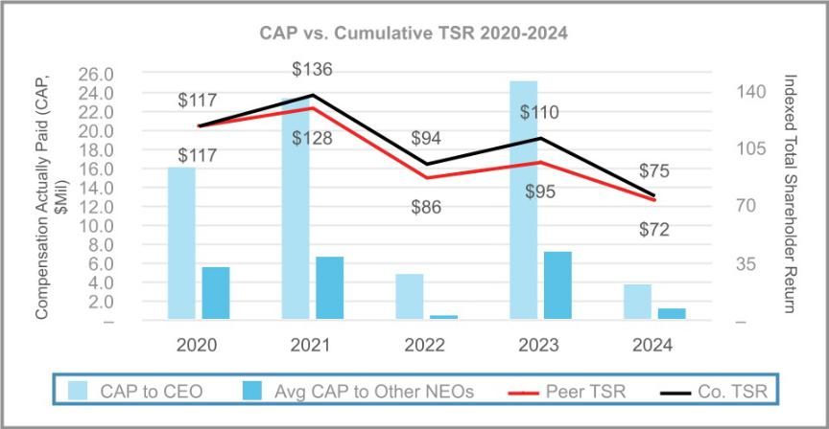

-

Relationship between CAP and Company Net Income over 2020-2024

As shown below, the Company’s CAP for the CEO and Average CAP for the non-CEO NEO varied significantly each year, primarily due to the Company’s significant emphasis on equity incentives, which are sensitive to changes in stock price. The Company’s net income increased significantly in 2021 (reflecting the COVID-19 pandemic in 2020), decreased slightly in 2022 (reflecting the ongoing

macroeconomic challenges described above), increased significantly again in 2023 (reflecting higher than anticipated industry volumes combined with strong operating performance in both business segments) and decreased in 2024 (reflecting the challenging environment

as the automotive industry was impacted by a number of global economic issues).

- | LEAR CORPORATION

Table of Contents

EXECUTIVE COMPENSATION

As a result, CAP and Average CAP are generally aligned with net income. Although net income is not used by the Company as a performance measure in either its annual or long-term incentive plans, net income is correlated with other financial measures which we

do use in setting goals for both the annual and the long-term incentive plans.
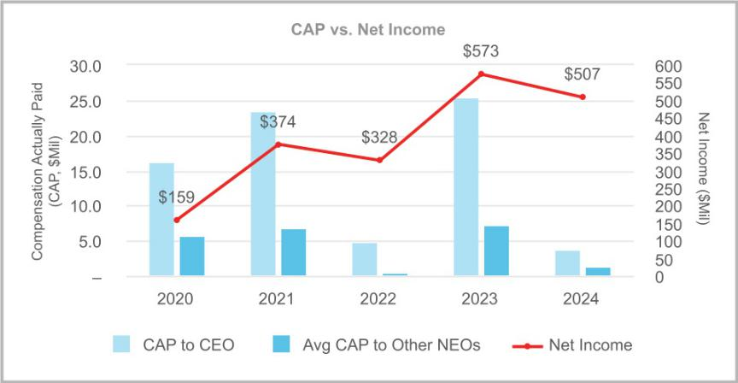

-

Relationship between CAP and Company Adjusted Operating Income* over 2020-2024

The chart below illustrates the relationship between the CEO and average non-CEO NEO CAP amounts and the Company's Adjusted Operating Income for the applicable years. We consider Adjusted Operating Income to be the most important financial measure used to

link pay to performance during this period because it is both a key measure in our AIP and is the largest driver of a key measure in our LTI (Adjusted Annual Pretax Income). Adjusted Operating Income is a well understood operating metric that can be influenced by all levels of employees of the Company and provides motivation to maximize earnings from current operations. It is substantially correlated

with our stock price performance, and thus to CAP.
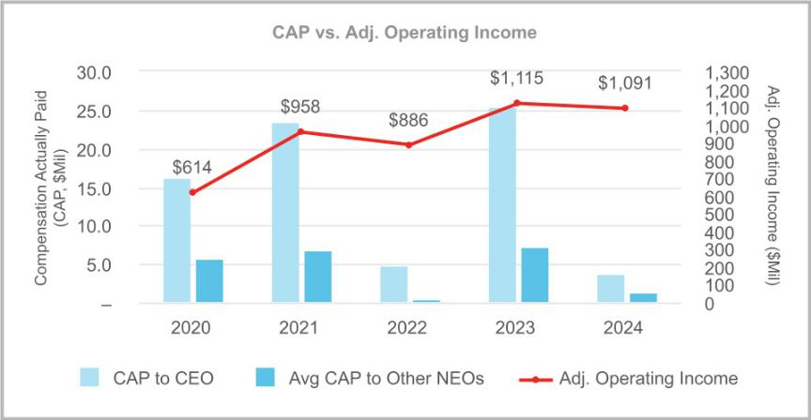

- Adjusted Operating Income is a Non-GAAP financial measure. See pages 43 and 47 and Appendix A "Reconciliation of Non-GAAP Financial Measures" on page 90 for more information on this financial measure and how it is used.

All information provided in “Pay Versus Performance Disclosures” above will not be deemed to be incorporated by reference into any filing of the Company under the Securities Act of 1933, as amended, or the Securities Exchange Act of 1934, as amended, whether made before or after the date hereof and
irrespective of any general incorporation language in any such filing, except to the extent the Company specifically incorporates such information by reference.

2025 Proxy Statement | | 75

Table of Contents

ADDITIONAL PROXY MATERIALS

P&C COMMITTEE INTERLOCKS AND INSIDER PARTICIPATION

The following persons served on our P&C Committee during all or a portion of 2024: Messrs. Cheng and Halverson, Dr. Jepsen, and Mses. Lewis and Ligocki. No member of the P&C Committee was, during the fiscal year ended December 31, 2024, an officer, former

officer or employee of the Company or any of our subsidiaries. None of our executive officers served as a member of:

- the compensation committee of another entity in which one of the executive officers of such entity served on our P&C Committee;

- the board of directors of another entity in which one of the executive officers of such entity served on our P&C Committee; or

- the compensation committee of another entity in which one of the executive officers of such entity served as a member of our Board.

- | LEAR CORPORATION

Table of Contents

ADDITIONAL PROXY MATERIALS

P&C COMMITTEE REPORT

The information contained in this Report shall not be deemed to be “soliciting material” or to be “filed” with the SEC or subject to Regulation 14A or 14C other than as set forth in Item 407 of Regulation S-K, or subject to the liabilities of Section 18 of the Exchange

Act, except to the extent that we specifically request that the information contained in this Report be treated as soliciting material, nor shall such information be incorporated by reference into any past or future filing under the Securities Act of 1933, as amended (the

“Securities Act”), or the Exchange Act, except to the extent that we specifically incorporate it by reference in such filing.

The P&C Committee of the Board has reviewed and discussed the “Compensation Discussion and Analysis” required by Item 402(b) of Regulation S-K with management, and based on such review and discussions, the P&C Committee recommended to the Board that the

“Compensation Discussion and Analysis” be included in this proxy statement and the Annual Report on Form 10-K for the year ended December 31, 2024.

This Report is submitted by Messrs. Cheng and Halverson, Dr. Jepsen, and Mses. Lewis and Ligocki, being all of the current members of the P&C Committee.

Patricia L. Lewis, Chair

Mei-Wei Cheng

Bradley M. Halverson

Mary Lou Jepsen

Kathleen A. Ligocki

2025 Proxy Statement | | 77

Table of Contents

ADDITIONAL PROXY MATERIALS

AUDIT COMMITTEE REPORT

The information contained in this Report shall not be deemed to be “soliciting material” or to be “filed” with the SEC or subject to Regulation 14A or 14C, other than as set forth in Item 407 of Regulation S-K, or subject to the liabilities of Section 18 of the Exchange

Act, except to the extent that we specifically request that the information contained in this Report be treated as soliciting material, nor shall such information be incorporated by reference into any past or future filing under the Securities Act or the Exchange Act, except to

the extent that we specifically incorporate it by reference in such filing.

The Audit Committee of the Board is responsible for evaluating audit performance, appointing, compensating, retaining and overseeing the work of our independent registered public accounting firm and evaluating policies and procedures relating to internal accounting
functions and controls. The Audit Committee also oversees the audit fee negotiations associated with the retention of Ernst & Young LLP.
The Audit Committee has discussed the advantages and disadvantages of independent registered public accounting firm rotation.

Further, in connection with the periodic mandated rotation of the independent registered public accounting firm’s lead engagement partner, the Audit Committee is involved in the selection of Ernst & Young LLP’s lead engagement partner.

The Audit Committee is currently comprised of Messrs. Cheng, Foster, Halverson, Krone and Mallett, each a non-employee director, and

operates under a written charter that was last amended by our Board in November 2020. A copy of the current charter is available on the investor relations page of our website (https://ir.lear.com/) or in printed form upon request. Our Board has determined that all of the members of the Audit Committee are “independent” as defined in the listing standards of the NYSE and under Rule 10A-3 of the

Exchange Act and that all such members are financially literate. Our Board also has determined that all members of the Audit Committee are “audit committee financial experts,” as defined in Item 407(D) of Regulation S-K under the Exchange Act and have accounting or

related financial management expertise.

The Audit Committee members are neither professional accountants nor auditors, and their functions are not intended to duplicate or to certify the activities of management or the independent auditor, nor can the Audit Committee certify that the independent auditor is

“independent” under applicable rules. The Audit Committee serves a board-level oversight role in which it provides advice, counsel and direction to management and the auditors on the basis of the information it receives, discussions with management and the auditors and

the experience of the Audit Committee’s members in business, financial and accounting matters. Our management has the primary responsibility for the financial statements and reporting process, including our systems of internal controls. In fulfilling its oversight responsibilities, the Audit Committee reviewed and discussed with management the audited consolidated financial statements included in

the Annual Report on Form 10-K for the fiscal year ended December 31, 2024, as well as the report of management, for the year ended December 31, 2024, regarding the Company’s internal control over financial reporting required by Section 404 of the Sarbanes-Oxley

Act.

The Audit Committee has retained Ernst & Young LLP as the Company’s independent registered public accounting firm for 2024. Ernst & Young LLP has been the independent registered public accounting firm for the Company since 2002. The members of the Audit

Committee and the Board believe that the continued retention of Ernst & Young LLP to serve as the Company’s independent registered public accounting firm is in the best interests of the Company and its shareholders. In reaching this conclusion, the Audit Committee

considered Ernst & Young LLP’s integrity, controls and processes to ensure Ernst & Young LLP’s independence, objectivity, industry and company-specific experience, quality and effectiveness of personnel and communications, commitment to serving the Company, appropriateness of fees for audit and non-audit services and external data on audit quality and performance, including recent Public

Company Accounting Oversight Board (United States) (PCAOB) reports on Ernst & Young LLP and tenure as the Company’s auditors, including the benefits of having a long-tenured auditor.

The Audit Committee has discussed with the Company’s internal auditors and Ernst & Young LLP the overall scope and plans of their

respective audits. The Audit Committee meets with the Company’s internal auditors and Ernst & Young LLP, with and without management present, to discuss the results of their procedures, their evaluations of the Company’s internal control, including internal

control over financial reporting, and the overall quality of the Company’s financial reporting.

The Audit Committee reviewed with Ernst & Young LLP, its judgments as to the quality, not just the acceptability, of the Company’s accounting policies and such other matters as are required to be discussed by the applicable requirements of the PCAOB and the SEC.

The Audit Committee has also received written disclosures and the letter from Ernst & Young LLP required by applicable requirements of the PCAOB regarding Ernst & Young LLP’s communications with the Audit Committee concerning independence and has discussed with

Ernst & Young LLP its independence from the Company. The Audit Committee has considered whether the provision of non-audit services to the Company is compatible with maintaining the independence of Ernst & Young LLP.

- | LEAR CORPORATION

Table of Contents

ADDITIONAL PROXY MATERIALS

Based on the review and discussions referred to above, the Audit Committee recommended to the Board that the Company’s audited consolidated financial statements be included in the Company’s Annual Report on Form 10-K for the fiscal year ended December 31,

2024, filed with the SEC on February 14, 2025.

This Report is submitted by Messrs. Cheng, Foster, Halverson, Krone and Mallett, being all of the members of the Audit Committee. Bradley M. Halverson, Chair

Mei-Wei Cheng

Jonathan F. Foster

Roger A. Krone

Conrad L. Mallett, Jr.

2025 Proxy Statement | | 79

Table of Contents

ADDITIONAL PROXY MATERIALS

FEES OF INDEPENDENT ACCOUNTANTS

In addition to retaining Ernst & Young LLP to audit our consolidated financial statements for 2024, we retained Ernst & Young LLP, as well as other accounting firms, to provide tax and other advisory services in 2024. We understand the need for Ernst & Young LLP to maintain

objectivity and independence in its audit of our consolidated financial statements. It is also the Audit Committee’s goal that the fees that the Company pays to Ernst & Young LLP for permitted non-audit services in any year should not exceed the audit and audit-related fees

paid to Ernst & Young LLP in such year, a goal that the Company achieved in 2024 and 2023.

In order to assure that the provision of audit and permitted non-audit services provided by Ernst & Young LLP does not impair its independence, the Audit Committee is required to pre-approve the audit and permitted non-audit services to be performed by Ernst &

Young LLP, other than de minimis services that satisfy the requirements pertaining to de minimis exceptions for non-audit services described in Section 10A of the Exchange Act. The Audit Committee also has adopted policies and procedures for pre-approving all audit

and permitted non-audit work performed by Ernst & Young LLP. Any pre-approval must set forth in detail the particular service or category of services approved and is generally subject to a specific cost limit. All of the fees for audit, audit-related, tax and other services performed by Ernst & Young LLP were pre-approved by the Audit Committee in accordance with the pre-approval policies and

procedures described in this paragraph.

The Audit Committee has adopted policies regarding our ability to hire employees, former employees and certain relatives of employees of the Company’s independent registered public accounting firm.

During 2024 and 2023, we retained Ernst & Young LLP to provide services in the following categories and amounts (in thousands):

 | 2024 | 2023
Audit fees⁽¹⁾ | $13,457 | $12,779
Audit-related fees⁽²⁾ | 747 | 1,261
Tax fees⁽³⁾ | 2,619 | 2,705
All other fees⁽⁴⁾ | — | 287

- Audit fees include services related to the annual audit of our consolidated financial statements, the audit of our internal controls over financial reporting, the reviews of our Quarterly Reports on Form 10-Q, international statutory audits and other services that are normally provided by the independent accountants in connection with our regulatory filings.

- Audit-related fees include services related to the audits of employee benefit plans, an information technology pre-implementation review and agreed-upon procedures related to certain due diligence services in connection with acquisitions and divestitures.
- Tax fees include services related to tax compliance, tax advice and tax planning.
- All other fees include services that are not contained in the above categories and consist of permissible non-audit services. The 2023 fees include insurance claim services related to a typhoon in the Philippines.

- | LEAR CORPORATION

Table of Contents

ADDITIONAL PROXY MATERIALS

CERTAIN RELATIONSHIPS AND RELATED PARTY TRANSACTIONS

Our Code of Business Conduct & Ethics prohibits activities that conflict with, or have the appearance of conflicting with, the best interests of the Company and its shareholders. Such conflicts of interest may arise when an employee, or a member of such employee’s

immediate family, receives improper personal benefits as a result of such employee's position in the Company. We also maintain a Related Party Transaction Policy regarding the identification, review, monitoring and, as necessary, approval of transactions between the

Company and related parties. Related parties include directors and director nominees, executive officers and such other employees as may be designated by the Company from time to time (together with executive officers, “senior officers”), significant shareholders and immediate family members of any of the foregoing. Under the policy, a related party transaction includes any transaction, or series of

transactions, involving the Company and a related party in excess of $120,000, whether undertaken in or outside the ordinary course of our business and where the related party has a direct or indirect material interest in such transaction or series of transactions. All related

party transactions must be reviewed and approved by the G&S Committee.

Under the policy, directors and senior officers are required to complete an annual questionnaire regarding their immediate family members, related entities and potential related party transactions. Following review of such questionnaires, the Vice President of Audit

Services and Chief Accounting Officer determine whether the Company has engaged in any transactions with the identified individuals and entities. All such transactions, if any, are reviewed by the General Counsel, other members of management and outside counsel, as necessary, to evaluate whether such transactions constitute related party transactions and are therefore subject to the review and

approval of the G&S Committee.

In connection with any required approval of the G&S Committee, a member of senior management must represent to the G&S

Committee that the related party at issue has been held to the same standards as unaffiliated third parties. The G&S Committee assesses the terms of the transaction, the business purpose of the transaction, the benefit to the Company and to the related party, whether the transaction was in the ordinary course of business and any other relevant factors. G&S Committee members having (or

having an immediate family member that has) a direct or indirect interest in the transaction must recuse themselves and abstain from voting on the approval or ratification of the related party transaction. All related party transactions are disclosed annually in our proxy

statement.

Certain Transactions

Joshua Scott, a program manager for the Company, is the son of Raymond E. Scott, a director of the Company and the Company’s President and CEO. In 2024, total compensation (base salary and cash bonus) paid to Mr. Scott was approximately $127,000. The

compensation paid to Mr. Scott was reviewed and approved by the G&S Committee and was in accordance with the Company’s standard compensation practices for similarly situated employees.

Jacob Scott, a purchasing manager for the Company, is the son of Raymond E. Scott, a director of the Company and the Company’s President and CEO. In 2024, total compensation (base salary and cash bonus) paid to Mr. Scott was approximately $143,000. The compensation paid to Mr. Scott was reviewed and approved by the G&S Committee and was in accordance with the Company’s standard

compensation practices for similarly situated employees.

2025 Proxy Statement | | 81

Table of Contents

ADDITIONAL PROXY MATERIALS

RATIFICATION OF RETENTION OF INDEPENDENT REGISTERED PUBLIC ACCOUNTING FIRM FOR 2025 (PROPOSAL NO. 2)

Our Audit Committee has retained Ernst & Young LLP as our independent registered public accounting firm for the year ending December

31, 2025. A proposal will be presented at the Annual Meeting to ratify this retention. Ratification of the retention of our independent registered public accounting firm requires the affirmative vote of the majority of shares present in person or represented by proxy at the Annual Meeting and entitled to vote. If the shareholders fail to ratify such selection, another independent registered public accounting

firm will be considered by our Audit Committee, but the Audit Committee may nonetheless choose to engage Ernst & Young LLP. Even if the retention of Ernst & Young LLP is ratified, the Audit Committee in its discretion may select a different independent registered public

accounting firm at any time during the year if it determines that such a change would be in the best interests of the Company and its shareholders. We have been advised that a representative of Ernst & Young LLP will be present at the Annual Meeting and will be available to respond to appropriate questions and, if such person chooses to do so, make a statement.

THE BOARD UNANIMOUSLY RECOMMENDS A VOTE “FOR” RATIFICATION OF THE RETENTION OF ERNST & YOUNG LLP AS OUR INDEPENDENT REGISTERED PUBLIC ACCOUNTING FIRM FOR 2025.

PROXIES SOLICITED BY THE BOARD WILL BE VOTED “FOR” THE PROPOSAL UNLESS SHAREHOLDERS SPECIFY A CONTRARY VOTE.

- | LEAR CORPORATION

Table of Contents

ADDITIONAL PROXY MATERIALS

ADVISORY VOTE TO APPROVE THE COMPANY’S EXECUTIVE COMPENSATION SET FORTH IN THIS PROXY STATEMENT (PROPOSAL NO. 3)

Pursuant to Section 14A of the Exchange Act, we are seeking the advisory approval by shareholders of the Company’s executive compensation program and practices as disclosed in this proxy statement. As most recently approved by shareholders at the annual

meeting of shareholders in 2024 and consistent with the Board’s recommendation, we are submitting this proposal for a non-binding vote on an annual basis. While this vote is advisory, and not binding on the Board, it will provide information to the Board and P&C

Committee regarding investor sentiment about our executive compensation programs and practices, which the P&C Committee will carefully review when evaluating our executive compensation program. At the annual meeting of shareholders in 2024, our executive compensation program and practices disclosed in our 2024 proxy statement received a favorable vote by 90.2% of shares voted.

Shareholders are being asked to vote on the following advisory resolution:

“RESOLVED, that the Company’s shareholders approve, on an advisory basis, the compensation of the Company’s executive officers, as

disclosed in the 2025 proxy statement pursuant to the compensation disclosure rules of the Securities and Exchange Commission, including the Compensation Discussion and Analysis, the 2024 Summary Compensation Table and the other related tables and disclosures.”

The Company is committed to maintaining executive compensation programs and practices that are aligned with the Company’s business strategy. As a result, the Company has a strong pay-for-performance philosophy that greatly impacts its decisions regarding executive compensation. Our executive compensation programs seek to align management’s interests with our shareholders’ interests to support

long-term value creation and pay for performance. This philosophy and the compensation structure are essential to the Company’s ability to attract, retain and motivate individuals who can achieve superior financial results in the best interests of the Company and its

shareholders. To that end, our program links pay to performance by delivering a significant majority of the total compensation opportunity of our NEOs in variable or performance-based compensation programs (annual and long-term incentive plans). Performance measures used in the Company’s annual and long-term incentive plans support the Company’s annual operating plan and longer-term

strategy and are tied to key Company measures of short and long-term performance. Our program also aligns the NEOs’ financial interests with those of our shareholders by delivering a substantial portion of their total compensation in the form of equity awards and

other long-term incentive vehicles.

We urge our shareholders to read the “Compensation Discussion and Analysis” above, which describes in detail how our executive compensation program and practices operate and are designed to achieve our compensation objectives, as well as the accompanying

compensation tables which provide detailed information on the compensation of our NEOs.

The affirmative vote of a majority of the shares of common stock present in person or represented by proxy and entitled to be voted on the proposal at the Annual Meeting is required for approval of this advisory resolution.

THE BOARD UNANIMOUSLY RECOMMENDS A VOTE “FOR” THE ADVISORY APPROVAL OF THE COMPANY’S EXECUTIVE COMPENSATION SET FORTH IN THIS PROXY STATEMENT.

PROXIES SOLICITED BY THE BOARD WILL BE VOTED “FOR” THE ADVISORY APPROVAL OF THE COMPANY’S EXECUTIVE COMPENSATION SET FORTH IN THIS PROXY STATEMENT UNLESS SHAREHOLDERS SPECIFY A CONTRARY VOTE.

2025 Proxy Statement | | 83

Table of Contents

ADDITIONAL PROXY MATERIALS

QUESTIONS AND ANSWERS ABOUT THE ANNUAL MEETING

Why did you send me this proxy statement?

We sent you this proxy statement because the Board is soliciting your proxy to vote at the Annual Meeting to be held on May 16, 2025, at 9:00 a.m. (Eastern Time) and at any postponements or adjournments of the Annual Meeting. This proxy statement summarizes information that is intended to assist you in making an informed vote on the proposals described in this proxy statement.

Who can vote at the Annual Meeting?

Only shareholders of record as of the record date are entitled to vote at the Annual Meeting. The record date to determine shareholders

entitled to notice of and to vote at the Annual Meeting is the close of business on March 18, 2025. On the record date, there were 53,540,555 shares of our common stock, par value $0.01 per share, outstanding. Our common stock is the only class of voting securities outstanding.

How many shares must be present to conduct the Annual Meeting?

We must have a quorum present in person or by proxy to conduct the Annual Meeting. A quorum is established when a majority of shares entitled to vote is present in person or represented by proxy at the Annual Meeting. Abstentions and broker non-votes (as

described below) are counted for purposes of determining whether a quorum is present.

What matters are to be voted on at the Annual Meeting?

The agenda for the Annual Meeting is to:

- elect eleven directors named in this proxy statement;

- ratify the retention of Ernst & Young LLP as our independent registered public accounting firm for 2025;

- provide an advisory vote to approve our executive compensation; and

- conduct any other business properly brought before the Annual Meeting or any adjournments or postponements thereof.

As of the date of this proxy statement, we do not know of any other matters to be presented at the Annual Meeting. If any other matters

properly come before the Annual Meeting, however, the persons named as proxies will be authorized to vote or otherwise act in accordance with their judgment.

How does the Board recommend that I vote?

The Board recommends that you vote:

- FOR the election of each of Lear’s director nominees named in this proxy statement;

- FOR the ratification of the retention of Ernst & Young LLP as our independent registered public accounting firm for 2025; and

- FOR the approval, on an advisory basis, of our executive compensation.

How do I vote at the Annual Meeting?

If you do not request printed copies of the proxy materials by mail, you will receive a Notice of Internet Availability of Proxy Materials.

Shareholders that receive a Notice of Internet Availability of Proxy Materials may vote via the Internet in the following ways:

- Prior to the Annual Meeting — You can vote via the Internet by navigating to www.proxyvote.com and entering the 16-digit control number included on the Notice of Internet Availability of Proxy Materials, proxy card or voting instructions form previously distributed; or

- At the Annual Meeting — You may vote via the Internet at the Annual Meeting by attending the live meeting at www.virtualshareholdermeeting.com/LEA2025 and entering the 16-digit control number included on the Notice of Internet Availability of Proxy Materials, proxy card or voting instructions form previously distributed.

If you request printed copies of the proxy materials by mail, you will receive a proxy card or a voting instruction form and will be able to vote in the following ways in addition to the methods of voting via the Internet described above:

- By Telephone — You can vote by proxy by calling the toll-free number found on your proxy card or voting instruction form. You will need to use the 16-digit control number included on the proxy card to vote by

- | LEAR CORPORATION

Table of Contents

ADDITIONAL PROXY MATERIALS

telephone. The availability of telephone voting may depend on the voting process of the organization that holds your shares; or 2. By Mail — You can vote by completing, dating, signing and returning the proxy card or voting instruction form.

Telephone and Internet voting facilities will be available 24 hours a day. You may vote over the telephone or via the Internet at www.proxyvote.com until 11:59 p.m. on May 15, 2025. Even if you plan to attend the Annual Meeting, we recommend that you vote in

advance of the meeting via Internet or submit your proxy or voting instructions as described above so that your vote will be counted if you later decide not to attend the Annual Meeting.

Your proxy will be voted in accordance with your instructions so long as, in the case of a proxy card returned by mail, such card has

been signed and dated. If you vote your shares via the Internet, by telephone or by executing and returning a proxy card by mail but you do not provide specific instructions with respect to the proposals, your shares will be voted FOR the director nominees named in this

proxy statement, FOR the ratification of the retention of our independent registered public accounting firm and FOR the advisory approval of executive compensation described in this proxy statement.

As of the date of this proxy statement, we do not know of any matters to be presented at the Annual Meeting except those described in

this proxy statement. If any other matters properly come before the Annual Meeting, however, the persons named as proxies will be authorized to vote or otherwise act in accordance with their judgment.

What does it mean if I receive more than one Notice of Internet Availability of Proxy Materials?

You may receive more than one Notice of Internet Availability of Proxy Materials, more than one e-mail or multiple proxy cards or voting instruction cards. For example, if you hold your shares in more than one brokerage account, you may receive a separate Notice of

Internet Availability of Proxy Materials, a separate e-mail or a separate voting instruction card for each brokerage account in which you hold shares. If you are a shareholder of record and your shares are registered in more than one name, you may receive more than one Notice of Internet Availability of Proxy Materials, more than one e-mail or more than one proxy card. To vote all of your shares by proxy,

you must complete, sign, date and return each proxy card and voting instruction card that you receive and vote over the Internet the shares represented by each Notice of Internet Availability of Proxy Materials that you receive (unless you have requested and received a

proxy card or voting instruction card for the shares represented by one or more of those Notices of Internet Availability of Proxy Materials).

May I change my vote?

Yes. You may revoke your proxy at any time before it is voted at the Annual Meeting. To change your vote, you may vote your shares electronically as described above, submit another later dated proxy by telephone or mail or submit new voting instructions to your bank, broker, trustee or nominee. Your attendance at the Annual Meeting will not, by itself, revoke your proxy; you must vote via the Internet

during the meeting to revoke your proxy.

Do common shareholders have appraisal rights?

Holders of shares of our common stock do not have appraisal rights under Delaware law or under the Company's governing documents in connection with this solicitation.

What vote is required to elect directors and approve the other matters described in this proxy statement?

Because this is an uncontested election, the director nominees must receive the affirmative vote of a majority of the votes cast to be elected (i.e., the number of shares voted “for” a director nominee must exceed the number of votes cast “against” that nominee) (Proposal No. 1). Abstentions and broker non-votes will have no effect on the outcome of the election of directors. In an uncontested

election, our Bylaws provide that any incumbent director that fails to receive a majority of votes cast shall immediately tender his or her resignation. Our Board, in a process managed by the G&S Committee and following a recommendation by that committee, must decide

whether or not to accept the tendered resignation.

For the ratification of the retention of Ernst & Young LLP as our independent registered public accounting firm (Proposal No. 2) and the advisory approval of our executive compensation (Proposal No. 3), the affirmative vote of the holders of a majority of the shares

represented in person or by proxy and entitled to vote on the proposal will be required for approval. For Proposal No. 2 and Proposal No. 3, abstentions and broker non-votes will be counted as shares represented and entitled to vote for the purposes of determining whether there is a quorum. Abstentions will have the same effect as a vote against Proposal No. 2 and Proposal No. 3. Absent specific

instructions on Proposal No. 2, brokers are permitted to exercise voting discretion with respect to such proposal. Broker non-votes will have no effect on Proposal No. 3. For additional information about broker non-votes see “How do I vote if my bank or broker holds my

shares in ‘street name’?”

2025 Proxy Statement | | 85

Table of Contents

ADDITIONAL PROXY MATERIALS

What is the difference between holding shares as a shareholder of record and as a beneficial owner?

If your shares are registered in your name on the Company’s books and records or with our transfer agent, you are the “shareholder of

record” of those shares, and this proxy statement and accompanying materials have been provided directly to you by the Company. On the other hand, if you purchased your shares through a brokerage or other financial intermediary, the brokerage or other financial intermediary will automatically put your shares into “street name” which means that the brokerage or other financial intermediary will

hold your shares in its name or another nominee’s name and not in your name but will keep records showing you as the “beneficial owner.” If you hold shares beneficially in street name, this proxy statement and accompanying materials have been forwarded to you by

your broker, bank or other holder of record.

How do I vote if my bank or broker holds my shares in “street name”?

If you hold your shares in “street name” through a bank, broker or other nominee, such bank, broker or nominee will vote those shares

in accordance with your instructions. To so instruct your bank, broker or nominee, you should refer to the information provided to you by such entity. Without instructions from you, a bank, broker or nominee will be permitted to exercise its own voting discretion with respect

to so-called routine matters (Proposal No. 2 - ratification of auditors) but will not be permitted to exercise voting discretion with respect to non-routine matters (Proposals No. 1 - director elections and No. 3 - advisory vote on our executive compensation). Thus, if you do not give your bank, broker or nominee specific instructions with respect to Proposal No. 2, your shares will be voted in such entity’s

discretion. If you do not give your bank, broker or nominee specific instructions with respect to the remaining proposals, your shares will not be voted on such proposals. This is called a “broker non-vote.” Shares represented by such broker non-votes will be counted in determining whether there is a quorum and will have no effect on the non-routine proposals. We urge you to promptly provide your

bank, broker or nominee with appropriate voting instructions so that all your shares may be voted at the Annual Meeting.

How many votes do I have?

Each share of common stock that you hold as of the record date entitles you to one vote, without cumulation, on each matter to be voted upon at the Annual Meeting.

How will the votes be counted at the Annual Meeting?

The votes will be counted by the inspector of election appointed for the Annual Meeting.

How will the Company announce the voting results?

The Company will report the final results of the voting at the Annual Meeting in a filing with the SEC on a Current Report on Form 8-K.

Who pays for the Company’s solicitation of proxies?

The Board is soliciting your proxy to vote your shares of common stock at our Annual Meeting. We will bear the cost of soliciting proxies on behalf of the Company, including preparing, printing and mailing this proxy statement. Proxies may be solicited personally, by mail,

email or by telephone by certain of our directors, officers, employees or representatives.

Our directors and employees will not be paid any additional compensation for soliciting proxies. We will reimburse brokerage houses, banks, custodians and other nominees and fiduciaries for out-of-pocket expenses incurred in forwarding our proxy solicitation materials.

What is “householding” and how does it work?

Under the rules adopted by the SEC, we may deliver a single set of proxy materials to one address shared by two or more of our

shareholders. This delivery method is referred to as “householding” and can result in significant cost savings. To take advantage of this opportunity, we have delivered only one set of proxy materials to multiple shareholders who share an address, unless we received

contrary instructions from the impacted shareholders prior to the mailing date. We agree to deliver promptly, upon written or oral request, a separate copy of the proxy materials, as requested, to any shareholder at the shared address to which a single copy of these documents was delivered. If you prefer to receive separate copies of the Notice of Internet Availability of Proxy Materials, proxy

statement or annual report, contact Broadridge Financial Solutions, Inc. by calling 1-800-542-1061 or in writing at Broadridge, Householding Department, 51 Mercedes Way, Edgewood, New York 11717.

In addition, if you currently are a shareholder who shares an address with another shareholder and would like to receive only one copy of future notices and proxy materials for your household, you may notify your broker if your

- | LEAR CORPORATION

Table of Contents

ADDITIONAL PROXY MATERIALS

shares are held in a brokerage account or you may notify us if you hold registered shares. Registered shareholders may notify us by contacting Broadridge Financial Solutions, Inc. at the above telephone number or address or sending a written request to Lear

Corporation, 21557 Telegraph Road, Southfield, Michigan 48033, Attention: Investor Relations.

How do I participate in the Annual Meeting?

We are hosting the Annual Meeting through a virtual web conference. You will not be able to attend the meeting in person. You will be

able to attend the virtual meeting, vote your shares electronically, and submit your questions during the live webcast of the meeting by visiting www.virtualshareholdermeeting.com/LEA2025 and entering your 16-digit control number included in your Notice of Internet

Availability of Proxy Materials, on your proxy card, or in any additional voting instructions accompanying these proxy materials. The Annual Meeting will begin promptly at 9:00 a.m. (Eastern Time). Online check-in will be available beginning at 8:30 a.m. (Eastern Time). Please allow ample time for the online check-in process. Please be assured that you will be afforded the same rights and opportunities to

participate in the virtual meeting as you would at an in-person meeting.

As part of the Annual Meeting, we will hold a question and answer session, during which we intend to answer questions submitted during

the meeting in accordance with the Annual Meeting procedures which are pertinent to the Company and the meeting matters, as time permits. Questions may be submitted during the Annual Meeting through www.virtualshareholdermeeting.com/LEA2025. Questions and answers will be grouped by topic and substantially similar questions will be grouped and answered once.

There will be technicians ready to assist you with any technical difficulties you may have accessing the virtual meeting website. If you encounter any difficulties accessing the virtual meeting website during the check-in or meeting time, please call the technical support

number that will be posted on the Annual Meeting login page.

2025 Proxy Statement | | 87

Table of Contents

ADDITIONAL PROXY MATERIALS

SHAREHOLDER PROPOSALS FOR 2026 ANNUAL MEETING OF SHAREHOLDERS

Shareholders who intend to present proposals at the Company’s annual meeting of shareholders in 2026 pursuant to Rule 14a-8 under the Exchange Act must send notice of their proposal to us so that we receive it no later than December 4, 2025. Shareholders who

intend to present proposals at the annual meeting of shareholders in 2026 other than pursuant to Rule 14a-8 must comply with the notice provisions in our Bylaws. The notice provisions in our Bylaws require that, for a proposal to be properly brought before the annual

meeting of shareholders in 2026, proper notice of the proposal must be received by us not less than 90 days nor more than 120 days prior to the first anniversary of the preceding year’s annual meeting; provided, however that in the event next year’s annual meeting is more than 30 days before or less than 70 days after such anniversary date, notice must be delivered not less than the later of 90 days

prior to next year’s annual meeting or the 10th day following the day the Company first publicly announces next year’s annual meeting date. Under these requirements, the deadline for proposals brought under our Bylaws is no earlier than January 16, 2026, and no later

than February 16, 2026. Additionally, any nominations of directors must comply with the universal proxy rules contained in Rule 14a-19. Please note that the notice requirements under Rule 14a-19 are in addition to the applicable notice requirements under the advance notice provisions of our Bylaws as described above. Shareholder proposals should be addressed to Lear Corporation, 21557 Telegraph

Road, Southfield, Michigan 48033, Attention: Amanda J. Pontes, Vice President, General Counsel and Corporate Secretary.

- | LEAR CORPORATION

Table of Contents

ADDITIONAL PROXY MATERIALS

OTHER MATTERS

We know of no other matters to be submitted to the shareholders at the Annual Meeting. If any other matters properly come before the Annual Meeting, persons named in the proxy intend to vote the shares they represent in accordance with their own judgments.

Upon written request by any shareholder entitled to vote at the Annual Meeting, we will promptly furnish, without charge, a copy of the Annual Report on Form 10-K for the fiscal year ended December 31, 2024, which we filed with the SEC,

including the financial statements and schedule. If the person requesting the report was not a shareholder of record on March 18, 2025, the request must contain a good faith representation that he or she was a beneficial owner of our common stock at the close of business on that date. Requests should be addressed to Lear Corporation, 21557 Telegraph

Road, Southfield, Michigan 48033, Attention: Amanda J. Pontes, Vice President, General Counsel and Corporate Secretary.

YOUR VOTE IS IMPORTANT. WE URGE YOU TO VOTE TODAY BY TELEPHONE, VIA THE INTERNET OR BY MAIL.

By Order of the Board of Directors,
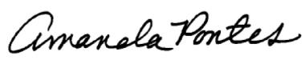

Amanda J. Pontes

Vice President, General Counsel

and Corporate Secretary

2025 Proxy Statement | | 89

Table of Contents

ADDITIONAL PROXY MATERIALS

APPENDIX A RECONCILIATION OF NON-GAAP FINANCIAL MEASURES

The information presented in this proxy statement in “Proxy Summary” and “Compensation Discussion and Analysis — Executive Summary” regarding core operating earnings, adjusted earnings per share and free cash flow does not conform to GAAP and should not

be construed as an alternative to the reported financial results of the Company determined in accordance with GAAP.

Management believes that the non-GAAP information used in this proxy statement is useful to both management and investors in their

analysis of the Company’s financial position and results of operations. In particular, management believes that core operating earnings and adjusted earnings per share are useful measures in assessing the Company’s financial performance by excluding certain items that are not indicative of the Company’s core operating performance or that may obscure trends useful in evaluating the Company’s

continuing operating activities. Management also believes that these measures are useful to both management and investors in their analysis of the Company’s results of operations and provide improved comparability between fiscal periods. Management believes that
free cash flow is useful to both management and investors in their analysis of the Company’s ability to service and repay its debt.
Further, management uses these non-GAAP financial measures for planning and forecasting future periods.

The non-GAAP information provided may not be consistent with methodologies used by other companies. All non-GAAP information

regarding core operating earnings, adjusted earnings per share and free cash flow is reconciled to the most directly comparable reported GAAP results in the tables below.

Core Operating Earnings

(unaudited; in millions) |  | 2024 |  | 2023
Net income attributable to Lear | $ | 506.6 | $ | 572.5
Interest expense |  | 106.2 |  | 101.1
Other expense, net |  | 48.6 |  | 54.9
Income taxes |  | 191.1 |  | 180.8
Equity in net income of affiliates |  | (50.0) |  | (49.3)
Net income attributable to noncontrolling interests |  | 85.2 |  | 73.2
Restructuring costs and other special items -
Costs related to restructuring actions |  | 158.5 |  | 152.4
Acquisition costs |  | 0.6 |  | 0.8
Acquisition-related inventory fair value adjustment |  | — |  | 1.8
Costs related to CrowdStrike Holdings, Inc. |  | 3.2 |  | —
Impairments related to Fisker, Inc. |  | 15.0 |  | —
Impairments (recoveries) related to Russian operations |  | (1.7) |  | 2.4
Intangible asset impairment |  | — |  | 1.9
Insurance recoveries related to typhoon in the Philippines, net of costs |  | — |  | (3.3)
Favorable tax ruling in a foreign jurisdiction |  | — |  | (0.2)
Other |  | 32.8 |  | 31.0
Core operating earnings | $ | 1,096.1 | $ | 1,120.0

2024 PROXY STATEMENT | | 90

Table of Contents

ADDITIONAL PROXY MATERIALS

Adjusted Net Income and Adjusted Earnings Per Share

(unaudited; in millions, except per share amounts) |  | 2024 |  | 2023
Net income attributable to Lear | $ | 506.6 | $ | 572.5
Restructuring costs and other special items -
Costs related to restructuring actions |  | 145.0 |  | 134.2
Acquisition costs |  | 0.6 |  | 0.8
Acquisition-related inventory fair value adjustment |  | — |  | 1.8
Non-cash loss related to pending disposal on a non-core business |  | 24.4 |  | —
Costs related to CrowdStrike Holdings, Inc. |  | 3.2 |  | —
Impairments related to Fisker, Inc. |  | 15.0 |  | —
Impairments (recoveries) related to Russian operations |  | (1.7) |  | 2.4
Intangible asset impairment |  | — |  | 1.9
Insurance recoveries related to typhoon in the Philippines, net of costs |  | — |  | (7.3)
Non-cash settlement loss on pension lump-sum payout |  | 6.6 |  | —
Foreign exchange gains due to foreign exchange rate volatility related to Russia |  | (2.0) |  | (1.9)
Favorable tax ruling in a foreign jurisdiction |  | — |  | (0.7)
Loss related to affiliate |  | — |  | 7.0
Other |  | 39.7 |  | 34.3
Tax impact of special items and other net tax adjustments⁽¹⁾ |  | (24.6) |  | (34.7)
Adjusted net income attributable to Lear | $ | 712.8 | $ | 710.3
Weighted average number of diluted shares outstanding |  | 56.5 |  | 59.1
Diluted net income per share attributable to Lear | $ | 8.97 | $ | 9.68
Adjusted earnings per share | $ | 12.62 | $ | 12.02

- Reflects the tax effect of restructuring costs and other special items, as well as several discrete tax items. The identification of these tax items is judgmental in nature, and their calculation is based on various assumptions and estimates.

Free Cash Flow

(unaudited; in millions) |  | 2024 |  | 2023
Net cash provided by operating activities | $ | 1,120.1 | $ | 1,249.3
Settlement of accounts payable in conjunction with acquisition of IGB |  | — |  | 15.4
Capital expenditures |  | (558.7) |  | (626.5)
Free cash flow | $ | 561.4 | $ | 638.2

- | LEAR CORPORATION



